Business Training on the Value of Nature
Location | Date

Participant workbook
This workbook was developed by on behalf of the We Value Nature Campaign.
Authors: Katia Bonga, Francesca Jaworska

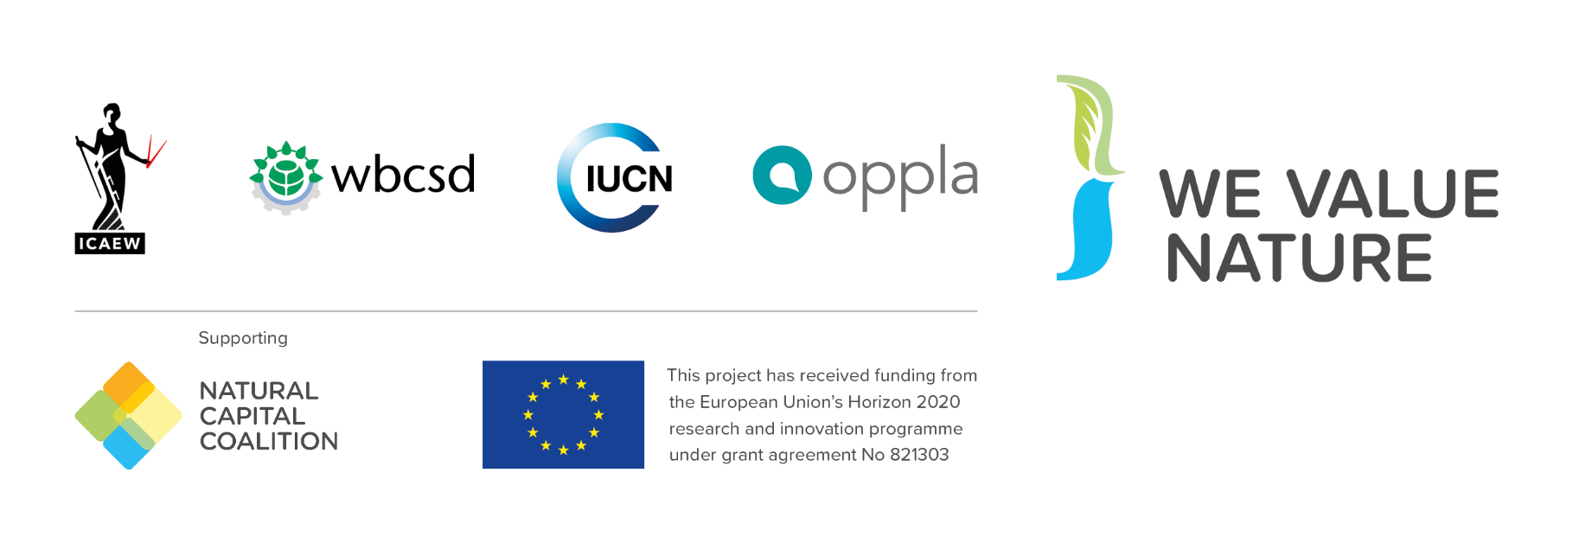
Contents
How to use this workbook 4
Introduction to natural capital 5
What is natural capital 5
Reflection: impacts and dependencies 7
The business case for action 9
Natural Capital Approach 10
Risk Game 11
Debrief: Risk Game 15
Tools and approaches 16
Natural Capital Protocol 16
Linkages with social & human capital 17
Integrating natural capital into business decision-making 17
Natural Capital Toolkit 19
Debrief: exploring tools and resources 19
Case studies 21
Company 1 21
Company 2 23
Company 3 25
Natural capital put into practice 27
Measuring and Valuation 27
Valuing Nature 27
Debrief: valuing nature 27
Wrap-up 30
Reflection: next steps 30
Key takeaways 31
Useful resources and further reading 32
Multimedia resources 33
Notes 34

How to use this workbook
This workbook is intended to complement the training you will be receiving today. It includes copies of the key definitions and diagrams included in the slides, as well as some additional ones you may find useful. There is also space for you to write personal reflections and responses to activities and discussions, as well as key learnings for each section. You can refer back to these in the future as you progress on your natural capital journey.

Introduction to natural capital

What is natural capital

Natural Capital Protocol definition
Natural Capital is the stock of renewable and non-renewable natural resources that combine to yield a flow of “services” to people. In turn, these flows provide value to business and society.
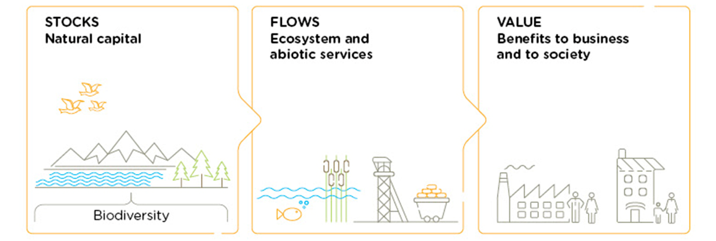
Figure 1: Natural Capital Protocol, p. 12

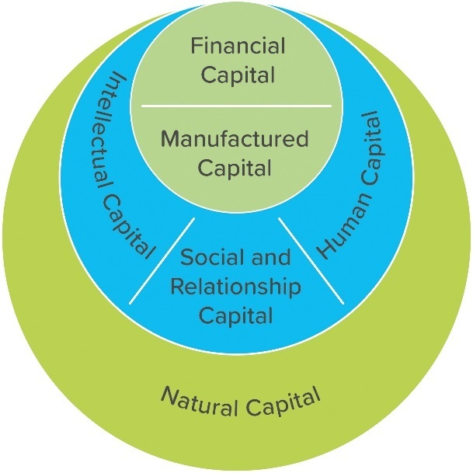
Natural Capital underpins all the other kinds of capital we also talk about. Without natural capital, human, social, and financial capital would not exist. Yet we also need to use other kinds of capital in order to realise some of the value of natural capital, for example extracting minerals.

Figure 2: IIRC Capitals Background Paper 2013, p.3

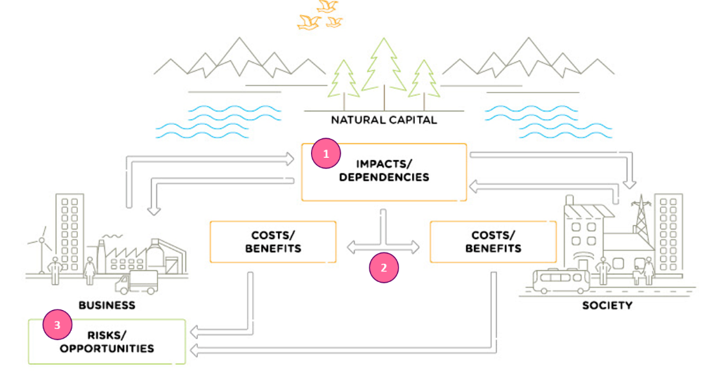
Dependencies and impacts
Figure 3: Natural Capital Protocol, p. 15
- All businesses impact and depend upon natural capital.

- This relationship delivers costs and benefits back to themselves and to society.

- These in turn lead to risks and opportunities to the business

Reflection: impacts and dependencies
- In what ways do you think your own company impacts and depends on nature?
- Write down three risks & three opportunities you think your company could be facing in the next 10 years

Risks | Opportunities

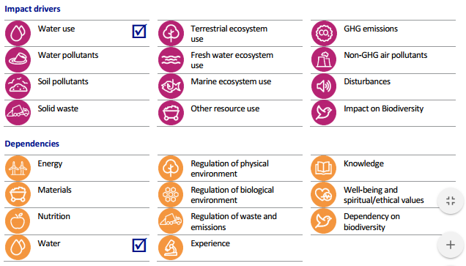

Figure 4: Natural Capital Coalition
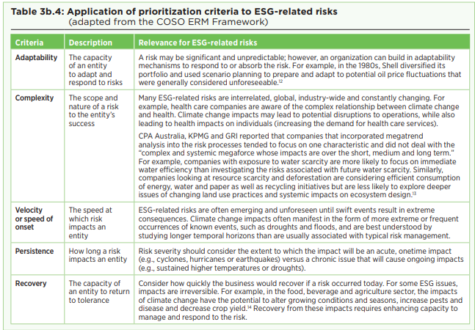
Figure 5: COSO & WBCSD, Enterprise Risk Management Guidance p.51

See p.18 in your Natural Capital Protocol for a more detailed list of risks and opportunities associated with natural capital.

My key learning(s)

The business case for action
Many natural capital risks and opportunities are becoming increasingly visible, and business needs a way to understand and manage these.

- Understand relationships with nature in a structured way
- Challenge your business model
- Mitigate risks
- Increased competitive advantage
- Create opportunities
- Inform decisions that are really important to your business
- Access to finance
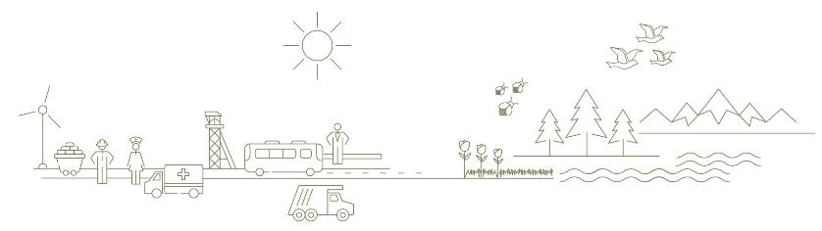
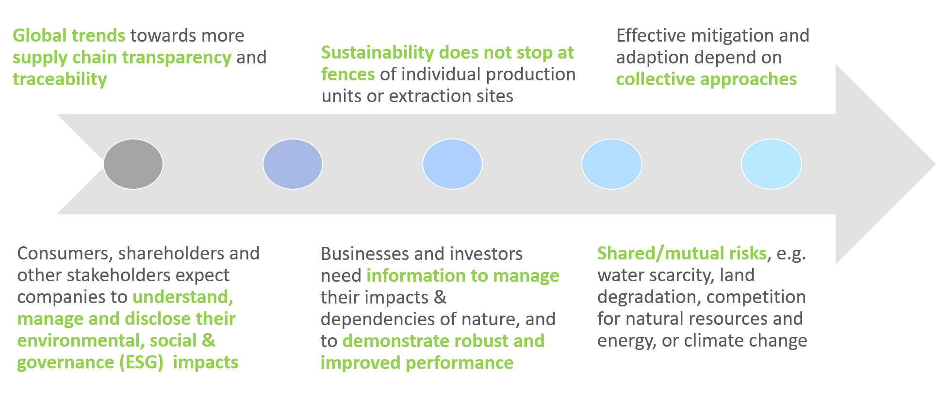

Natural Capital Approach
A natural capital approach integrates the concept of natural capital into decision-making.

It aims to illuminate nature’s (often hidden) value, whether it be economic, social, environmental, cultural or spiritual value, and whether this value is expressed in qualitative or quantitative (including economic) terms.

“It is not a requirement of the natural capital approach to apply all the features listed below. However it is good practice to consider their relevance, and all assessments must link to natural capital stocks. When natural capital assessments are used for compiling accounts and undertaking comparisons over time, these are referred to as natural capital accounting.” (Source: Natural Capital Protocol)
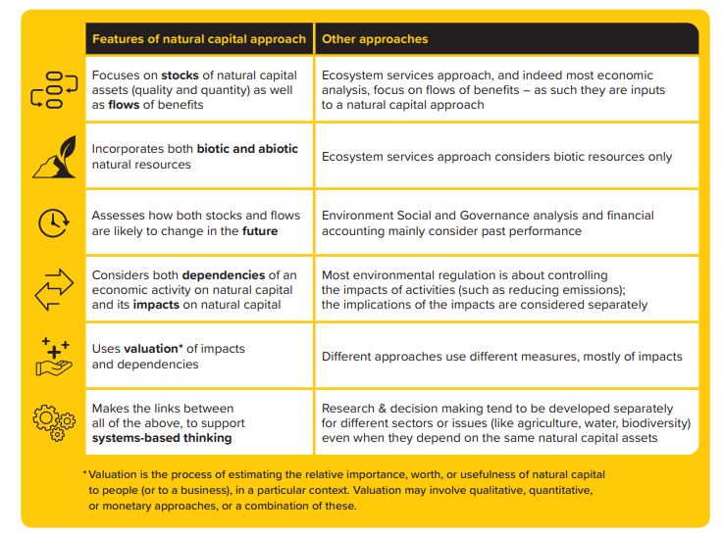
Figure 6: Natural Capital Coalition

Risk Game
This game has been adapted from Resilience; a board game to accompany the guidance on Applying Enterprise Risk Management to Environmental, Social and Governance-related risks.
Per table, work through the following scenario:
Context: You are part of the management team of “Pro P&P”, a pulp and paper company operating in South America. Recently, the issues of climate change and deforestation have increasingly been in the spotlight and one of your competitors has even been impacted by floods in one of its operational plants in Brazil.
Objective: In view of this context, your CEO has requested to re-assess the company’s environmental risks (bearing in mind its overall objective) and put into place appropriate risk mitigation measures.
Pro P&P’s overall objective is to be a recognized brand in the industry that takes into account customers’ increasing request for responsible brands and products.
After determining the risks and risks responses, the facilitator will spin a wheel of events that can either positively or negatively impact your final score as a team based on the risks responses you have put into place.
$10

Each team starts off with a share price of $10.

STEP 1
Keeping in mind your company’s overall objective and the provided context, in the list below circle the top three risks you believe are the most material ones to your company.
- New environmental regulation will lead to reduced forest or plantation availability and restrictions on the use of plastic packaging;
- Customer preferences will shift towards products with less environmental impacts impacting sales, revenue and market leadership;
- Association with environmental issues such as deforestation or plastics in the ocean will erode brand loyalty from customers;
- Lack of ESG skills, knowledge or capability from staff through to the board constrain management of ESG risks and opportunities;
- Megatrends such as e-commerce, online shopping and artificial intelligence will influence customer demands for paper and packaging and drive opportunities for efficiency;
- Severe weather events (e.g., cyclones floods) will disrupt the supply chain;
- Investors will begin to use information on how well a company manages its ESG risks as a key factor in making investment decisions.

STEP 2
Based on the identified key risks and the company’s overall objective, in the list below circle the top three measures that you believe are the most appropriate.
- Conduct life cycle assessments and invest in R&D to develop paper and packaging products that minimize environmental impact;

- Develop a customer interaction tool to monitor customer engagement on sustainability and changing customer preferences

- Develop a sustainability strategy and implement a goal to improve efficiency in water use, waste in the production and safety performance;

- Appoint an ESG-specialist to the board to drive board awareness on ESG-related risks and opportunities;

- Conduct 5-, 10-, 20 -year scenario analysis to monitor the impact of climate change and develop potential adaptation strategies;

- Purchase insurance to cover losses in the event of severe weather or pests;

- Develop relationships with NGOs around deforestation in an industry coalition to improve practices and expectations;

- Focus on producing paper and plastic products that can be certified as 'sustainable' (e.g. FSC and recyclable PET); invest in blockchain technology to enhance supply chain traceability.

$20
$19
$18
$17
$16
$15
$14
$13
$12
$11
$10
$9
$8
$7
$6
$5
$4
$3
$2
$1
$0

SHARE PRICE

YEAR

$

Final team score:

Debrief: Risk Game
- What did your team do well? What were some challenges?
- What did you learn from this activity about natural capital risk and how it can be managed more effectively?
- What are your key takeaways from the activity?
- How would you apply this in your company?

My key learning(s)

Tools and approaches

Natural Capital Protocol
The Natural Capital Protocol is a standardized framework for business to identify, measure and value its direct and indirect impacts and dependencies on natural capital.
It has been developed by the Natural Capital Coalition as a generally accepted framework built on existing approaches.

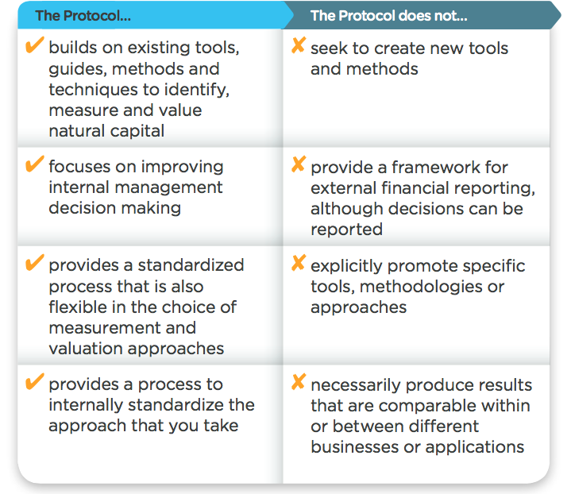

Figure 8: Natural Capital Coalition

Linkages with social & human capital
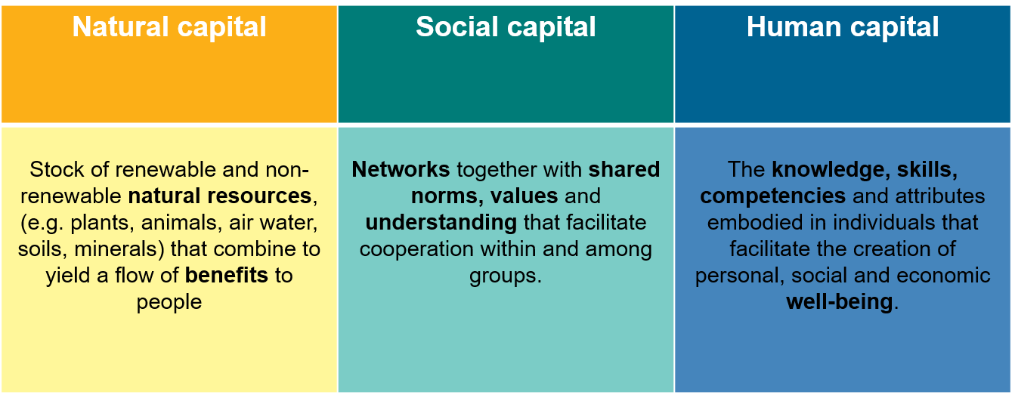
Business impacts on
Business depends on

Integrating natural capital into business decision-making
Assess risks and opportunities
Compare options
Assess impacts on stakeholders
Estimate total value and/or net impact
Communicate internally or externally
Potential Business Applications
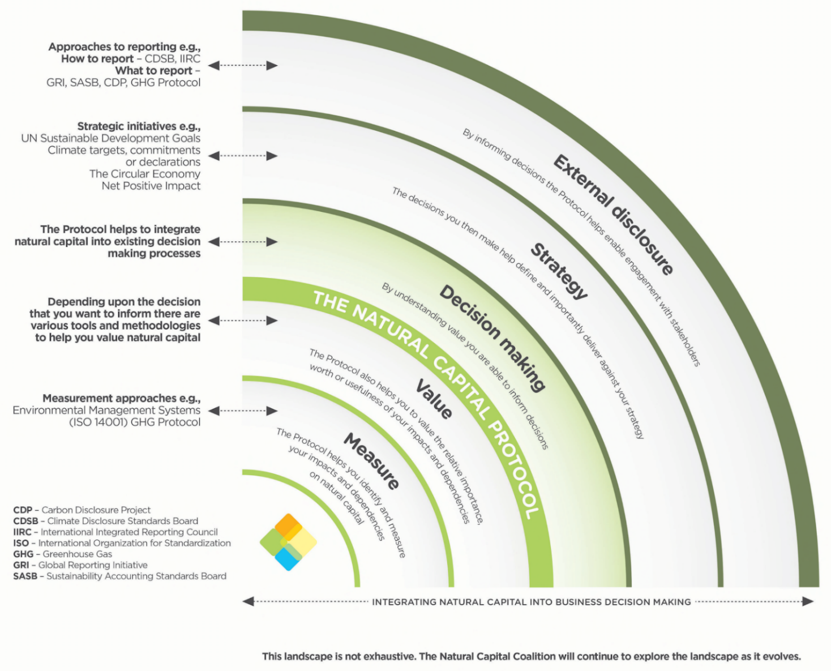
My key learning(s)
Figure 9: Natural Capital Coalition

Natural Capital Toolkit
You can find the Natural Capital Toolkit at https://shift.tools/nct

Debrief: exploring tools and resources
- What tools have you chosen?
- What are the advantages and disadvantages of the chosen tools?
- What kind of information did you look for when navigating on the Natural Capital Toolkit?
- What factors did you consider to help make the choice of tools?
- In what way(s) could the Natural Capital Toolkit and SHIFT be helpful to you?
- What did you learn from this activity?

Case studies
As you listen to the case studies, pay particular attention to the following points:
- The situation, the challenge
- Approach / tool(s) used
- Barriers / challenges + how these were overcome
- How natural capital supported decision-making
- Key stakeholders / enablers involved
- Commonalities between the three case studies
- Any other reflections or questions for the speakers

Company 1

My key learning(s)

Company 2

My key learning(s)

Company 3

My key learning(s)

Natural capital put into practice

Measuring and Valuation

To measure ≠ to value
- To measure: determine the amounts, extent and condition in physical terms, e.g. m3, tons, number of injuries, number of jobs
- To value: estimate the relative importance, worth, or usefulness of natural / social / human capital to people (or to a business), in a particular context.

Assessments can be qualitative, quantitative and monetary

Valuing Nature

Debrief: valuing nature
- What were your assumptions (incl. sources of data, methods used)?
- What are the limitations to putting a monetary value on water?
- What are the benefits of having a monetary value?
- How else could water be valued?

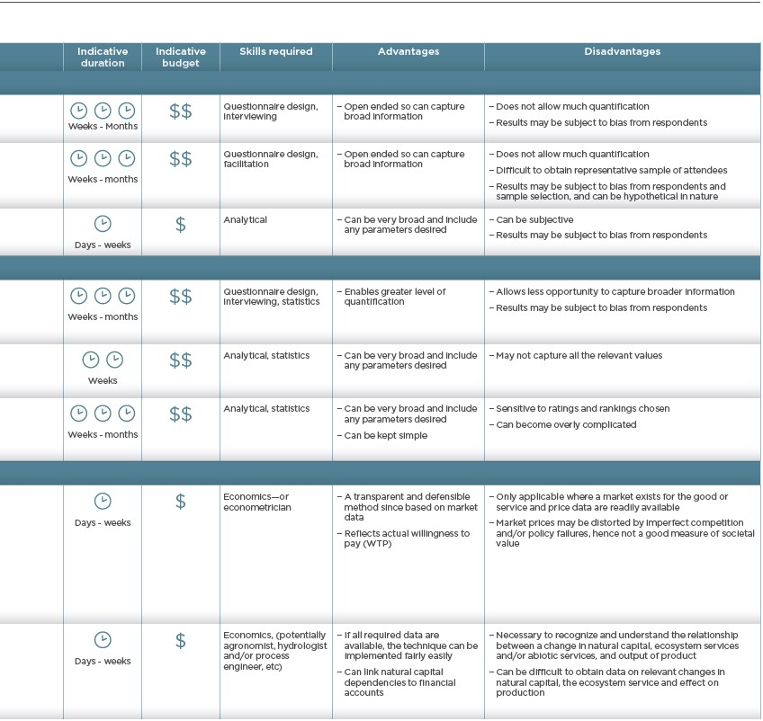
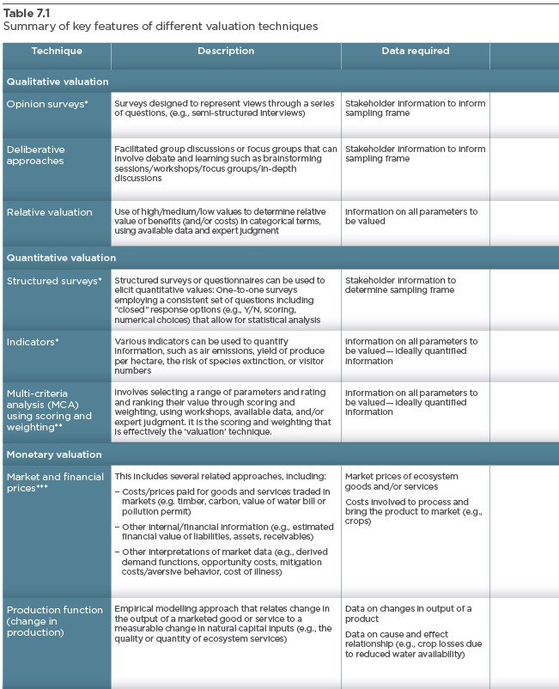
Figure 10: Natural Capital Protocol p. 84

Wrap-up

Reflection: next steps
- One concrete next step / activity you could take to move your company forward in its natural capital journey?

- Write the name and contact details of one person you’ve met today that you will stay in touch with to update on your progress. When will you check-in with each other?

Key takeaways
- Business impacts and depends on nature – the NCP provides the framework to identify and assess impacts and dependencies,
- Understanding, measuring and valuing natural capital (i.e. taking into account) will help business make better decisions,
- There are many existing approaches to measure and value impacts and dependencies. The one you chose depends on the information you are aiming to get or the decision you are trying to inform,
- Assessments are like snowflakes - no two are alike. The amount of resources, time and skills needed will depend on the scope of the assessment, what you're asking for and what data is already available,
- Companies can start to conduct an assessment themselves by getting the project going, scoping the assessment and integrating natural capital considerations into internal processes,
- For natural capital to become strategically important, buy-in must extend beyond the sustainability team.

My key learning(s)

Useful resources and further reading

General reading
- Biodiversity & Business Risk: A Global Risks Network Briefing (WEF & PwC)
- Business for Nature – a global coalition calling for action to reverse nature loss
- Is natural capital a material issue? (ACCA, Flora & Fauna International, KPMG)
- IPBES report (summary) - a 2019 report highlighting the extent of human impact on biodiversity, ecosystems and the natural world
- Natural Capital Committee terminology
- WBCSD Business Examples

Blogs:
- Natural capital assessments: how far are you willing to stick your neck out and why (WBCSD)
- What does it take to carry out a natural capital assessment? (WBCSD)
- Why We Must Move From Measuring Only Impacts to Also Measuring Dependencies on the Natural World (Natural Capital Coalition)

Reporting
- Capitals Background Paper (International Integrated Reporting Council)
- Framework for reporting environmental information and natural capital (Climate Disclosure Standards Board)
- Environmental Profit & Loss Statement (Kering) - this is just one example of an EP&L, but Kering provides a comprehensive explanation of how and why they did it.
- GHG Protocol
- Global Reporting Initiative

Assessing & measuring

Guidance:
- Natural Capital Protocol
- Natural Capital Protocol Sector Guides & Supplements (for apparel, food & beverage, and forest products)
- E.VALU.A.TE: The practical guide (The Cambridge Natural Capital Leaders Platform)
- Valuing Corporate Environmental Impacts (PwC Methodology)
- Demystifying Valuation (Valuing Nature)

Tools:
- ENCORE (Exploring Natural Capital Opportunities, Risks and Exposure)
- Integrated Biodiversity Assessment Tool
- Natural Capital Toolkit
- NatCap Checker - A self-assessment tool to help evaluate how credible and fit for purpose your assessments are, therefore giving stakeholders a level of confidence they can place in the process, results and decisions taken based on the assessment.

Multimedia resources
There are many informative videos about natural capital out there. A few that we particularly recommend are;
Pitch4Nature
Natural Capital Protocol training videos
ThinkNature Nature Based Solutions game

Contact
Keep in touch! You can contact Katia at bonga@wbcsd.org for specific questions or further information on We Value Nature trainings.
For queries about the We Value Nature campaign, email info@wevaluenature.eu
or sign-up to our mailing list on wevaluenature.eu to stay up to date.

Notes
Use this page for your own notes throughout the training

