amaz

Speaking notes for 3-hour session: Module 3
(full version)

Contents
Welcome & opening 2
Setting the scene & brief recap on Modules 1&2 14
Mapping impact drivers & dependencies 25
Practicalities on data collection & available datasets 39
Group Exercise 52
Introduction to Natural Capital Measurement 58
Valuing changes to the state of natural capital & biodiversity 77
Wrap up & close 93

Welcome & opening

Slide 1
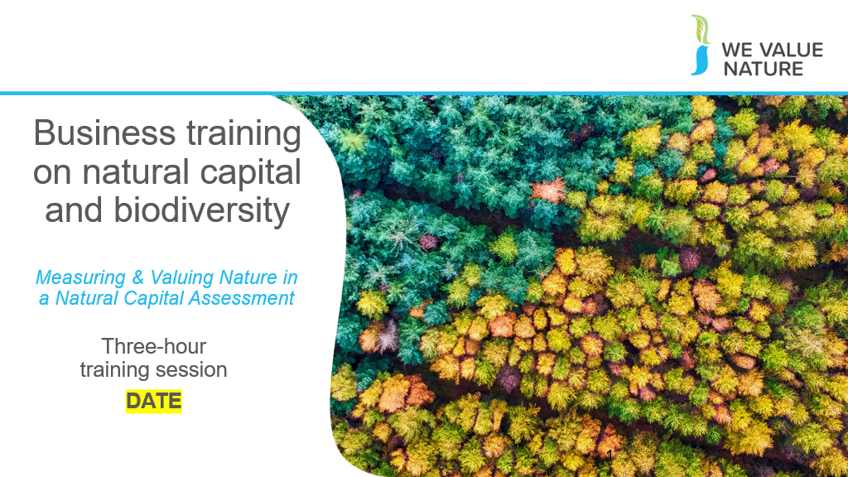
Presenter to welcome the group to the business training on natural capital

Slide 2
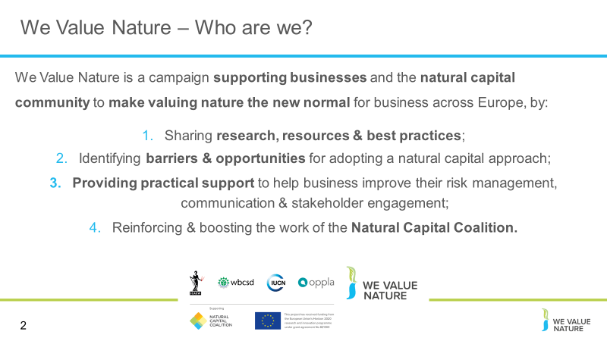
Before starting the training, presenter should introduce that this training is being given as part of the We Value Nature Campaign and explain what it is, its purpose, objectives and partners involved:

The We Value Nature Campaign is a €2 million EU-funded campaign supporting businesses and the natural capital community across Europe with the aim of making valuing nature the new normal for business. As we will have a chance to explore during today’s training, by valuing nature, businesses can make smarter decisions that benefit themselves, society and the planet as a whole.

The campaign is coordinated by the Institute of Chartered Accountants in England and Wales (ICAEW), World Business Council for Sustainable Development (WBCSD), The International Union for Conservation of Nature (IUCN) and Oppla. And it is supporting the Natural Capital Coalition, which has recently merged with the Social & Human Capital Coalition to become now the ‘Capitals Coalition’.

The campaign will aim to increase the uptake of the natural capital approach (including: natural capital assessment, natural capital accounting, nature-based solutions and green infrastructure) by identifying barriers and opportunities, providing practical support to business through activities (such as webinars, helpdesk calls, etc.) and training such as this one, as well as by inspiring businesses to adopt the NATURAL CAPITAL PROTOCOL.

Presenter to take this opportunity to thank the different stakeholders that support the training (if relevant).

Slide 3
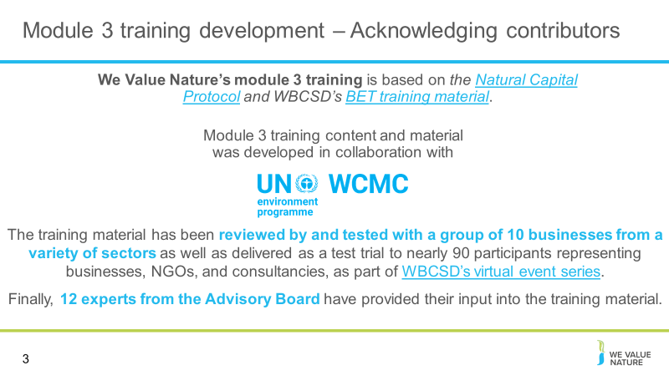
Presenter to read through the slide, to acknowledge contributors
Slide 4
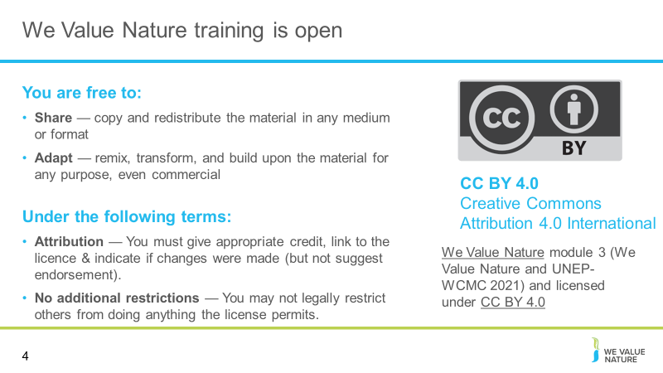
Presenter to read through the slide stating that the training is free to use under a creative commons license

Slide 5
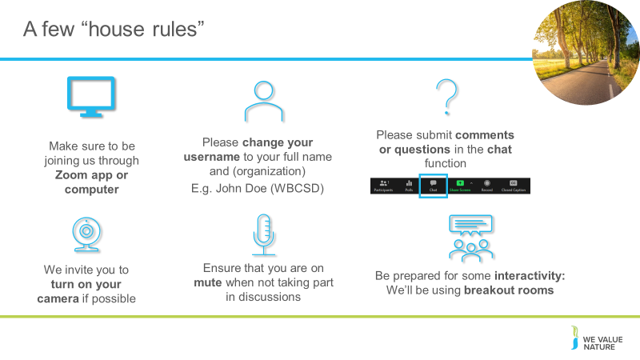
Optional depending on session type:
Presenter to explain the house rules on the screen, also using the notes below for a virtual session:
Point 1: Explain that for now are all muted but will unmute when open floor for Qs & discussion – will be flexible with time
Point 2: Encourage to participate – the more discussions, the more beneficial the VO
Point 3: Explain that we will be following the Chatham House Rule – “When a meeting, or part thereof, is held under the Chatham House Rule, participants are free to use the information received, but neither the identity nor the affiliation of the speaker(s), nor that of any other participant, may be revealed.”

Slide 6
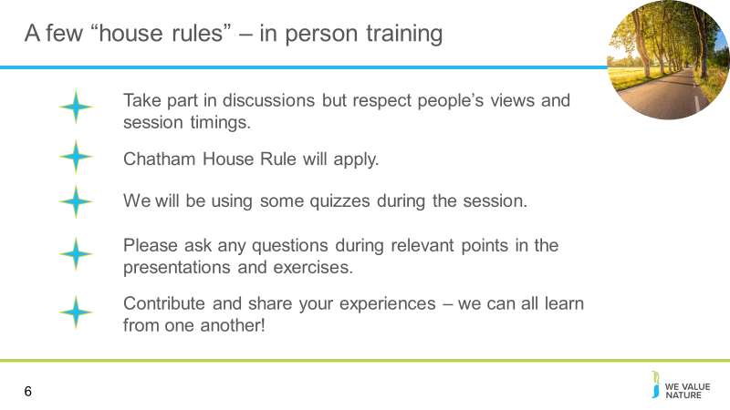
Optional depending on session type:
Presenter to explain the house rules on the screen, also using the notes below for an in-person training:
Point 1: Encourage to participate – the more discussions, the more beneficial the VO
Point 2: Explain that we will be following the Chatham House Rule – “When a meeting, or part thereof, is held under the Chatham House Rule, participants are free to use the information received, but neither the identity nor the affiliation of the speaker(s), nor that of any other participant, may be revealed.”
Point 3: Option of using a parking lot for questions that cannot be answered during the training

Slide 7
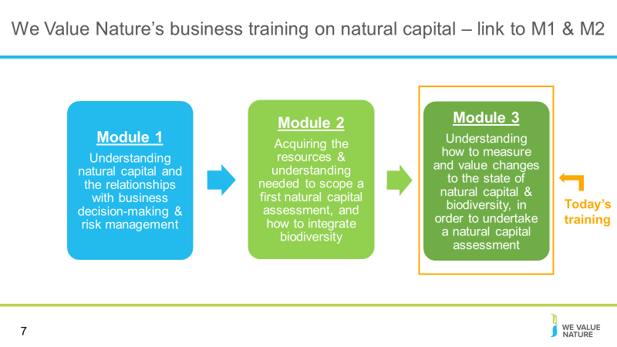
Presenter to provide context on the previous two modules, and how they all fit together in this training
- In M1, we were familiarized with the basic concepts of natural capital, how biodiversity is part of natural capital and how these can be applied to a business context. This helped us to understand why one would conduct a natural capital assessment.
- In M2, we introduced measuring and assessing impacts and dependencies between ecosystems and services. This module was a primer to module 3, to help delegates understand how impact/dependency assessment can aid business decision making
- M3 builds upon this, to consider how to measure and value changes to the state of natural capital & biodiversity, in order to undertake a natural capital assessment

Slide 8
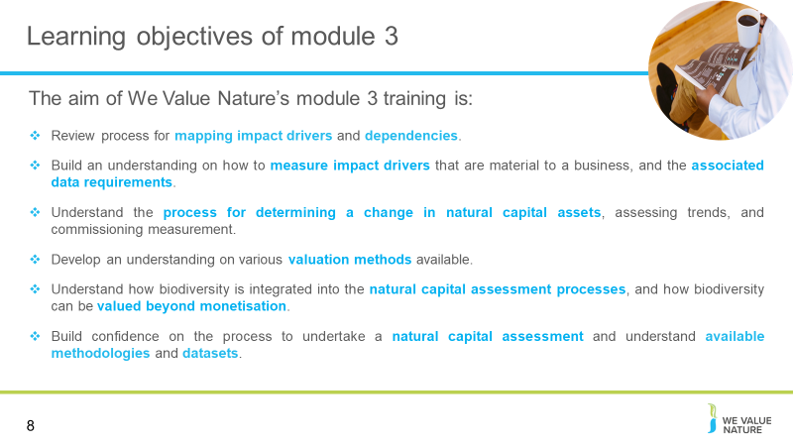
Presenter to go through the session objectives

Slide 9
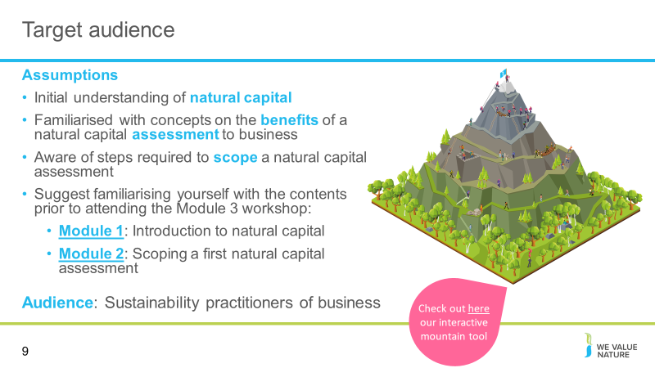
Presenter to discuss the assumptions as shown on slide.
It is assumed that all participants will already have an initial understanding of natural capital, and will likely have taken part in Modules 1 & 2.
We will carry forward many of the concepts within Module 3 and build on what was discussed in the previous modules.
An initial understanding of natural capital is important to be comfortable with the material presented. The training was built with the understanding that we would be targeting an audience of sustainability practitioners within a business. We recognise many of you will be at the start of your natural capital journey, so we will be providing the basic concepts related to measuring and valuing natural capital, including biodiversity.

Slide 10
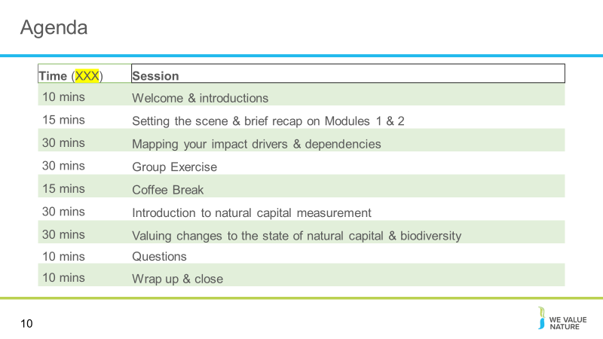
Presenter to run through the agenda for the session

Slide 11
Presenter to say we will now have some brief introductions for both presenters, and participants

Slide 12
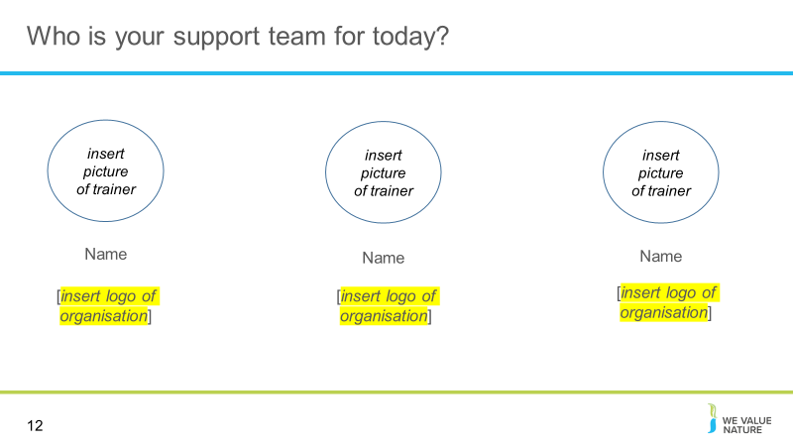
NOTE: slide is optional – please adapt to your context
Introductions for those who are presenting the session (virtual or in person)

Slide 13
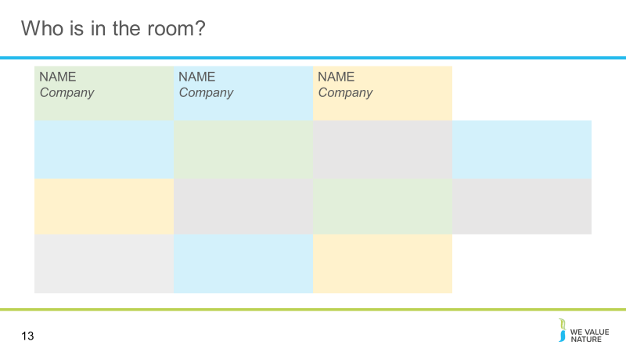
NOTE: slide is optional – please adapt to your context
Either use this slide or the previous slide to introduce delegates – this is dependent on the number of participants in the training and whether it is virtual
For the virtual session, presenter should add all participants to the slide names and place of work.

Slide 14
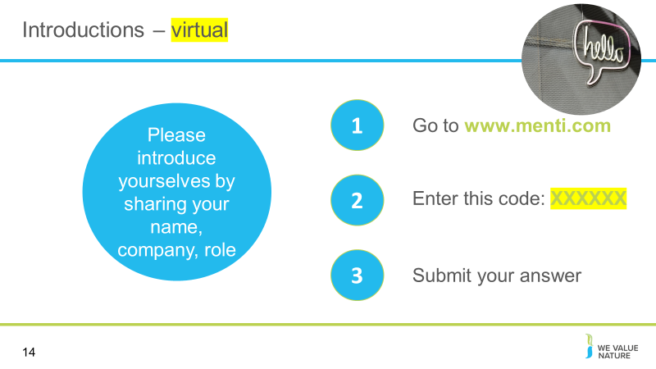
Presenter should ask the delegates to introduce themselves via Menti: ask people for name and job title/company/sector

Slide 15
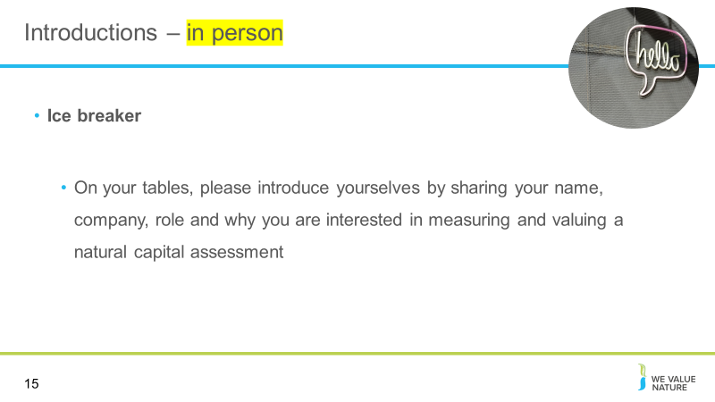
Presenter should ask the delegates to introduce themselves to the rest of their table

Slide 16
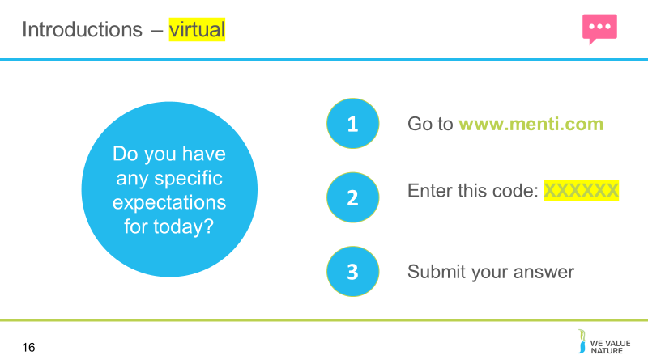
Presenter to ask the delegates to answer the question on expectations in Menti
- We can provide options for expectations, or leave open ended
- Options may include e.g. understanding impact drivers and dependencies, learning about tools to apply, other

Slide 17
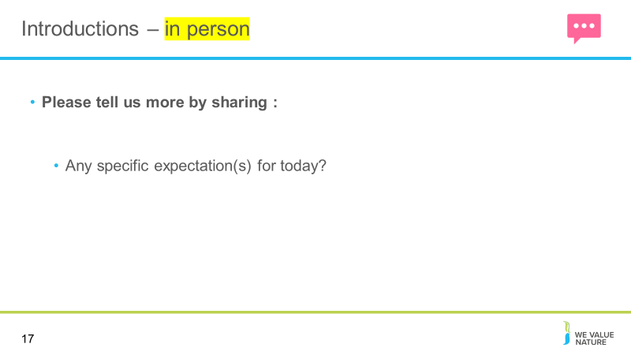
Presenter to ask all participants to write their expectations on a sticky note and discuss on their tables.
- Presenter may choose 2-3 people to share their expectations with the whole room.
- Presenter may provide options as examples to help the discussion (examples can be taken from virtual options)

Setting the scene & brief recap on Modules 1&2
Slide 18
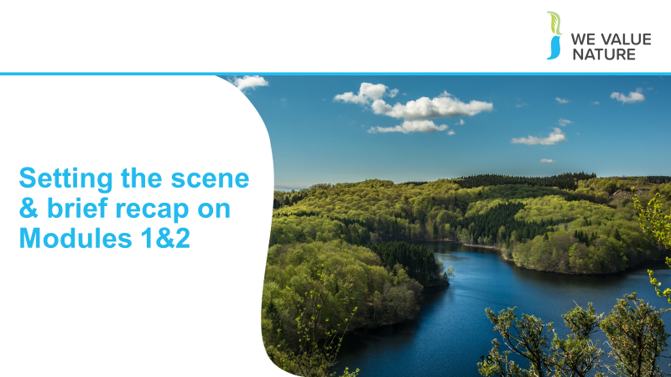
Presenter to note that before we get started, we will recap the high-level lessons learned in modules 1 & 2

Slide 19
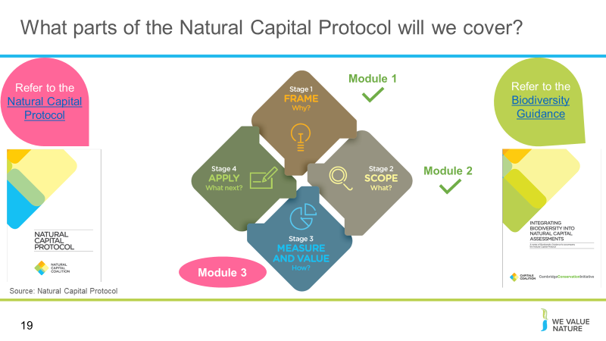
Presenter to explain that these modules cover different aspects of the Natural Capital Protocol
Presenter to outline key learning objectives and lessons learned in module 1: We have already covered stage 1 of the Natural Capital, framing, in Module 1
In module one, we explored the relationships between your business and nature. To do so, we:
- Demonstrated an understanding of natural capital and biodiversity and its linkages with business decision-making and risk management,
- Identified natural capital impacts & dependencies as well as risks & opportunities and related these to our respective business context,
- Familiarized ourselves with a few key approaches and tools to integrating natural capital into business decision-making
Presenter to outline key learning objectives and lessons learned in module 2: Module 2 focused on the second stage of the protocol, scoping
In module 2, we started to consider scoping a natural capital assessment. The learning objectives were:
- To understand how to identify natural capital impacts and dependencies that are important to your business,
- Acquire the necessary tools, resources and understanding to scope your own assessment,
- To be introduced to the key practical considerations and steps to take when undertaking a first natural capital assessment as well as some tools to help undertake an assessment
- To understand materiality assessments in the context of impacts and dependencies and how to undertake them
- To introduce valuation following on from the brief overview provided in module one
Module 3 will focus on methods for measuring and valuing natural capital – this was introduced in module 2, and will be built upon in this session
- We will draw upon the Natural Capital Protocol and Biodiversity Guidance throughout this training, but before doing so, we would like to recap some of the key concepts from Modules 1 & 2

Slide 20
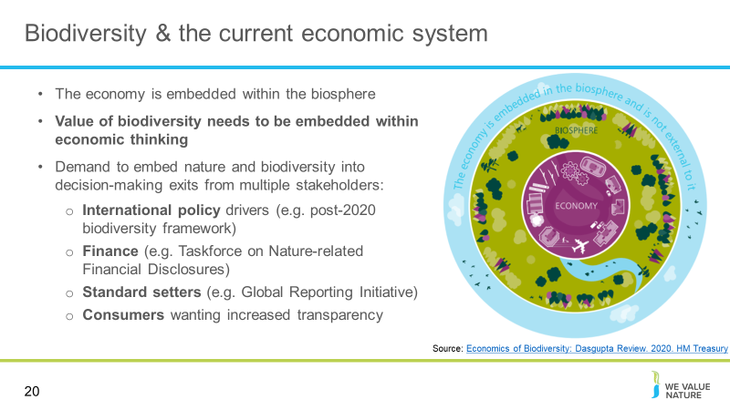
Presenter to highlight that natural capital stocks underpin the functioning of the economy, which is embedded within the biosphere:
Adapted from Dasgupta Review (2020):
Ecosystems are bounded and self-regulating
- The benefits humans receive from ecosystem services are complementary to one another. If one changes/weakens (e.g. through overuse) it will affect the ecosystems around it. An example of complementary ecosystem services are ‘regulating and maintenance services’
- The current economy (e.g. macroeconomic models) do not recognise that growth/development must have materials that balance from ‘source’ to ‘sink’.
  - E.g. We often recognise that persistent pollutants such as plastics, nylon fishing nets, and toxic chemicals add to our ecological footprint – but we must also recognise the ‘invisible’ materials such as biodegradable waste
- Recognising ecosystems are bounded, complimentary entities leads us to the conclusion that the efficiency society is able to convert its goods and services to produced goods and services is ALSO bounded and limited by its regenerative rate. “This means that humanity is embedded in Nature” and relates to the concept of Planetary Boundaries

Slide 21
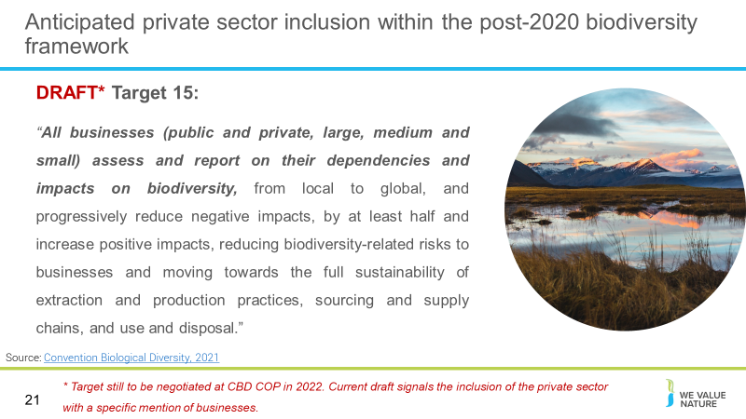
Presenter to explain policy drivers leading to increased disclosure on biodiversity/natural capital impacts.
Presenter to emphasize that the target is currently a draft and will be negotiated by the CBD at COP15 in 2022 (likely in April or May).
- The Convention of Biological Diversity is currently negotiating the terms of the post-2020 biodiversity framework
- Like the Paris Agreement, there is hope that this will provide goals and targets to decrease the rate of biodiversity loss on our planet
- Unlike the Paris Agreement we will NOT be able to determine a common indicator (e.g. limiting global temperature rise to below 2°C). This is due to the multi-dimensional of biodiversity requiring multiple indices of measurement
- The current draft includes Target 15 - which specifically mentions the private sector (including business and finance). In it, there is a SMART target of reducing negative impacts by half and increasing positive impacts
- This points in the direction of quantified measurement and disclosure on impacts/dependencies to biodiversity which can be accomplished through an assessment using the Natural Capital Protocol or a similar framework

Slide 22
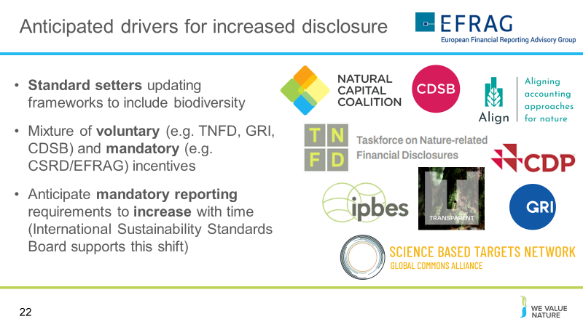
Presenter to discuss anticipated drivers for increased disclosure, using the notes on slide:
- Standard setters updating frameworks to include biodiversity
- Mixture of voluntary (e.g. TNFD, GRI, CDSB) and mandatory (e.g. CSRD/EFRAG) incentives
- Anticipate mandatory reporting requirements to increase with time (International Sustainability Standards Board supports this shift, creating the framework for mandatory disclosure to be legislated – albeit for climate to start with, but will likely expand over time)

Slide 23
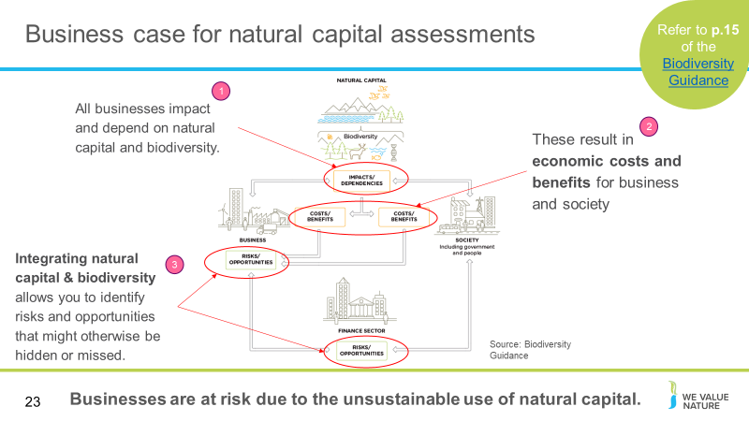
Presenter to discuss the business case for a natural capital assessment: showing how all businesses impact and depend upon natural capital and biodiversity.
Natural capital and the benefits that flow from it sustain us all: individuals, families, companies, and society as a whole. At the same time, our individual or collective actions can build or degrade natural capital, depending on how we use it. Every business impacts and depends on natural capital to some degree and will experience risks and/or opportunities associated with those impacts and/or dependencies.
Biodiversity describes the variety of life and is the living component of what can be thought of as natural capital stocks. It plays an important role in the provision of the services we receive from nature. The terms “capital” and “stocks” are used as metaphors to help describe the role of nature within the economy. The presence of, and interactions between, natural capital stocks generate a flow of goods and services; these goods and services create value through the benefits they provide to business and society. Biodiversity is an integral part of natural capital and underpins the goods and services that natural capital generates. It is important to note that biodiversity is not an asset, rather a descriptive feature of assets we call natural capital.
The figure shown on the slides highlights biodiversity impacts and dependencies. It is a conceptual model for business, the finance sector and society.
- Natural, social and economic issues are fundamentally interconnected and cannot be separated from one another. Natural capital underpins all the other capitals and without it we would not have social and human or financial capital.
- Natural resources encompass a range of materials occurring in nature that can be used for production and/or consumption.
- Renewable resources: These may be exploited indefinitely, provided the rate of exploitation does not exceed the rate of replacement, allowing stocks to rebuild (assuming no other significant disturbances). Renewable resources exploited faster than they can renew themselves may effectively become non-renewable, such as when over-harvesting drives species extinct (UN 1997).
- Non-renewable resources: These will not regenerate after exploitation within any useful time period. Non-renewable resources are sub-divided into reusable (e.g., most metals) and non-reusable (e.g., thermal coal).
- It is important for businesses to understand their impacts and dependencies on natural capital stocks, and the ecosystem services they provide. Because the current economic system assumes infinite availability of these resources, use and extraction are currently unsustainable, and provide a systemic risk to your business, and society as a whole.

Slide 24
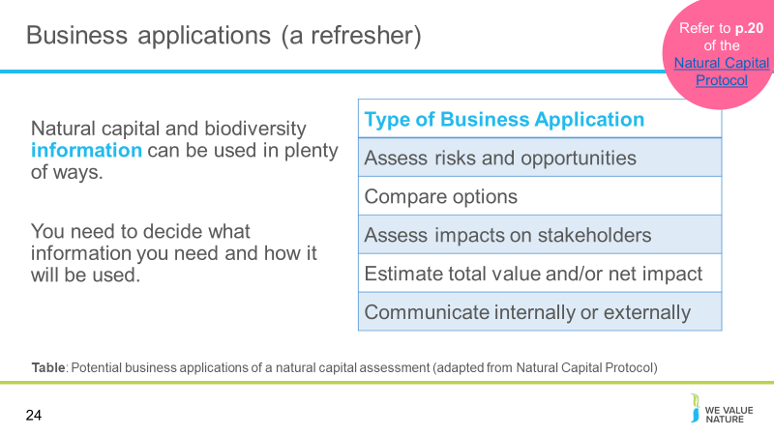
Presenter to explain that it is important to keep your business application in mind when going through steps 5, 6 and 7, because it will help you with decisions made in terms of types of data needed, and measurement approaches.
A natural capital assessment provides information. Whilst this can be valuable in its own right, there are also numerous ways to use this information.
The Natural Capital Protocol focuses on using natural capital assessment for decision-making, measurement and valuation, but it can also be used for disclosure and communication, or to help formulate strategy.
The best way for your company to use natural capital information is highly individual – think back to the challenges and risks you identified in earlier training courses and consider how more information could help you meet these challenges.
Presenter to highlight some types of business applications using the table provided
- Assessing risks and opportunities: e.g. assess risks and opportunities of capital expenditure when deciding which flood solution to choose
- Assessing impacts on stakeholders: e.g. assess how a company's dependency on a local water supply affects local communities
- Estimating the total value and/or net impact of the company: e.g. estimating the total impact of a manufacturing company across the entire value chain (upstream, direct operations, downstream)

Slide 25
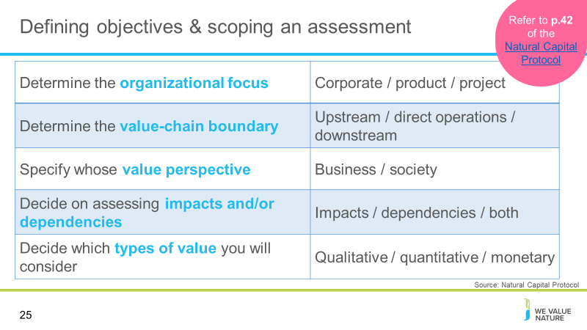
Presenter to walk through the steps to scope an assessment using the table on the slide, the notes below and referring to p.42 of the Natural Capital Protocol. Note: these points represent the ambition for the project and not all of the practicalities.
The organizational focus is where the assessment will focus, e.g. will the focus be on the corporate level (the whole company), product level (one product or a site), or project level?
Organizational focus: the part or parts of the business to be assessed (e.g., the company as a whole, a business unit, or a product, project, process, site, or incident). For simplicity, these are grouped under three general levels as below:
  - Corporate: assessment of a corporation or group, including all subsidiaries, business units, divisions, different geographies or markets, etc.
  - Project: assessment of a planned undertaking or initiative for a specific purpose, and including all related sites, activities, processes, and incidents.
  - Product: assessment of particular goods and/or services, including the materials and services used in their production.

Value-chain boundary: The part or parts of the business value chain to be included in a natural capital assessment. For simplicity, the Protocol identifies three generic parts of the value chain: upstream, direct operations and downstream. An assessment of the full lifecycle of a product would encompass all three parts. To determine the value-chain boundary, you need to decide where in the value chain the assessment will take place:
  - Upstream (cradle-to-gate): covers the activities of suppliers, including purchased energy.
  - Direct operations (gate-to-gate): covers activities over which the business has direct operational control, including majority owned subsidiaries.
  - Downstream (gate-to-grave): covers activities linked to the purchase, use, re-use, recovery, recycling, and final disposal of the business’ products and services.
  - For example, a clothing company may decide that the assessment should take place across all upstream operations (e.g. cotton farming and clothes manufacture).
Value perspectives: the value perspective identifies the potential values that the assessor wishes to be measured as part of the assessment i.e. the value to business, the value to society, or both. This determines which costs or benefits are included in an assessment.
  - Business value: The costs and benefits to the business, also referred to as internal, private, financial, or shareholder value.
  - Societal values: The costs and benefits to wider society, also referred to as external, public, or stakeholder value (or externalities).
  - Both business and societal value perspectives should be considered when incorporating biodiversity ü Biodiversity’s intrinsic value is difficult to capture, so values are likely to be minimum estimates
Impacts or dependencies: Decide whether you will assess impacts, dependencies, or both. We will recap the difference between impacts and dependencies in the coming slides
Types of value: The types of value to be considered include qualitative, quantitative and monetary. These will all be considered individually later in this session

Slide 26
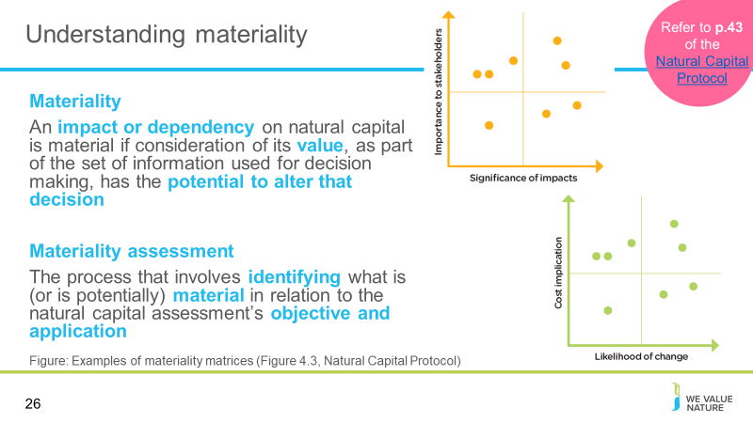
Presenter to read out the definitions of materiality and materiality assessment on the slide. Presenter to then walk through the four stages of conducting a materiality assessment, using the notes below:
- Identifying potentially material impacts and/or dependencies
- Identifying criteria for the materiality assessment
- Gathering relevant information
- Completing the materiality assessment
Presenter to describe graphs, noting the following:
After discreet activities are identified, you can use a matrix to help assess the relative materiality of each natural capital impact or dependency. It is recommended to establish a panel of relevant people with a broad range of skills to complete the materiality assessment, and to ensure the panel is consistent throughout the assessment. When ranking, it is also good practice to set a threshold above which issues are considered significant, and also to consider your ability to influence your impact and/or dependency. Once you have assessed and ranked potentially material natural capital impacts and/or dependencies, you should be able to identify those that are material, definitely not material, or still uncertain. The result is a short list of material impact drivers and/or dependencies that you will include in your assessment.
To carry out a materiality assessment, the assessor must identify a small group of potentially material impacts and/or dependencies.
- Information will need to be gathered and criteria set to measure the materiality of the chosen impacts and dependencies.
- Note that the information gathering stage of the materiality assessment will involve identifying the potential sources of data.
Output: The output of a materiality assessment is a prioritized list of material impacts, dependencies, and
changes in natural capital to include in your natural capital assessment.
It is to note that potentially material impacts and dependencies will need to consider hidden biodiversity values, business impacts that also affect dependencies, and a societal value perspective (impacts may appear more material because of regulation and consumer pressure as concern for biodiversity grows)
- The criteria for assessing materiality may vary when including biodiversity (e.g. for operational criteria, particular upstream operations may be specifically dependent on biodiversity; while reputational criteria may have higher materiality weighting due to the intrinsic value of biodiversity to many stakeholders)

Slide 27
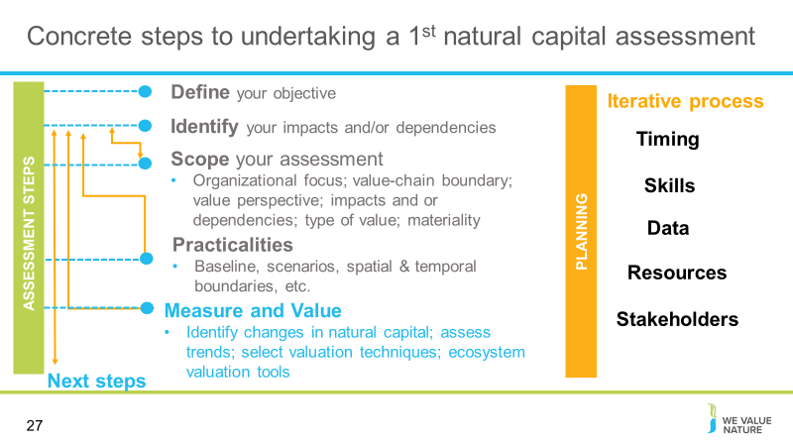
Presenter to outline the steps we have already covered in previous modules, and provide brief information on each step, and shown on slides
- Through modules 1 & 2, we have covered the first four points on this slide and begun to think about measurement
- Today we dive deeper into measurement and valuation, with a focus more on data and resources
Presenter to showcase what is coming in module 3: Measuring and valuing
The Measure and Value Stage involves three linked Steps:
- Step 5: Measure impact drivers and/or dependencies
- Step 6: Measure changes in the state of natural capital
- Step 7: Value impacts and/or dependencies
The Protocol does not attempt to provide detailed instructions on how to apply specific measurement or valuation methods. It refers instead to the extensive academic, practitioner, and policy literature on these methods.
- The three Steps in this Stage follow a logical progression.
- Example: To assess the costs and benefits of using water in a manufacturing process, a business will:
  - Measure the cubic meters of water extracted for a particular business process (Step 05).
  - Quantify the impact of the water extraction on society and/or business, by understanding the changes in natural capital that results from the extraction of water (Step 06)
  - Value the consequences for business and/or society, associated with these changes in natural capital (Step 07).
  - The measurement carried out in Step 05 alone does not explain the significance of the water extraction. Once it is quantified in Step 06, the business will know whether the water system has been altered by the extraction and if sufficient water is likely to remain in the system to meet the current or future needs of other users. Once this is valued in Step 07 they will then be able to tell what these changes mean for the business or society.

Mapping impact drivers & dependencies
Slide 28
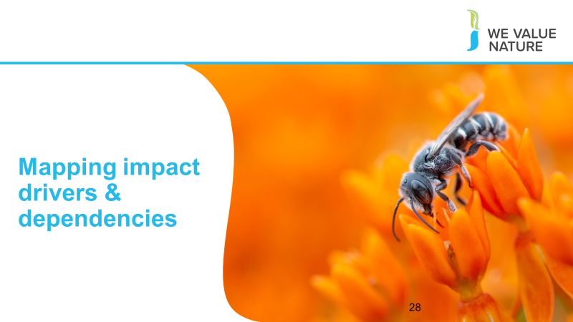
Presenter to explain that we will now start to consider steps 5, 6 & 7 of Natural Capital Protocol, beginning with mapping impact drivers and dependencies
- This is not a linear process, so we will introduce some concepts and refer back to them as we go along.
- We will cover the concepts needed to apply the Natural Capital Protocol.
- We will focus on differences between impact drivers and impacts, provide an understanding of measuring dependencies, and consider the different tools needed to start the processes

Slide 29
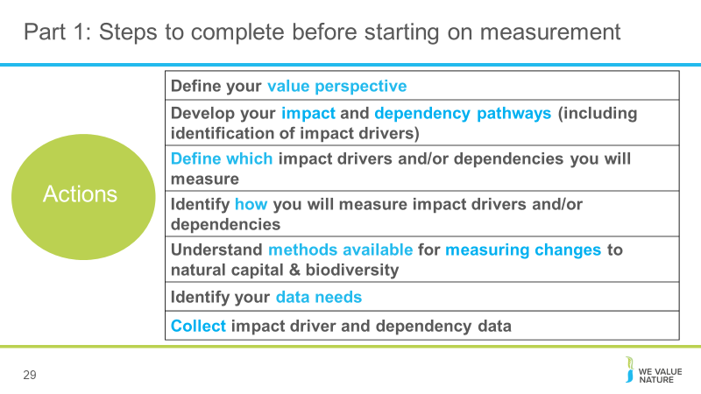
Presenter to review key steps that will need to be completed prior to commissioning measurement.
Presenter to note that we will run through each of these points within the section.
There are a number of steps that must be completed before commissioning measurement:
- Map your activities against impact drivers and/or dependencies
- Define which impact drivers and/or dependencies you will measure
- Identify how you will measure impact drivers and/or dependencies
- Select methods for measuring changes
- Collect data

Slide 30
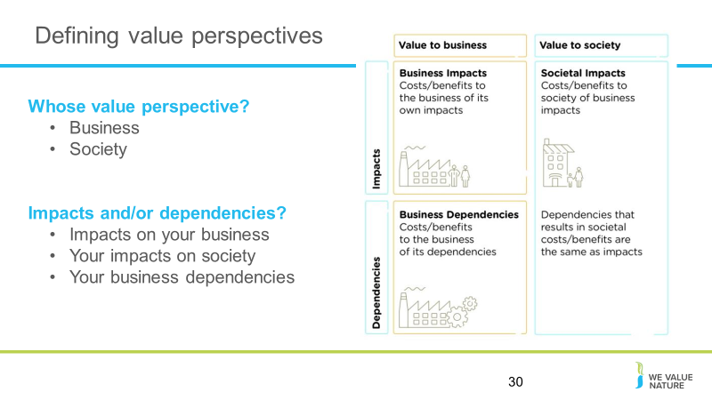
Presenter to explain that the value perspective identifies the potential values that the assessor wishes to be measured as part of the assessment i.e. the value to business, the value to society, or both:
Value perspectives: the perspective or point of view from which value is assessed; this determines which costs or benefits are included in an assessment.
- Business value: Consequences of your impacts on biodiversity/natural capital for your own operations and performance (e.g., reputational damage due to your impacts on biodiversity, or social license to operate and other legal, operational, or reputational risks).
- Societal values: Consequences of your biodiversity/natural capital impacts on society (e.g., loss of earning by fishers affected by an oil spill from your company; depleting coastal fish stocks within a reef community, causing a downturn in tourism revenue).
Both business and societal value perspectives should be considered when incorporating biodiversity. Biodiversity’s intrinsic value is difficult to capture, so values are likely to be minimum estimates.
The value perspective becomes important when trying to determine your impacts and/or dependencies on biodiversity and natural capital more generally.
This is because your business will impact and depend on the state/extent of natural capital which can affect the sustainability of your business by incurring risks (generating costs) or opportunities (generating benefits!).
- For example a mining company will depend on freshwater to extract ore. If this mine uses a greater amount of freshwater than is naturally restored, this negatively impacts the amount of freshwater available to the mine and can incur a cost to the business, if freshwater needs to be sourced from a different location. In this example, the impact on the amount of freshwater available, is also a dependency (as the business relies on the availability of freshwater to operate).
Equally though, the impacts of your business can affect society more generally, by changing the condition/extent of natural capital resources that society (and other businesses rely on). Stakeholder and societal responses to these effects can create additional risks and opportunities. Reputational risks to business are increasing as biodiversity continues to decline, and as pressure from consumers to slow and reverse this decline continues to grow.
- For example, impacts on charismatic species affect societies who place value upon them for cultural, ethical, and/or philosophical reasons. Threats to these species resulting from business operations can create reputational risks for business.

Slide 31 – optional
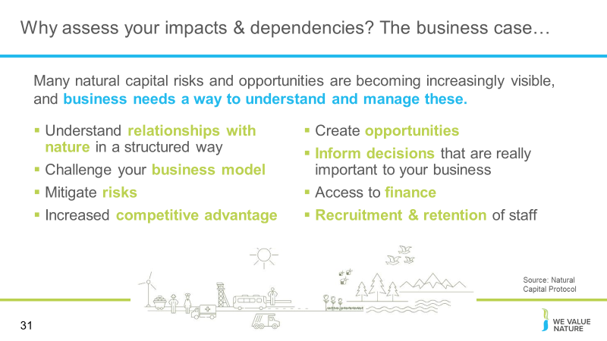
Add in if need a time filler – but likely not needed

Slide 32
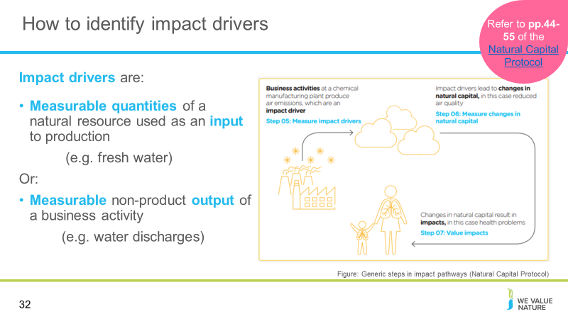
Presenter to define impact drivers and discuss impact pathways figure
Impact Driver – In the Protocol, an impact driver is a measurable quantity of a natural resource that is used as an input to production (e.g., volume of sand and gravel used in construction) or a measurable non-product output of business activity (e.g., a kilogram of NOx emissions released into the atmosphere by a manufacturing facility).
Impact drivers are generally expressed in quantitative units (e.g., kilograms, m3, hectares) and may already be included in company non-financial reporting or generated through life-cycle assessments.
Generally you can think of impact drivers as verbs – water use, land use, soil use – input. It is an impact diver because you can measure it, leading to measurement and valuation, which we will discuss shortly. The output is a quantifiable, measurable product e.g. GHG emissions
The figure on the slides illustrates the impact pathway for air pollution, a classic non-product output of industry. In this example, the business activity is the manufacture of industrial chemicals, which results in the emission of certain pollutants (the impact driver, measured in Step 5). These emissions lead in turn to a reduction in air quality (the change in natural capital, measured in Step 6), which may have significant impacts on various people depending on the local environment (the impact, valued in Step 7). Note that changes in natural capital that result from your business activity are sometimes called “outcomes”. In this example, a materiality assessment would be needed to determine whether air pollution was a material impact and, if so, which specific pollutants and resulting impacts are most relevant.

Slide 33
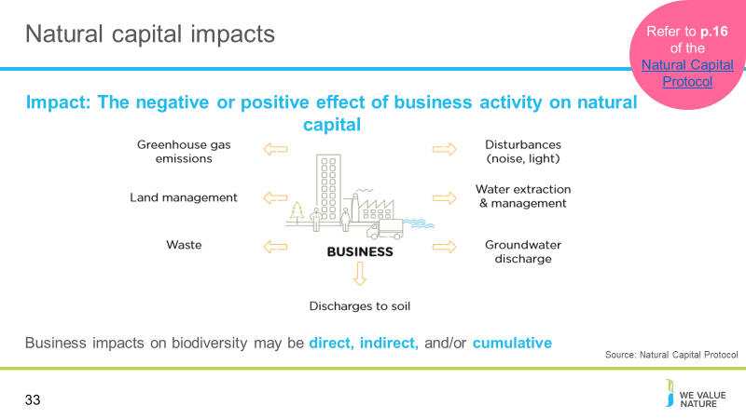
Presenter to provide detail on natural capital impacts using the notes below and referring to p. 16 of the Natural Capital Protocol:
The Protocol defines a natural capital impact as: The negative or positive effect of business activity on natural capital. They can arise directly from business operations or indirectly from the use of products and services. As a result of your impact on natural capital you can generate impacts on your business as well as impacts on society.
Your business impacts on biodiversity may be direct, indirect, and/or cumulative. Indirect impacts are triggered in response to the presence of your business projects or operations, rather than being directly caused by them. Cumulative impacts arise from the combined impacts of your operations, those of other organizations (including other businesses, governments, and local communities), and other background pressures and trends (BBOP 2012a). Similarly, impacts can accumulate over time, so that relatively small impacts of each subsequent activity can add up to a large overall impact. Your business impacts on biodiversity, particularly your indirect and cumulative impacts, may often be non-linear and difficult to predict.
Presenter to link natural capital impacts with the risks and opportunities material covered in M1, using the notes below. Presenter to elaborate on the business impact diagram, using some examples:
- Thinking back to some of the content in M1, we can see how natural capital impacts can pose different risks and opportunities for businesses:
Presenter to discuss examples from below:
- Land management e.g. forest management
  - This may pose an operational risk by reducing resilience to natural hazards through degradation of natural ecosystems
  - This may also pose an operational opportunity if businesses invest in sustainable land management, hence reducing costs by protecting against natural hazards
  - Waste/Site based impacts (e.g. development of an open cast mine may lead to a reduction in total vegetation cover and complexity).
    - This could pose a risk to the structural integrity of the mine due to an increased likelihood of flood (from the loss of provisioning services provided by the local habitat) and it would pose a reputational risk depending on the location of the mine
    - Uncontrolled leakage from tailing ponds (e.g. selenium) could lead to acute and chronic impacts on surrounding flora and fauna, which could affect local livelihoods and cause trophic cascades/decrease in population of local species
    - This may pose a reputational risk if there is negative publicity about the business’ impacts on natural capital
  - Groundwater discharge e.g. wastewater
  - Thinking of the example above, groundwater discharge may pose risks to biodiversity
  - This may pose financial risks if social conflict over polluted water adds to security costs
  - This may also pose societal opportunities if businesses use managed water catchments to improve water quality for local communities

Slide 34
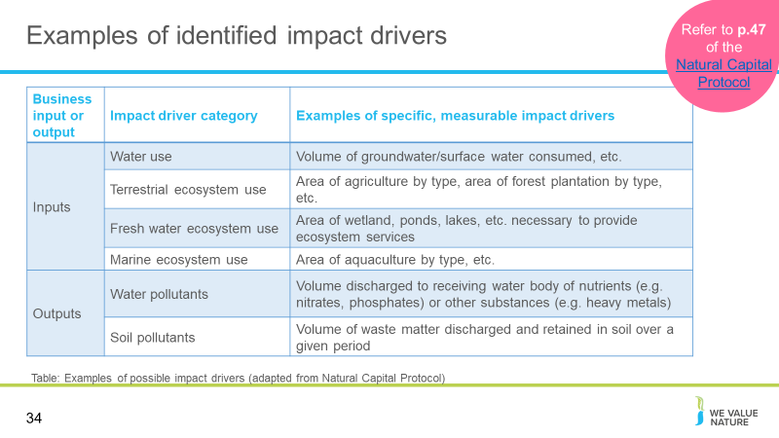Presenter to consider different examples of impact drivers, as shown in the table. Presenter to discuss some of the examples shown in the table.
The table shows examples of possible impact drivers to consider when identifying which are most material to your business. You will see for example that a business activity (e.g., the use of water) holds impact drivers such as the volume of groundwater and surface consumed.

Slide 35
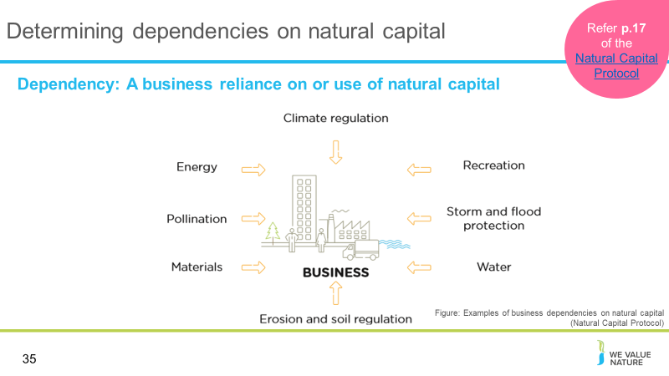
Presenter to provide detail on natural capital dependencies using the notes below and referring to p. 34 of the Natural Capital Protocol:
The protocol defines natural capital dependency as: A business reliance on or use of natural capital. This can occur in your direct operations or somewhere else in your value chain.
Presenter to link natural capital dependencies with the risks and opportunities material covered in M1, using the notes below. Presenter to elaborate on the business impact diagram, using some examples:
- Again, thinking back to some of the content in M1&M2, we can see how natural capital dependencies can pose different risks and opportunities for businesses. This is useful in establishing the value of natural capital dependencies in relation to other inputs and services that you rely on.
- Pollination e.g. regulating service critical in agriculture
  - This may pose an operational risk for agricultural sectors if pollinator populations decline
  - Land use change may lead to a decrease in local pollinator-supporting habitats. This could reduce yield and create unpredictable changes in supply. Pollination of surrounding habitats could also decrease, leading to a reputational risk to your business and a societal risk to the local community (through a decrease in livelihoods).
  - Materials e.g. reliance on timber
  - This may pose a societal risk if timber sourcing begins to impact on access to forests for local communities in sourcing regions
  - This may pose a societal opportunity if local communities start to benefit from good forestry management
  - The creation of timber based products could be affected by climate change, leading to unpredictable growth rates. Climate change is a driver of biodiversity loss

Slide 36
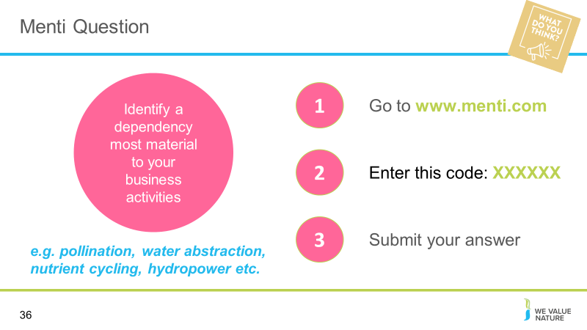
Presenter to direct participants to Menti to answer the question – answers will be used to produce wordcloud in menti

Slide 37
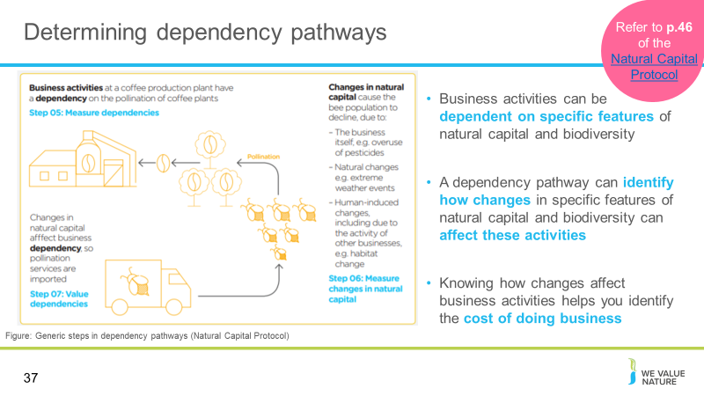
Presenter to discuss dependencies and outline the relevance of the figure on the slides
- Business activities can be dependent on specific features of natural capital and biodiversity
- A dependency pathway shows how a particular business activity depends upon specific features of natural capital. It identifies how observed or potential changes in natural capital affect the costs and/or benefits of doing business.
- The figure illustrates a dependency pathway using the pollination of coffee plants as an example. In this situation, a decline in the populations of wild pollinators (due to deforestation) results in lower yields and/or additional costs to coffee producers, who may be forced to rely on commercial pollinating services.
- A materiality assessment in this example would consider whether the yield loss or extra cost of commercial pollination is likely to have a significant impact on the business, compared to other potential relevant dependencies.

Slide 38
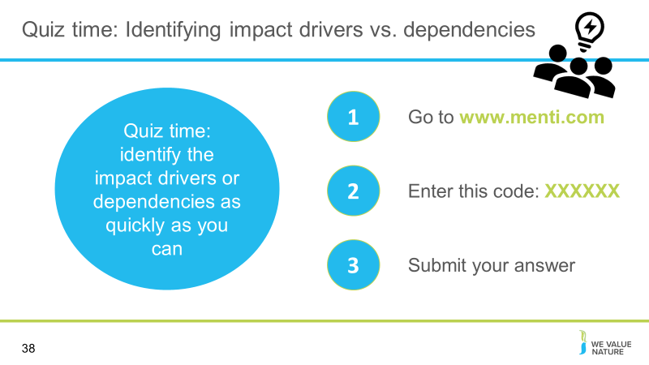
Presenter to announce that we will now have a quick quiz on impact drivers vs. dependencies
Menti questions below are provided as options to choose from (generally about 7 minutes per question, allow time for this)
Quiz: ask 6 questions – 3 impact drivers, 3 dependencies e.g. flower company is uses 10 litres of water a day to keep flowers alive. Is this an impact driver or a dependency?

Slide 39
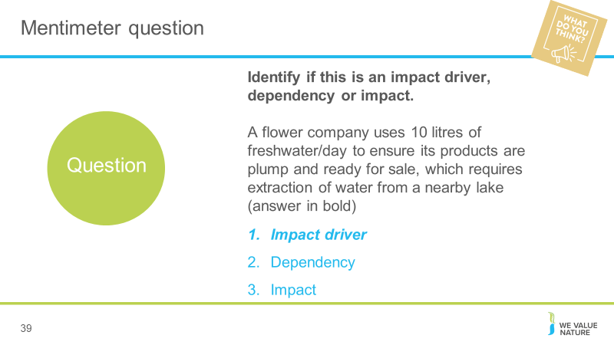
Presenter to input questions into Menti. Answers are in bold text.

Slide 40
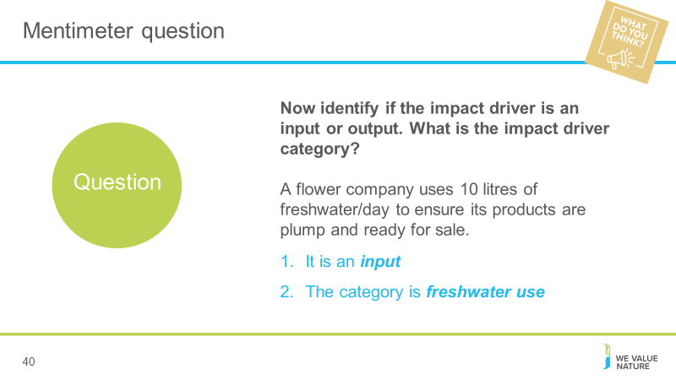
Presenter to input questions into Menti. Answers are in bold text.

Slide 41
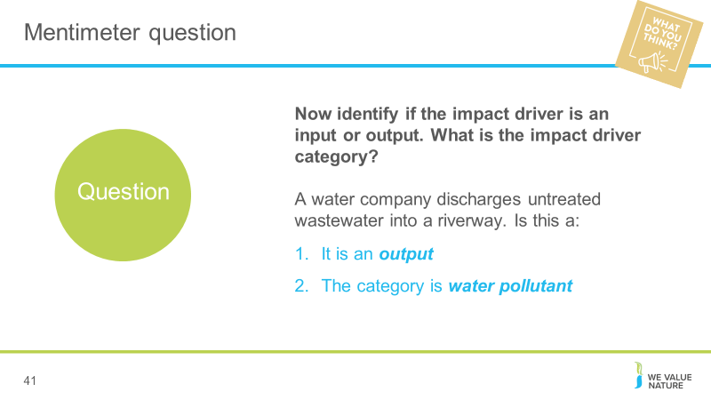
Presenter to input questions into Menti. Answers are in bold text.

Slide 42
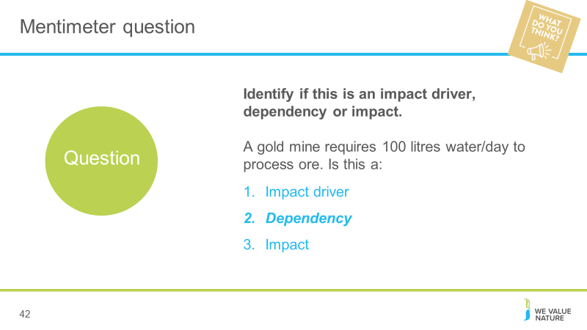
Presenter to input questions into Menti. Answers are in bold text.

Slide 43
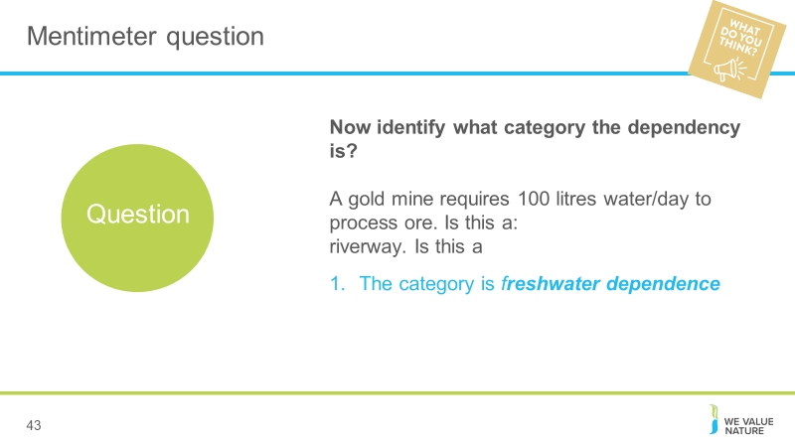
Presenter to input questions into Menti. Answers are in bold text.

Slide 44
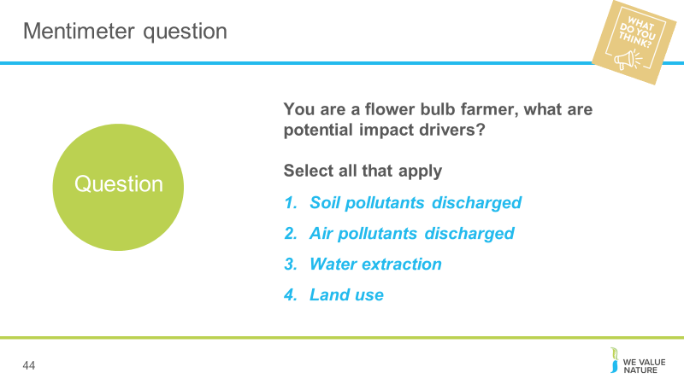
Presenter to input questions into Menti. Answers are in bold text.

Practicalities on data collection & available datasets
Slide 45
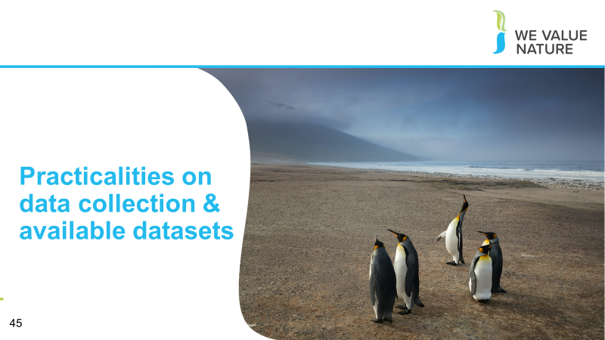
- Presenter to explain that we will now consider practicalities on data collection, as well as presenting some available datasets to help with this process

Slide 46
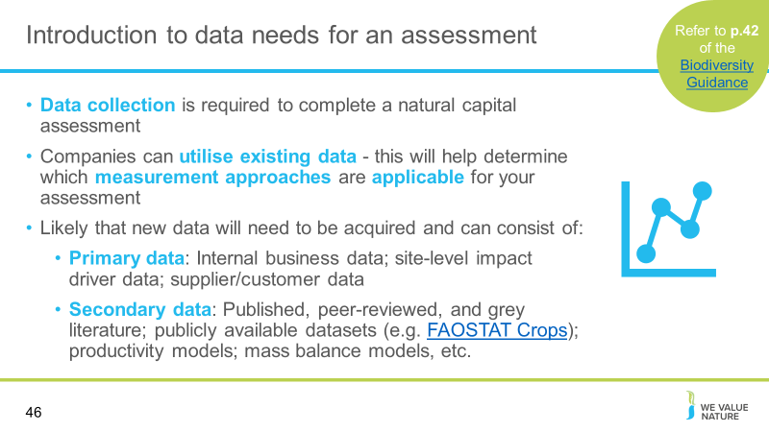
Presenter to introduce data needs, using the points on slides and notes below:
The availability of existing data and the ability to leverage biodiversity specific published literature are planning considerations not only for measurement and valuation but also when scoping your natural capital assessment. For biodiversity, there are a number of resources for measuring and valuing including guidelines, frameworks, and measurement tools.
To measure an impact driver and or dependency, you need to determine the type of data required. Many data sources exist and are described in detail within the Protocol (page 60). To measure biodiversity impact drivers and/or dependencies, there are generally two forms of data to consider acquiring and/or collecting. Each is described below with examples.
Primary data:
- Internal business data
- Site-level impact driver data collected through field surveys and sampling
- Data collected from suppliers or customers

Secondary data:
- Published, peer-reviewed, and grey literature (for example, life-cycle impact assessment (LCIA) databases; industry, government, or internal reports)
- publicly available datasets (e.g. FAOSTAT Crops)
- Estimates derived using modelling techniques, including:
- Environmentally extended input-output (EEIO) models. Many EEIO initiatives exist, including the commonly used EXIOBASE, EORA and GTAP.
- Productivity models
- Mass balance models
- Past natural capital assessments

Slide 47
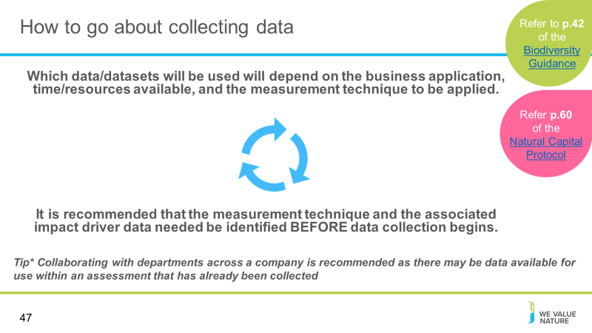
Presenter to discuss collecting data, using the points on the slide. Presenter to make clear that it is an iterative process.

Slide 48
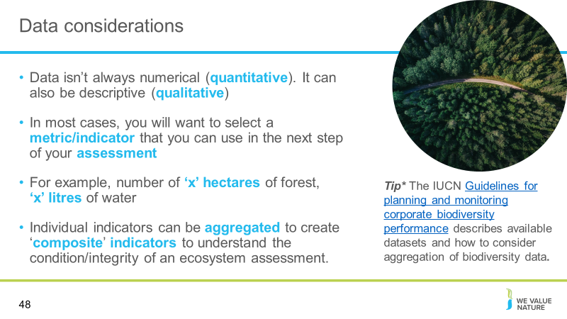
Presenter to highlight key data considerations, using the points on slides and the notes below:
- Data isn’t always numerical (quantitative). It can also be descriptive (qualitative)
- In most cases, you will want to reach a metric/indicator that you can use in the next step of your assessment. It is good to understand what measurement approach you are working towards before you collect data, so that you collect the correct data needed for your assessment
- For example, your desired data could be number of ‘x’, hectares of forest, litres of water
- Metrics are systems or standards of measurement, whilst indicators are what we are measuring. Metrics and indicators are important for the Natural Capital Protocol, as they help us to measure material impact drivers and/or dependencies
Data collection techniques are highly variable and often dependent on location, project, and area of the value chain being assessed. For this reason, one technique may not be practical or well suited across multiple applications (however techniques should be compatible to ensure consistency and comparability as far as possible). For example, a site-level project (e.g., an environmental assessment for a prospective mine) may involve habitat surveys to assess area of habitat that would be lost, whereas data collection for a wholesaler looking at impact drivers related to commodity sourcing may require information provided by individual farmers through a survey. Both techniques result in the collection of primary data.
Data should be collected and organized in a consistent manner, so that the various data collected are compatible with each other and with the scope of analysis, and are easily comparable, shareable, and interoperable across sites, countries, time, and organizations
(where applicable).
The Protocol provides more detail on the limitations and considerations when collecting and using primary or secondary data to measure impact drivers.
Pg. 60 of the protocol:
You may find that the data required to measure impact drivers and dependencies are frequently the same.... processing of raw materials requires water inputs. Data on the use of water can be used for defining the level of dependency on water, at the same time the use of water is also the impact driver, and can be used to calculate the scale of the impact on other users. You may also be interested in the impact on fresh water ecosystems, which is another related category of impact driver. Caution is required in how these data are accounted for in calculations to avoid double counting data on impact drivers with dependency data
Aggregated indicators are most commonly used in ‘x’ scenarios

Slide 49
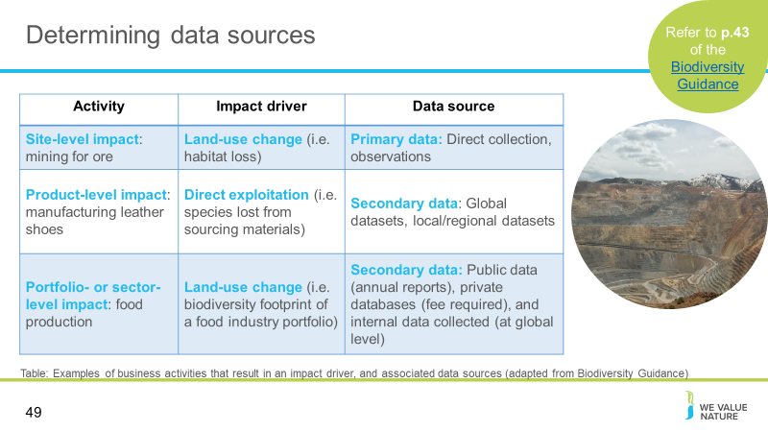
Presenter to identify how to measure impact drivers and/or dependencies, through primary vs. secondary data collection
To measure an impact driver and or dependency, you need to determine the type of data required. Many data sources exist and are described in detail within the Protocol. The table on the slides shows examples of business activities and their associated impact drivers, indicators, and data sources required. The right hand column is showing what needs to be measured/how it can be measured (qual vs. quant).
Users should consider how impact driver data, and the various assessments undertaken, may need to be compared over time when selecting data and methods that are compatible. The Protocol provides more detail on the limitations and considerations when collecting and using primary or secondary data to measure impact drivers. This includes the use of intermediate indicators.
In the case of a business’s dependencies on biodiversity, once these are identified they will need to be measured in a standardized way. Currently, changes to the stocks (i.e., the impacts on biodiversity) and flows (i.e., impacts to ecosystem services) are relatively well understood. However, the relationship between stocks and flows are poorly understood and hard for businesses to quantify.
There are some tools such as ENCORE (focused on identifying impact and dependency pathways for financial institutions). Currently, standardized corporate measurement approaches to quantify biodiversity dependencies are very limited and this is an area which will require innovation. Meanwhile, you can use the approach of the Natural Capital Protocol to incorporate dependencies on biodiversity as part of your assessment.

Slide 50
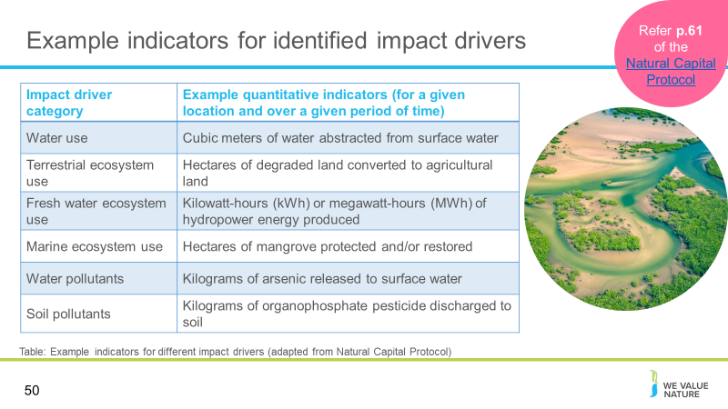
Presenter to discuss the data needs for measuring impact drivers
When mapping impact drivers and dependencies, you will need to consider the data required for this process. In ideal cases, an impact driver or dependency can be measured or estimated directly (e.g., the volume of water consumed or the mass of solid waste). In other cases, intermediate or proxy indicators are required. These provide a useful shortcut, which must then be combined with other information to measure or estimate the impact driver or dependency. For example, energy- or fuel-use data can indicate the volume of GHG and other emissions to air. Various published guides are available which provide emission factors (or conversion factors) to translate kilowatt hours (kWh) of electricity consumed or litres of fuel used into grams of emissions.
The table presents sample indicators for different categories of impact driver. This is relevant for impacts on your business and your impacts on society only.

Slide 51
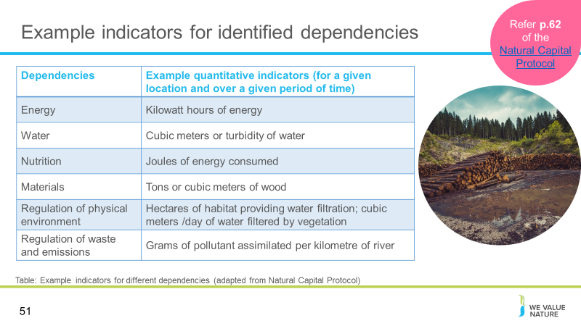
Presenter to discuss the data needs for measuring dependencies
Following the discussion on the pervious slide, this table presents sample indicators for different dependency categories. The indicators for dependencies that are business inputs (e.g., water) will often be the same as indicators for impact driver inputs. This is relevant if your business dependencies are part of your analysis. Selecting appropriate indicators to assess dependence on regulating services is more challenging. Relevant indicators may relate to the area and quality of habitats that provide the service (e.g., 10 hectares of mature forest providing a water filtration service), or they may be more specific to the service itself (e.g., 8 million litres of water filtered per year).

Slide 52
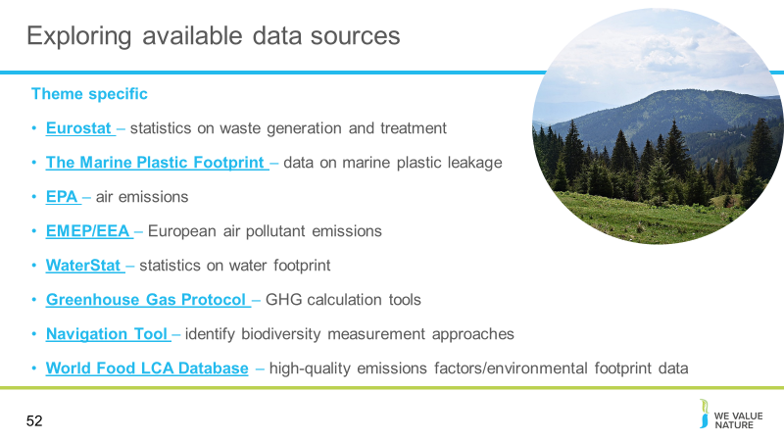
Presenter to discuss some of the available data sources, as shown on slide.
Cross thematic
- Ecoinvent: a life cycle inventory database. The ecoinvent database provides process data for thousands of products, helping you make truly informed choices about their environmental impact.
- Agribalyse program: The AGRIBALYSE® program consisted in elaborating a database of Life Cycle Inventories (LCI) of the main French agricultural products at the farm gate.
- World Food LCA Database: . The World Food LCA Database provides players across the agri-food value chain with high-quality emissions factors and environmental footprint data (including carbon, water, and land) to help them better understand the impacts of their products and bolster decision-making.
- EFSA Comprehensive European Food Consumption Database: a source of information on food consumption across the European Union (EU). It contains detailed data for a number of EU countries. The database plays a key role in the evaluation of the risks related to possible hazards in food in the EU and allows estimates of consumers’ exposure to such hazards.
Theme specific
- Eurostat – waste: Eurostat produces regular statistics on waste generation and treatment for the whole economy and on specific waste streams.
- The Marine Plastic Footprint: a comprehensive framework to measure the inventory of marine plastic leakage, step-by-step and using a life-cycle perspective. It also offers generic data that can be used to calculate marine plastic leakage for a defined list of identified sources, including plastic waste, textile fibres, tyre dust, micro beads in cosmetics, and fishing nets.
- EPA – air emissions: Emissions factors are tools for building emissions inventories, guiding air quality management decisions and developing emissions control strategies. This website provides current information on these tools and provides support for using them.
- EMEP/EEA: The EMEP/EEA air pollutant emission inventory guidebook is prepared by the UNECE/EMEP Task Force on Emissions Inventories and Projections (TFEIP) and published by EEA. The Guidebook provides a guide to European atmospheric emissions inventory methodologies and emission factors
- WaterStat: statistics on the water footprint. Part of the Water Footprinting - the Global Water Footprint Assessment Standard lays out the internationally accepted methodology for conducting a Water Footprint Assessment.
- Greenhouse Gas Protocol: Greenhouse Gas Protocol provides the world's most widely used greenhouse gas accounting standards for companies.
- IBAT (including STAR): Integrated Biodiversity Assessment Tool (IBAT) provides authoritative global biodiversity data. Users can import raw data on locations and create reports and map files. IBAT host and maintain 3 global biodiversity datasets; IUCN Red List of Threatened Species, World Database on Protected Areas, World Database of Key Biodiversity Areas. The Species Threat Abatement and Restoration Metric (STAR) allows quantification of the potential contributions that species threat abatement and restoration activities offer towards reducing extinction risk across the world.
- Navigation Tool: identify biodiversity measurement approaches

Slide 53
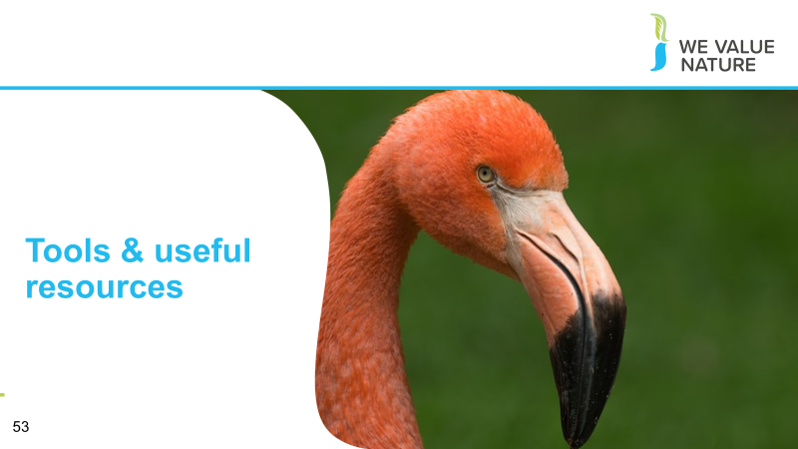
Presenter to explain that we will now look at some useful tools and resources that can help to get you started

Slide 54
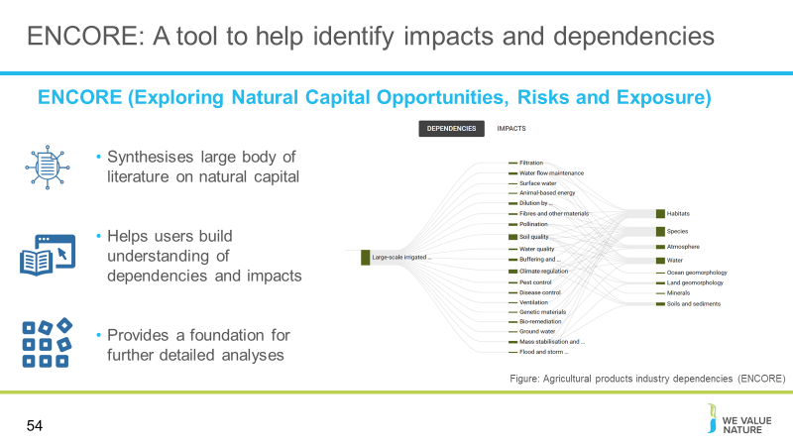
Presenter to explain that there are a number of tools that can be used to help identify material activities to your business, based on your sector. One example of this is ENCORE.
ENCORE can help with identification of impact drivers and dependencies that you will need to think about for measurement.
ENCORE stands for Exploring Natural Capital Opportunities, Risks and Exposure. This web-based tool was launched in November 2018 and was the first of its kind to synthesise a large body of literature on potential natural capital dependencies and impacts of all economic activities.
ENCORE was primarily developed for a finance sector audience, but the information it contains can be used by other audiences as well
It is a tool that helps users understand links between economic activities and natural capital based on associated potential dependencies and impacts. It can answer questions like:
- How do businesses depend and impact on nature?
- How does environmental change affect dependencies?
- What can be measured to gain insight on nature-related risk?
The knowledge base from ENCORE can serve, and has already served, as a basis for more refined types of analyses.
Once users have registered a free account, they can log in and visualise how economic activities potentially depend on nature, using flow diagrams shown here. Data is available for various sub-industries and production processes. The data shows how both dependencies and impacts for the production processes link to ecosystem services and the natural capital assets that underpin those services. The tool also provides a qualitative rating called a materiality rating, that denotes the importance of each ecosystem service for each production process. Flow diagrams can be produced for both dependencies and impacts.
The figure on the slides for example shows the aagricultural products industry dependencies on ecosystem services and natural capital assets, for the production process of large-scale irrigated arable crops. We can see these processes are dependent on 19 ecosystem services (out of 21 identified). ENCORE then shows which elements of nature (or natural capital assets) underpin the ecosystem services that these agricultural processes depend on. In this example, habitats and species are two key natural capital assets for this sector. The loss of key habitats could lead to loss of up to 11 ecosystem services that these production processes depend on. Similarly, the loss of key species could compromise up to 12 ecosystem services. This could have devastating consequences for the business. For example, if a key pollinator species is lost, this could result in major yield losses, or increased costs associated with alternative pollination methods.

Slide 55
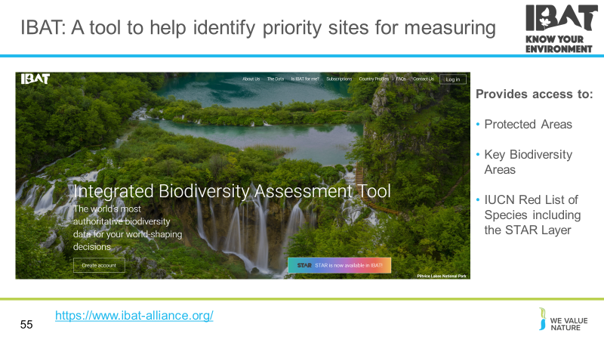
Presenter to consider tools available to help with measurement: IBAT
Presenter to explain that IBAT could be a useful tool to identify priority sites (i.e. based on proximity to Key Biodiversity Areas and/or red listed species) for a natural capital assessment. This could be completed during the materiality/scoping part of the assessment to prioritise locations for consideration (e.g. those in closet proximity to Key Biodiversity Areas and/or with the most threatened/endangered species).
Another helpful tool is IBAT. As previously mentioned, the Integrated Biodiversity Assessment Tool (IBAT) provides authoritative global biodiversity data. Users can import raw data on locations and create reports and map files. IBAT host and maintain 3 global biodiversity datasets; IUCN Red List of Threatened Species, World Database on Protected Areas, World Database of Key Biodiversity Areas. Additionally, the STAR metric is now available in IBAT. (this will be discussed later in this training)

Slide 56
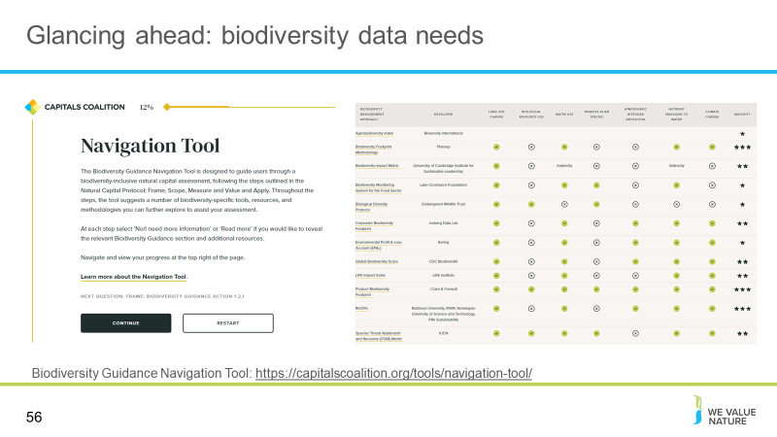
Presenter to outline the biodiversity guidance navigation tool and its role in supporting natural capital assessments.
The navigation tool recognises that you may need to work iteratively through the Protocol e.g. you go to Step 6 to determine the methods to quantify change in state of the natural capital assets, then go back to the impact drivers you have identified as material and determine how these can be measured
- We would recommend doing a first run through the navigation tool to see all the questions and consider how you would answer them. You can then choose an approach to fit the data you already have, or describe the data you need to collect.
- Currently there is no standardised way of measuring biodiversity (but Align project coming)

Slide 57
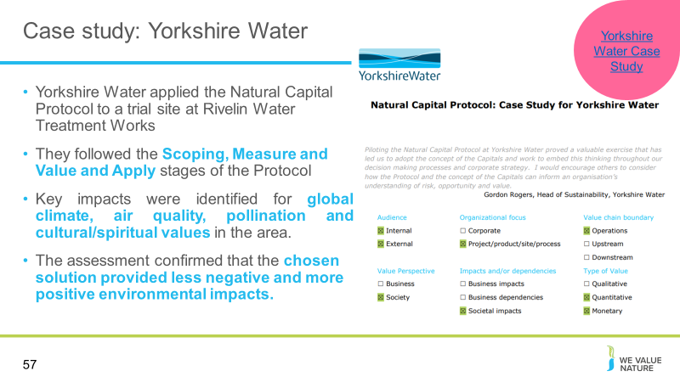
Presenter to outline Yorkshire Water case study, using notes below:
Yorkshire Water is a water and waste water services utility company servicing 5million domestic customers and 136,000 business premises in West Yorkshire, South Yorkshire, the East Riding of Yorkshire, part of North Lincolnshire, most of North Yorkshire and part of Derbyshire, in England.
Why a natural capital assessment?
Yorkshire Water, assisted by AECOM, applied the Natural Capital Protocol to a trial site at Rivelin Water Treatment Works, one of the primary water treatment plants supplying the City of Sheffield and undergoing a £24m capital upgrade. Yorkshire Water wanted to include the Protocol as part of their optioneering process, to better understand environmental impacts and trade-offs, better inform investments and operations, and enhance value with the upgrade. The Protocol was applied to a number of high level upgrade options, with two main solutions (‘notional’ and ‘chosen’ solutions) being assessed and compared to baseline infrastructure to retrospectively evaluate natural capital impacts. They took a social perspective in order to quantify impacts and dependencies.
How was the Natural Capital Protocol used?
Yorkshire Water followed all of the Scoping, Measure and Value and Apply stages of the Protocol in performing the assessment. The company used AECOM’s Ecosystem Services Identification, Valuation and Integration (ESIVI) tool to identify material impacts. This analysis incorporated criteria including beneficiaries affected by ecosystem services, importance of each service to local communities, and the degree of management control of the delivery of these services on site.
Key impacts were identified for global climate, air quality, pollination and cultural/spiritual values in the area. Methodologies for estimating monetary values of each material service were selected on the basis of relationships determined from the peer-reviewed academic literature and government guidance. The robustness of each selected valuation methodology was then assessed and categorised, to maintain transparency through the valuation process. Relative NPV was calculated for each option to select the one with the least negative impacts
What were the outcomes of the assessment?
The assessment confirmed that the chosen solution provided less negative and more positive environmental impacts. This was achieved, for example, by reducing impacts on global climate regulation through the use of a gravity-fed supply system that reduced energy requirements, by maintaining cultural and spiritual values by partially burying the building and by enhancing pollination services by creating a wildflower meadow on the building’s roof. The latter two approaches also assisted in obtaining planning permission for the project. By monetising the material environmental impacts, the assessment enabled direct comparison with more obvious costs and benefits, and therefore, richer internal debate around the environmental impacts than may occur traditionally.
Next steps
Yorkshire Water recognise that conducting future assessments that address all impacts and dependencies, including all relevant environmental, financial and social attributes of a project will provide even more power to the company’s decision-making process.

Group Exercise
Slide 58
Presenter to explain that we will now undertake a group exercise

Slide 59
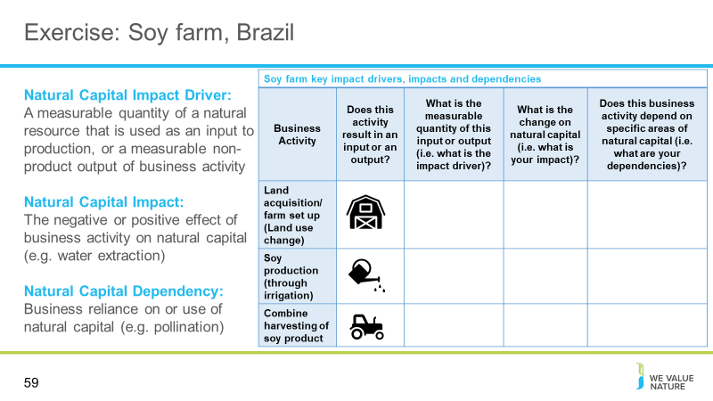
Presenter to introduce the case study for this exercise.
Presenter to describe a Brazilian soy company that has acquired 1,000 acres of land to convert to produce soy. The company is wanting to understand their impacts on natural capital, including biodiversity, in the process of developing the farmland and producing soy.
Presenter to introduce the table for the exercise: The table should be filled out by the participants, discussing each business activity, and the associated input or output, impact driver, impact, and dependency (if applicable).
It is important to be aware that impacts and dependencies do not exist in a loop. Impacts don't cause dependencies, as dependencies don't cause impacts. Whilst sometimes the two are related, this is the case in the minority, rather than the majority.
To get this process started, we would like you to:
- Identify the business activities required to complete this process, from farm set up to soy harvest.
- For each activity, you are required to identify if the activity results in an input or an output (i.e. would the activity require the use of a natural resource, or the output of a product, that would affect the state of natural capital surrounding the farmland?)
- You will identify what impact this results in, and if there are any associated dependencies.
Presenter to read out the definitions of impact driver, impact and dependencies:
An impact driver is a measurable quantity of a natural resource that is used as an input to production (e.g., volume of sand and gravel used in construction) or a measurable non-product output of business activity (e.g., a kilogram of NOx emissions released into the atmosphere by a manufacturing facility).
Natural capital impacts are defined as the negative or positive effect of business activity on natural capital. For example, businesses may extract a lot of water, depleting natural reserves.
Natural capital dependencies are defined as a business reliance on or use of natural capital. For example, businesses may be dependent on pollination as a regulating service in agriculture.
Presenter to ask participants to discuss in breakout sessions/at their tables, what impacts, or dependencies result from the business activities. Presenter to explain that the list of activities on the slide are not exhaustive but rather a list of examples. If time allows, presenter could encourage members to identify additional activities and pathways, in addition to those on the slide.

Slide 60
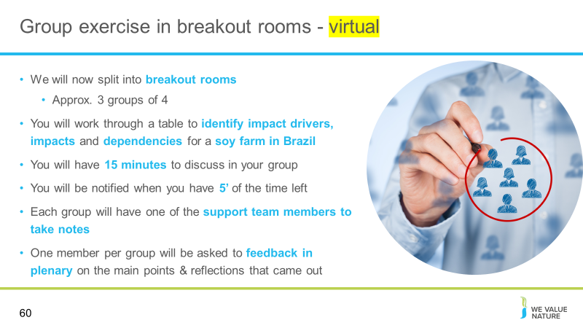
Presenter to read the points on the slide, explaining how the breakout rooms will work, for the virtual session.
Presenter to visualise a hypothetical case study for audience members, to set the scene. Presenter will describe the case study on the next slide.
Presenter to clarify that this is a hypothetical example, and they are looking to identify potential impact drivers and associated impacts (i.e. an impact pathway) and dependency pathways.
If time is short the exercise can be limited to either an impact or dependency pathway, rather than both
Note: Limit this exercise to considering the company’s Brazilian operations only.

Slide 61
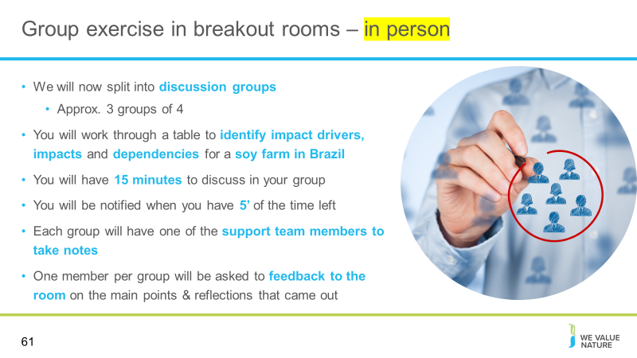
Presenter to read the points on the slide, explaining how the breakout rooms will work, for the virtual session.
Presenter to clarify that this is a hypothetical example, and they are looking to identify potential impact drivers and associated impacts (i.e. an impact pathway) and dependency pathways
If time is short the exercise can be limited to either an impact or dependency pathway, rather than both
Note: Limit this exercise to considering the company’s Brazilian operations only.

Slide 62
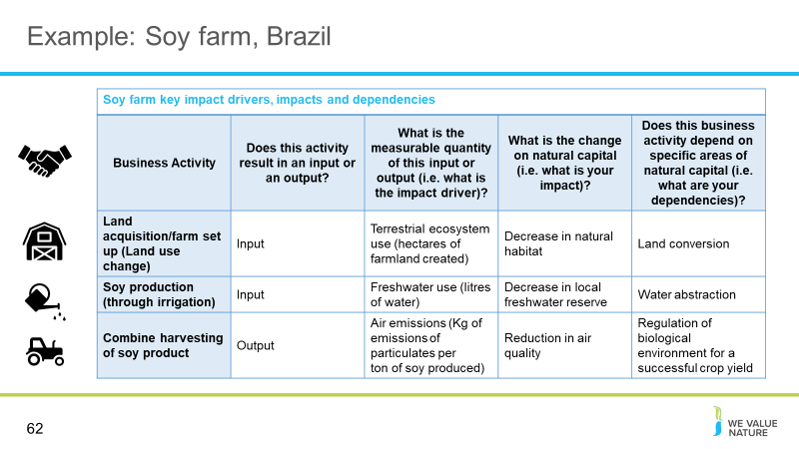
Presenter to introduce the idea of a business identifying an impact and dependency pathway, based on their activities (whilst considering points from modules 1&2 on scoping, boundaries etc. of their assessment).
Table provides hypothetical examples of how to think through an impact and dependency pathway related to the agricultural sector. Emphasize breaking down the process by business activities that are material, and have previously been identified in the scoping phase.
Presenter to talk through the different activities, whilst recognizing that others exist – however, three were included for time.
Presenter to ask if participants came up with similar inputs/outputs, and associated impact drivers, impacts and dependencies. Were there any surprises that they hadn’t previously considered?
Online/In person – hold an open discussion, either taking points from the floor or through the chat function (online).

Slide 63
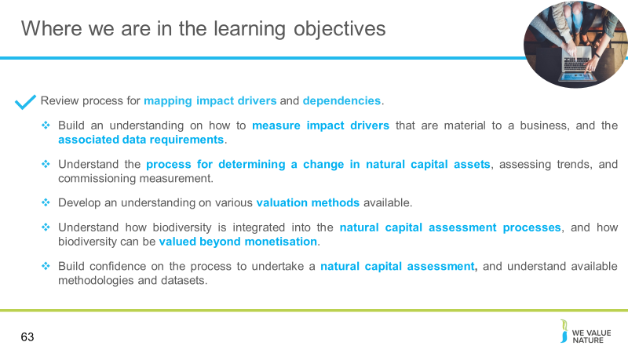
Presenter to highlight that learning objective 1 has now been covered and that the training will proceed to the next learning objectives

Slide 64
Presenter to indicate that we will now take a 15-minute break

Introduction to Natural Capital Measurement
Slide 65
Presenter to welcome participants back and introduce the next section on commissioning measurement.
In the first part of this session, we have been identifying impact drivers and dependencies and how they can be measured, and thinking about data needs (primary vs. secondary)
Once you understand this, you must then determine the measurement methodologies that you will be using, and think about how you will implement them – this is what this section discusses

Slide 66
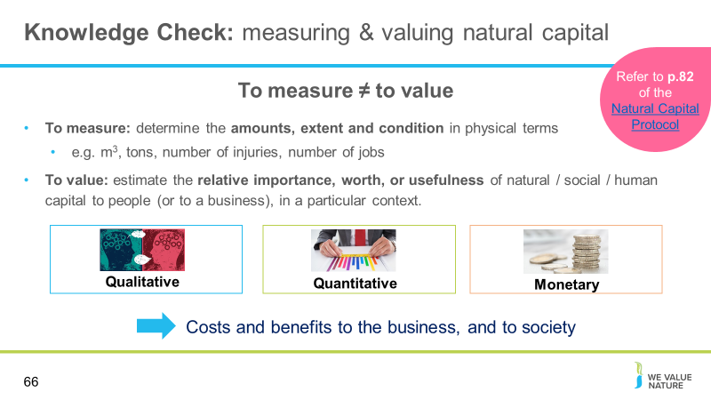
Presenter to introduce the difference between measuring and valuing
For the second part of this training, we will discuss ways to measure and to value changes in the state of natural capital based on your business activities.
It’s important to recognize the difference between these two concepts. Note that we will discuss various modes of valuation towards the end of the training as well.
Presenter to then run through material on the slide.

Slide 67
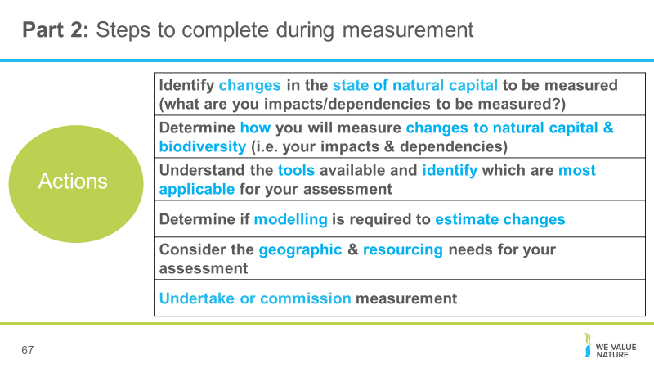
Presenter to review key steps to complete in order to measure changes in the state of natural capital
Presenter to note that we will run through these concepts during this part of the session.
- Identify changes in natural capital associated with your business activities and impact drivers
- Identify changes in natural capital associated with external factors
- Assess trends affecting the state of natural capital
- Select methods for measuring changes
- Undertake or commission measurement

Slide 68
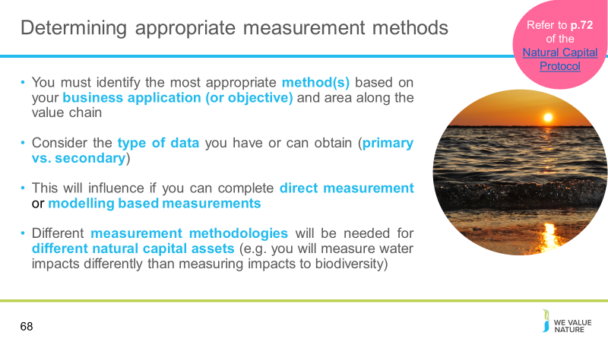
Presenter to run through the method considerations shown on the slide
To measure changes in the state of natural capital, you will need to select the most appropriate method(s) for measuring or estimating the relevant changes in natural capital for different impact and dependency pathways. In addition, where relevant, you may need to determine the likelihood of external factors affecting different changes in natural capital occurring, particularly when assessing dependencies
There are many different methods available for measuring and estimating changes in natural capital. The appropriate choice will depend on the level of detail required (or practical within the available time and resources), and the geographic scope under consideration.
We will provide some example impact drivers and associated impacts (i.e. changes to the state of natural capital) that may need to be measured on the next set of slides.

Slide 69
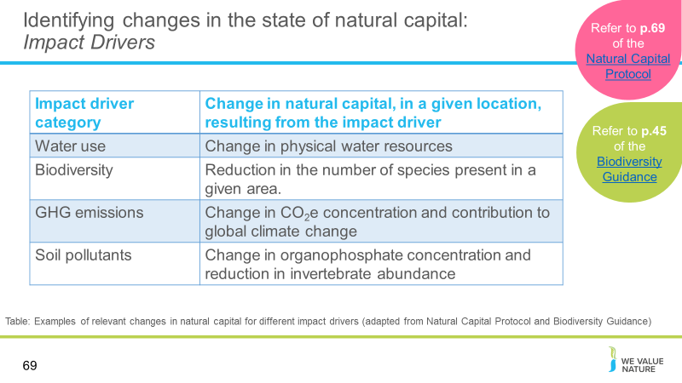
Presenter to discuss identifying changes in the state of natural capital - Impact Drivers
Thinking back to the impact pathway and the impact drivers you have identified that are material to your business, you will have to consider the impacts that will result and how they can best be measured.
Different natural capital assets will be measured in different ways. For more discrete assets (e.g. water and carbon), there are standardised methods for completing measurement.
For more complex natural capital assets such as biodiversity, greater consideration is needed in determining which measurement approach or method is most appropriate for your assessment. We will provide some resources for tool identification shortly.

Slide 70
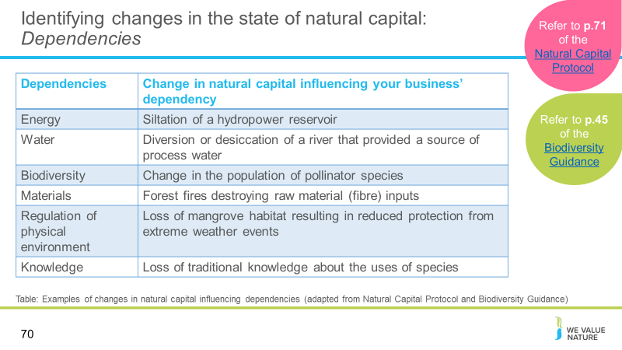
Presenter to discuss identifying changes in the state of natural capital - Dependencies
As before - here we are looking to identify the change in natural capital based on our dependency pathway identified previously.
Give examples of changes in natural capital – moving from impact drivers to change in state, based on your business activities.
Highlight importance of identifying what to measure, before moving to how to measure

Slide 71
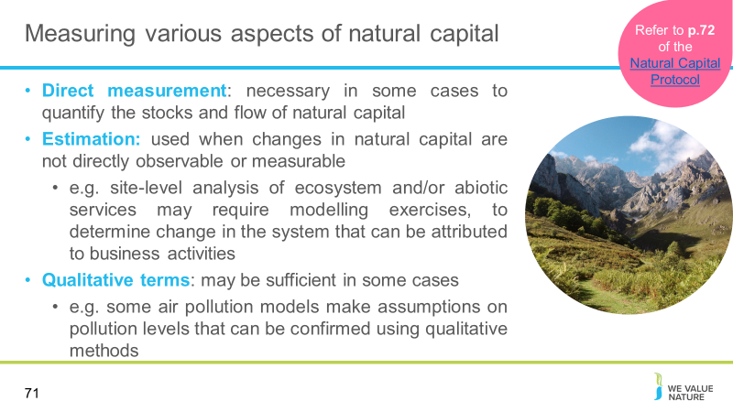
Presenter to discuss the different types of measurement approaches for different aspects of natural capital, using the notes on slide and below:
In some cases, it may be necessary to quantify the state and trends of natural capital through direct measurement; in other cases, this can be done through estimation (Where changes in natural capital are not directly observable or measurable, it is often possible to estimate changes using modelling methods)
For example, site-level analysis of ecosystem and/or abiotic services may require that you model current conditions, in order to understand pre-existing pressures on the system. The additional impacts of your business are then introduced to the model, in order to determine the portion of change in the system that can be attributed to your business activities.
In other cases, it may be sufficient to consider natural capital state and trends in qualitative terms, in order to validate the assumptions implied by your choice of assessment methods. For example, some air pollution models assume that the ambient level of pollution is already above the threshold where health impacts occur, and use a linear relationship to assess the impacts of additional pollution. In this example, you need only confirm your belief that the assumption is reasonable, rather than attempting to quantify the level of external pressures

Slide 72
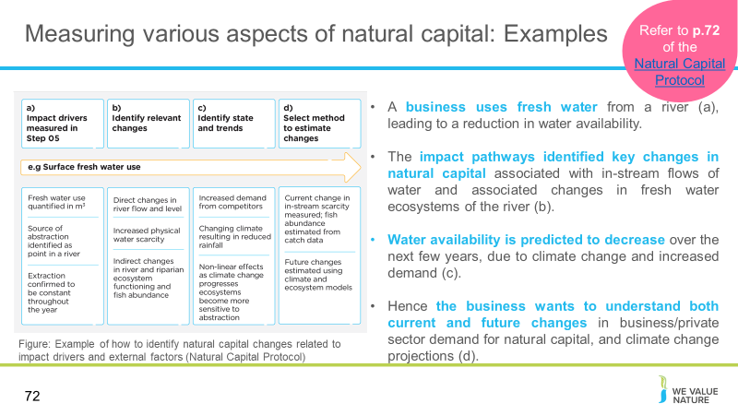
Presenter to discuss the example of a business identifying natural capital risks related to fresh water use from a river. Presenter will discuss how the figure shows methods to estimate the change in natural capital and attribute it to the impact driver.
As noted on the previous slide, where changes in natural capital are not directly observable or measurable, it is often possible to estimate changes using modelling methods. For example, modelling may be used to estimate likely changes in natural capital associated with activities in your supply chain, where the precise location of those activities is not known. In such cases, modelling allows you to integrate local knowledge in your analysis, generating more relevant estimates of changes in natural capital.
The figure on the slide shows an example of a business identifying natural capital risks related to fresh water use from a river and assessing these through the Components of impacts on their business and the impact on society. The figure depicts the impact drivers identified in Step 05 and the associated changes in natural capital that relate to the business’ impact drivers and to external factors affecting the state and trends. For each of the relevant changes, a method is identified to estimate the change in natural capital and attribute it to the impact driver.
As shown in the figure:
- A business uses fresh water from a river (a), leading to a reduction in water availability.
- The impact pathways identified key changes in natural capital associated with in-stream flows of water and associated changes in fresh water ecosystems of the river and riparian areas (b).
- Water availability is predicted to decrease over the next few years, due to climate change and increased demand (c).
- Hence the business wants to understand both current and future changes in business/private sector demand for natural capital, and climate change projections (d).

Slide 73
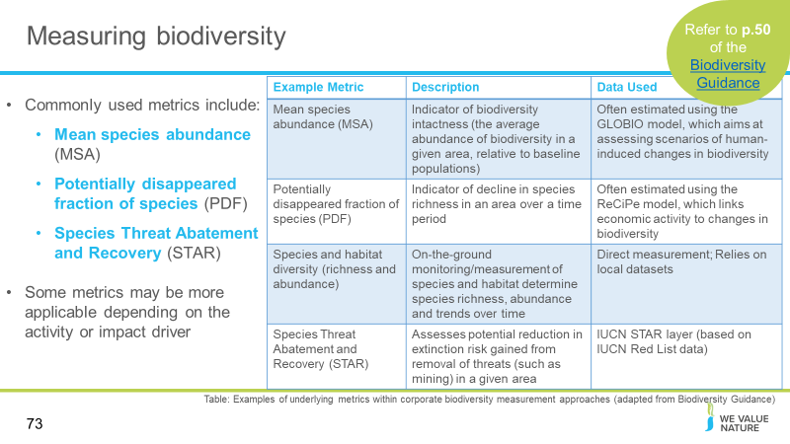
Presenter to explore commonly used metrics for biodiversity measurement, using the notes below and on the slide:
The most commonly used metrics underlying biodiversity measurement approaches include;
- mean species abundance (MSA)
- potentially disappeared fraction of species (PDF)
- Change in risk of species extinction (e.g., through the Species Threat Abatement and Restoration (STAR) metric)
A particular metric may be more applicable depending on the activity or impact driver that you want to assess. Metrics such as MSA and PDF should not be taken as substitution for measurement on the ground, which remains preferable where possible/when appropriate. These metrics do not capture changes to all aspects of biodiversity, such as genetic diversity. This is a current data gap within biodiversity measurement approaches requiring innovation.
The table shows example metrics and their descriptions, as well as the data that they use.
Mean Species Abundance:
- Generally an indicator of biodiversity intactness
- Considers mean abundance of species relative to their abundance in undisturbed ecosystems (i.e., reference site)
- Relative abundance giving a value from 0 (completely destroyed ecosystem with no original species) to 1 (species abundance is unchanged)
Limitations:
- Does not weight areas by species richness
- No distinction is made between species with potentially different conservation values (e.g., common vs. Red-listed)
PDF:
- Provides indicator of decline in species richness in an area over a time period
- Larger PDF values indicate a higher level of impact for the activity
- PDF impact factors focus on the species richness of plants
Limitations:
- No distinction is made between species with potentially different conservation values (e.g., common vs. Red-listed)
- Reliant on estimates based on species-area relationship
Species and habitat diversity:
- On-the-ground monitoring / measurement of species and habitats determine species richness, abundance and trends over time
Limitations:
- Time bound
- Costly
- Potential for species measured to vary depending on approaches used
Change in risk of extinction:
- Assesses potential reduction in extinction risk gained from removal of threats (such as mining) in a given area
Limitations:
- Assesses extinction risk to threatened species and does not consider common species

Slide 74
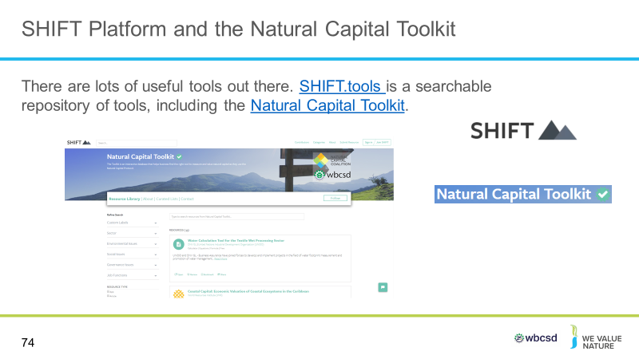
Presenter to consider tools available to help with measurement: first explaining the SHIFT tool
In addition to navigation tool, a number of resources to direct you to tools to help measure changes in state of natural capital
SHIFT tool for all areas of natural capital: SHIFT is an online platform that allows you to navigate the sea of sustainability tools and carve out your pathway to implementation.
SHIFT helps you to search for the tools and information you need, compare the tools you find, and choose the tools that suit you. You can filter your search according to criteria such as geographic location or asset class, or modify your search by tool type, price, ratings, and author.
SHIFT can help you to search for tools according to what you’re involved with and the business need you’re trying to meet.

Slide 75
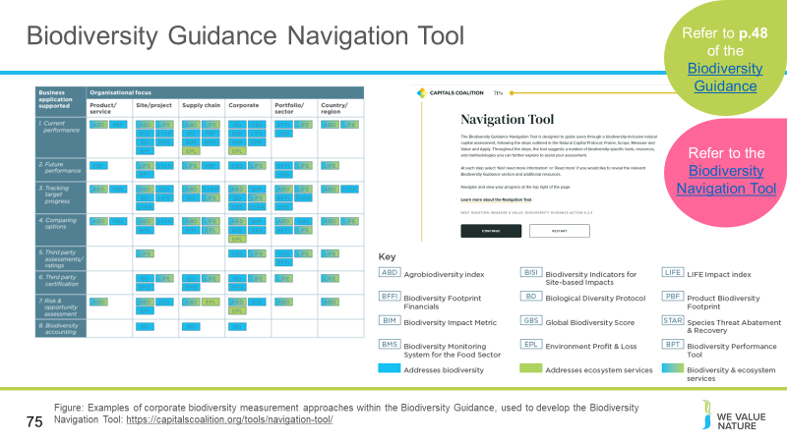
Presenter to consider tools available to help with measurement: the navigation tool
As previously discussed, the Navigation Tool and Biodiversity Guidance on Capital Coalitions website focuses on biodiversity specifically as it is a more complex, and context specific natural capital asset to measure.
Guidance takes user through all steps of the Protocol and asks you questions on user assessment needs that are related to biodiversity specifically
Will direct you to available biodiversity specific measurement approaches to measure impact (note that dependency measurement still a gap).
The matrix shown on the slide visualises how the Navigation Tool picks appropriate methods based on organisational focus and business application identified. It also described whether each tool, addresses biodiversity directly, addresses ecosystem services directly, or addressed both biodiversity & ecosystem services. This matrix was drafted in 2020, and will need to be updated as approaches improve and increase in number.
Background notes, if needed:
- The Biodiversity Guidance Navigation Tool is designed to guide users through a biodiversity-inclusive natural capital assessment, following the steps outlined in the Natural Capital Protocol; Frame, Scope, Measure and Value and Apply. Throughout the steps, the tool suggests a number of biodiversity-specific tools, resources, and methodologies you can further explore to assist your assessment.
- At each step select ‘No/I need more information’ or ‘Read more’ if you would like to reveal the relevant Biodiversity Guidance section and additional resources.
- As part of this navigation tool, there is a measurement approach matrix, as shown on the slides. The matrix highlights available measurement approaches to measure impacts and/or dependencies on biodiversity.
- It is recommended to reflect on your identified list of impact drivers to be measured when selecting a measurement approach, as well as the data sources you have identified as available.
- The matrix includes a link to each biodiversity measurement approach and details on the developer. It then indicates whether or not each approach is suitable for the following impact drivers: land use change, biological resource use, water use, invasive alien species, atmospheric nitrogen deposition, nutrient emissions to water, climate change. It includes a rating on the maturity of each approach (potential, emerging, mature).

Slide 76 – optional slide
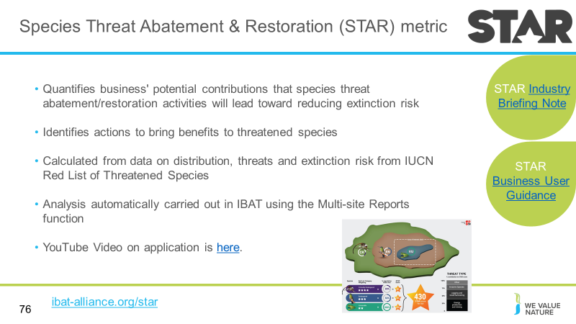
Presenter to play the video on STAR, before discussing the following points:
STAR
As shown in the video. the Species Threat Abatement and Restoration Metric (STAR) is available in IBAT. STAR allows quantification of the potential contributions that species threat abatement and restoration activities offer towards reducing extinction risk across the world. STAR can inform decisions made by businesses, governments, civil society, and other actors towards global goals for halting extinctions. As such, STAR helps identify actions that have the potential to bring benefits for threatened species, and it supports the establishment of science-based targets for species biodiversity, and commitments relevant to the post-2020 biodiversity framework. STAR is calculated from data on the distribution, threats, and extinction risk of threatened species derived from the IUCN Red List of Threatened Species. STAR Scores are disaggregated by 57 different threats from the Red List for both Threat Abatement and Restoration.
STAR is simple to use and interpret as the analysis is carried out automatically in IBAT. STAR insights can be gained by using IBAT site-specific reports, which calculate estimated STAR values for a given Area of Interest, as well as by using IBAT Multi-site Reports to gain a broad understanding at the portfolio/supply chain level. Additionally, the raw raster layer is available to download at the global level and at local scale with 5km granularity.
STAR is standardised across the globe as every grid cell can be directly compared using the same objective criteria. STAR is also scalable as users can sum their potential contributions across sites, regions and countries throughout the world to determine their overall opportunities for nature-positive action. STAR can help businesses identify both opportunities and risks associated with their activities and value-chains. STAR can also provide a basis for setting corporate “science-based targets” for nature that contribute to global conservation goals.
Limitations:
STAR’s flexibility and applicability across geographic scales makes it suitable for a wide range of applications. However, it is important to note that STAR focuses on threatened and near-threatened species. These are regarded as very high priority for conservation attention, but there may be other biodiversity features and aspects of concern or providing opportunities for conservation action. Therefore, STAR may need to be supplemented with additional information to provide a more accurate or complete picture of the biodiversity of an area.
Planned improvements include: Ability to disaggregate STAR scores for individual species, and inclusion of additional taxonomic groups beyond amphibians, birds and mammals, once these groups have been assessed, including freshwater and marine species.

Slide 77
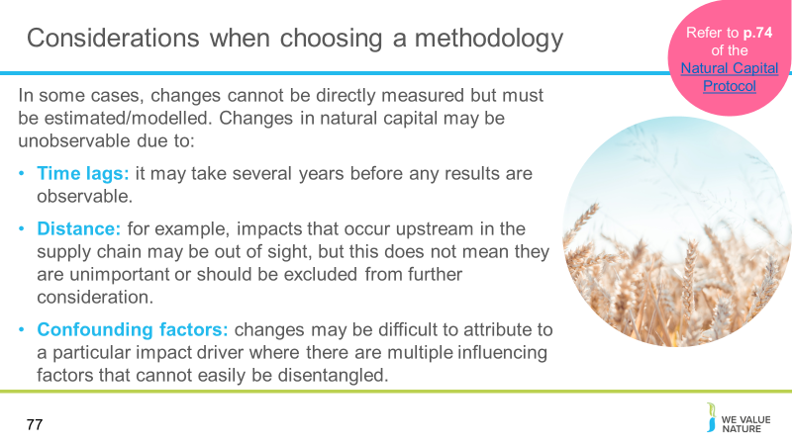
Presenter to highlight key considerations on methodology, to understand that there are some cases where changes in natural capital cannot be measured or observed.
Impact pathways describe the means through which your business activities and their associated impact drivers lead to changes in natural capital. In some cases these changes are directly observable and can be measured on-site (time and resources permitting). In other cases, significant changes in natural capital may be unobservable (by humans or machines), meaning they cannot be measured directly but must be estimated or modelled indirectly. A change may be unobservable due to:
- Time lags – for example, planting trees in upland areas can reduce soil erosion and sedimentation of water bodies downstream, but it may take several years before any results are observable.
- Distance – for example, plastic waste can harm marine organisms halfway around the world, where those conducting an assessment may not have a presence or be aware of their impacts. The challenge of distance also applies to impacts that occur upstream in the supply chain. Just because these changes are out of sight, it does not mean they are unimportant or that they should be excluded from further consideration.
- Confounding factors – changes may be difficult to attribute to a particular impact driver where there are multiple influencing factors that cannot easily be disentangled, such as the many drivers of species decline (e.g., habitat loss and fragmentation, unsustainable use, illegal harvest, invasive alien species, climate change).

Slide 78
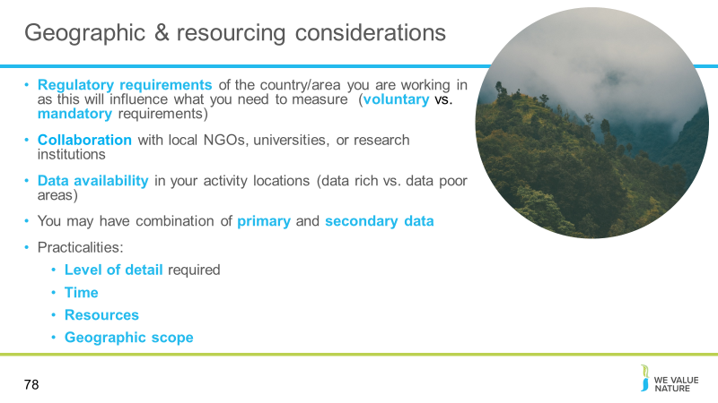
Presenter to read through slide material and note following:
- Regulatory considerations of the area they are working in should be considered e.g. working in many regions, need to be aware of the regulations in that region (e.g. air quality regulations may differ)
- There may be discrepancies in data availability in your activity locations (data rich vs. data poor areas)
- May have combination of primary and secondary data available and that is ok!
- Practicalities: level of detail required to complete assessment, time resources, geographic scope of assessment

Slide 79
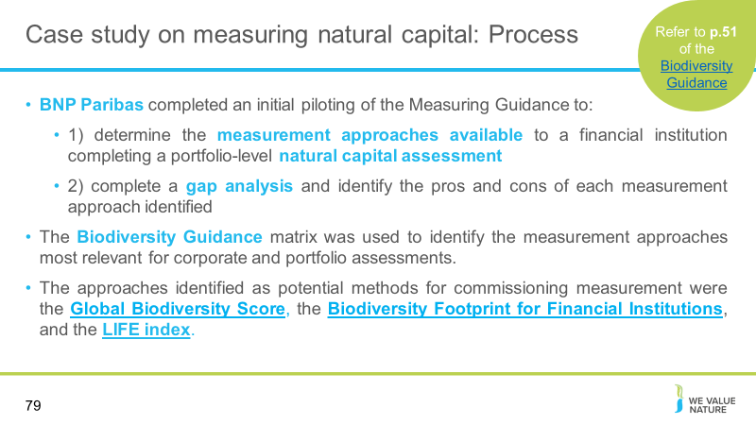
Presenter to discuss the BNP Paribas Case Study and read through the information on the slide, supported by the following notes:
Finance (asset management) BNP Paribas Asset Management completed an initial piloting of the Measuring Guidance to 1) determine the measurement approaches available to a financial institution completing a portfolio-level natural capital assessment, and 2) complete a gap analysis and identify the pros and cons of each measurement approach identified. The assessment of biodiversity measurement approaches revealed the importance of combining approaches to address some of the existing information gaps associated with different measurement approaches and ensure a comprehensive assessment that fully encompasses biodiversity.
After reviewing the actions outlined within the Measuring Guidance, the Biodiversity Guidance matrix was used to identify the measurement approaches most relevant for corporate and portfolio assessments. The approaches identified were the Global Biodiversity Score (GBS), the Biodiversity Footprint for Financial Institutions (BFFI), and the LIFE index. These approaches were chosen based on their ability to support corporate and portfolio-level assessments. Additional measurement approaches were assessed based on their ability to resolve limitations of the primary approaches. These approaches included the Species Threat Abatement and Restoration (STAR) metric and the Biodiversity Impact Metric (BIM). The TRASE tool was also considered.

Slide 80
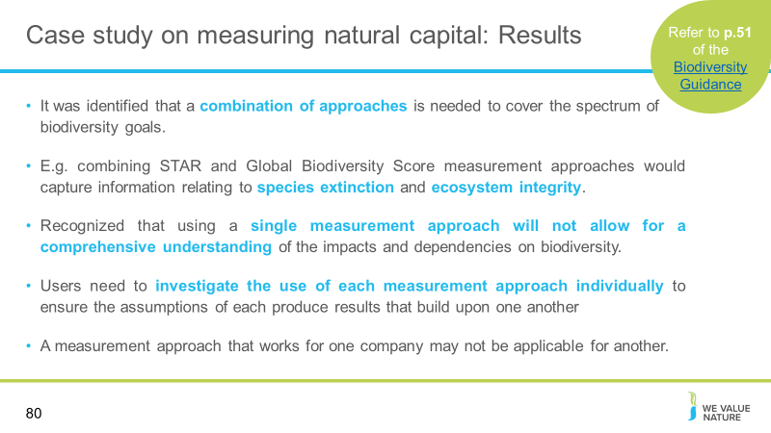
Presenter to discuss the BNP Paribas Case Study and read through the information on the slide, supported by the following notes:
In the context of this pilot, it was identified that a combination of approaches is needed to cover the spectrum of biodiversity goals. For example, combining the STAR and Global Biodiversity Score measurement approaches would capture information relating to species extinction and ecosystem integrity. BFFI and GBS are similar in their methods and data requirements—however their applicability is heavily dependent upon the objective of the assessment, highlighting the importance of using the online Biodiversity Guidance Navigation Tool. The tool is designed to help you understand what you need to analyse and why (based on your overall objective) as these are the most important factors when deciding which measurement approach to use. The Scoping Guidance is an important resource for determining which approaches should be further explored.
Where financial institutions hold large portfolios of companies, biodiversity assessments can be complex and time consuming. To fully assess and compare companies in a portfolio, a standardized approach for biodiversity measurement is considered necessary, but it is recognized that using a single measurement approach will not allow for a comprehensive understanding of the impacts and dependencies on biodiversity.
Similarly, in assessments identifying impacts and dependencies on biodiversity at the portfolio level, it is difficult to attribute or allocate the impacts of specific companies within the same area. This is a recognized gap even when using a combination of approaches and requires investigation by measurement approach developers.
Although it is recommended that a combination of measurement approaches be used to better assess corporate impacts and dependencies on biodiversity, users still need to investigate the use of these measurement approaches individually to ensure the assumptions of each produce results that build upon one another and avoid the misinterpretation of data (e.g., through double counting, etc.).
Additionally, a measurement approach that works for one company may not be applicable for another. Determining the most viable combination of tools for your specific sector and/or company is important. Ultimately, the combination of approaches is a suggested method to fill current gaps in available approaches, but a more permanent solution will be required.

Slide 81
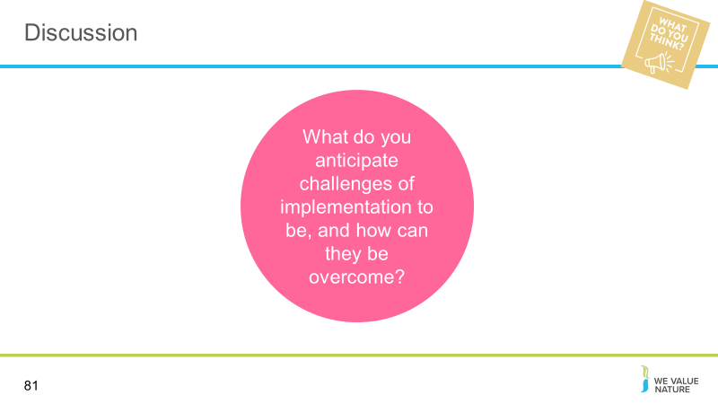
Presenter to introduce discussion on the challenges on implementation
In person: Participants to discuss at their table. Facilitator to ask a couple of tables to feedback key points of their discussion to the room.
Virtually: Facilitator to split participants into breakout rooms for 5 minutes of discussion. Speaker to nominate 2 rooms to feedback key points to the ‘room’

Slide 82
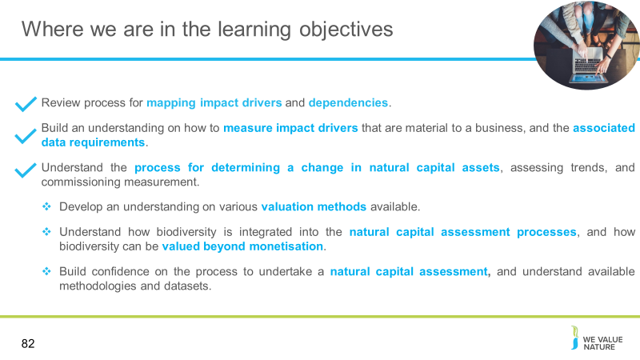
Presenter to highlight that learning objectives 2 and 3 have now been covered and that the training will proceed to the next learning objectives

Valuing changes to the state of natural capital & biodiversity
Slide 83
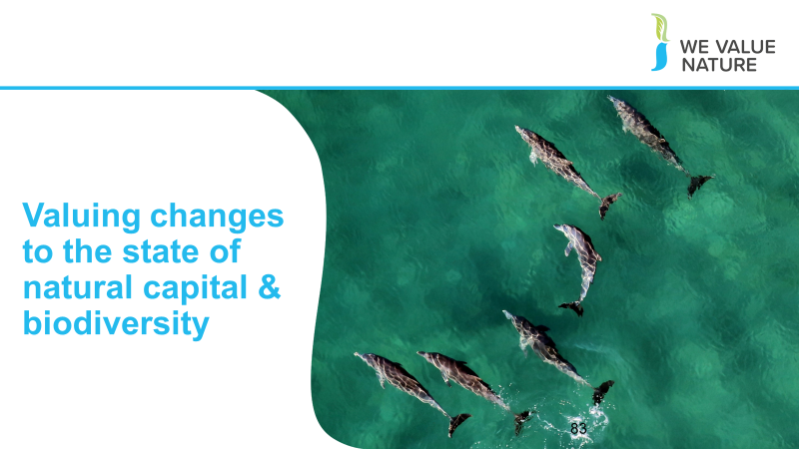
Presenter to introduce the final section: now that we have considered how to map your impact drivers & dependencies, and how to commission measurement, we will move on to valuing changes to the state of natural capital & biodiversity

Slide 84
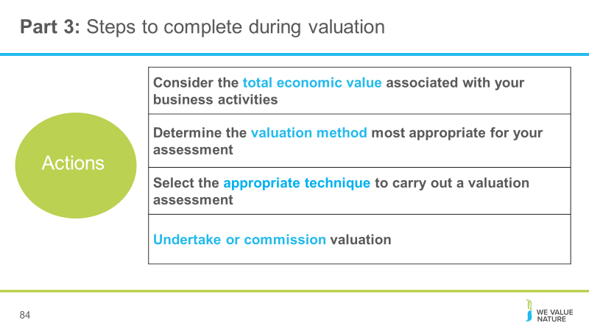
Presenter to review key steps to complete in order to define the value of impacts and/or dependencies
- Define the consequences of impacts and/or dependencies
- Determine the relative significance of associated costs and/or benefits
- Select appropriate valuation techniques
- Undertake or commission valuation

Slide 85
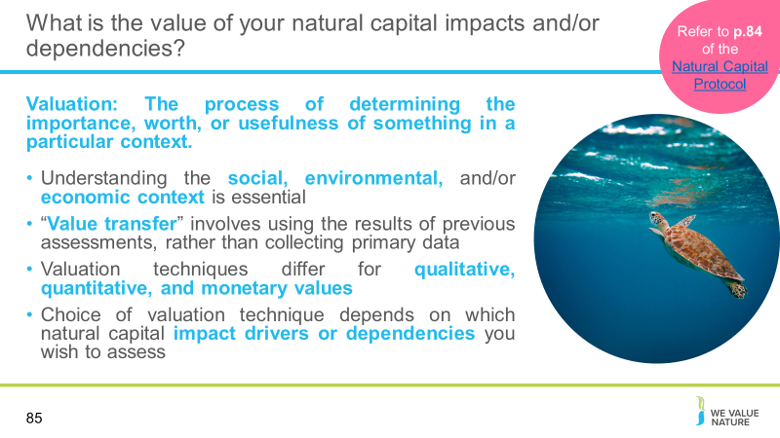
Presenter to discuss the value of your natural capital impacts and/or dependencies, drawing from the slides and the notes below:
- Valuation is the process of determining the importance, worth, or usefulness of something in a particular context.
- Valuation involves taking figures from your measurement, and trying to provide a societal perspective. This can help you to understand the value of natural capital to your company, but this is not only monetary valuation.
- Understanding this context, which can be social, environmental, and/or economic, is essential, as without such understanding you cannot meaningfully estimate value or correctly interpret results.
- A popular valuation shortcut is “value transfer”. This involves using the results of previous assessments, rather than collecting primary data for a new analysis. This allows businesses to value using data the already have.
- For each cost and/or benefit identified, you will need to select an appropriate valuation technique, based on whether you intend to assess values in qualitative, quantitative, or monetary terms. Each of these will be discussed individually
- The choice of valuation technique depends on which natural capital impact drivers or dependencies you wish to assess, the chosen value perspective (i.e., business, societal, or both), the ultimate objective of your assessment, and the time and resources available.
- There may be trade-offs between different types of valuation. Reiterate this point - which we described at the beginning of training

Slide 86
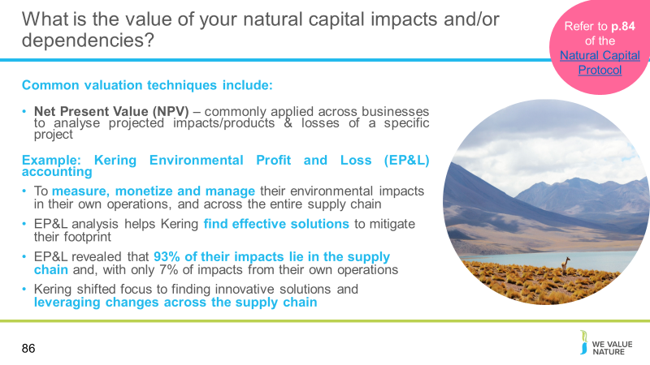
Presenter to discuss the valuation techniques described on slide, and the Kering case study.
Example: Kering: Environmental Profit and Loss (EP&L) accounting
Kering is a pioneer in Natural Capital assessment having created Environmental Profit and Loss (EP&L) accounting to measure, monetize and manage their environmental impacts in their own operations and across the entire supply chain.
The EP&L analysis reveals the true impacts resulting from Kering’s business activities and helps them find effective solutions to mitigate their footprint. In turn, this allows them to better address climate change and develop more resilient business models, as well as providing transparency to our stakeholders along the way.
Aligned with their open-sourcing philosophy, Kering’s EP&L methodology contributed to the Natural Capital Protocol development. Making it open-source aims to help advance the inclusion and adoption of Natural Capital accounting into mainstream decision-making and corporate reporting.
Kering also developed an easy to use tool, the "My EP&L" App, to assist the fashion community in understanding how design decisions influence the extent of environmental impacts such as material choices, sourcing regions, etc.
Kering publishes their Group EP&L on an annual basis. The EP&L is used as a day-to-day decision-making tool and is fully embedded into the business.
Among the lessons learned and key findings, Kering’s EP&L revealed that 93% of their impacts lie in the supply chain and, in particular, from the production and processing of raw materials which together represent 72% of the total. Their own operations represent only 7% of the impacts. Accordingly, Kering shifted focus to finding innovative solutions and leveraging changes across the supply chain, as well as avoiding high impact sources due to an increased transparency via the EP&L. Kering is currently expanding their natural capital accounting work to assess biodiversity and also linking natural capital accounting to Planetary Boundaries.

Slide 87
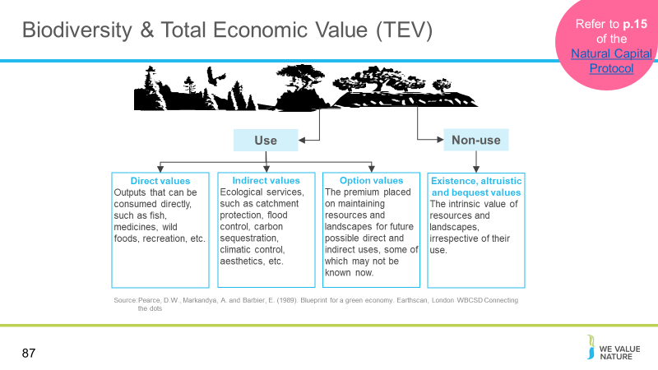
Presenter to explain the concept of total economic value, using the notes below:

- Economic value is a measure of how much something (e.g. an ecosystem service) improves the wellbeing of an individual or of society as a whole
- The concept of total economic value has now become one of the most widely used frameworks for identifying, categorizing and valuing ecosystem benefits
- Many of the services provided by ecosystems are not captured in existing markets, so are considered only in an assessment of total economic value
- Instead of focusing only on direct commercial values, TEV also considers subsistence and non-market values, ecological functions and non-use benefits
Direct use: raw materials and physical products that are used directly for production, consumption and sale (e.g. energy, shelter, food)
Indirect use: ecological functions that maintain and protect natural and human systems through services (e.g. maintenance of water quality and flow, flood control, storm protection, micro-climate stabilisation)
Optional values: premium placed on maintaining resources and landscapes for future possible direct and indirect use
Non-use: value of ecosystem regardless of current or future use, for cultural, spiritual, aesthetic, heritage and biodiversity reasons
Ultimately, TEV presents a more complete picture of the economic importance of ecosystems – this demonstrates the scale and range of economic costs associated with degradation, beyond the loss of direct use values

Slide 88
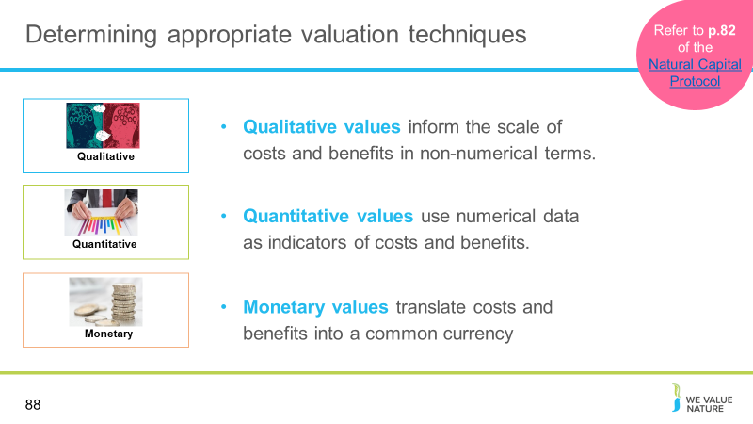
Presenter to outline that there are different ways of valuing – could be qualitative, quantitative, or monetary
These techniques may be used to assess the value of incremental or marginal changes in natural capital stocks or flows, which will be relevant for most business applications. The same techniques can be used to assess the total (aggregate) value of natural capital stocks, although this is rarely necessary and may require additional analysis.
- Qualitative valuation techniques are used to inform the potential scale of costs and/or benefits expressed through qualitative, non-numerical terms (e.g., increase in air emissions, decrease in social benefits of recreation).
- Quantitative valuation techniques, in turn, focus on numerical data which are used as indicators for these costs and/or benefits (e.g., changes in tons of pollutants, decrease in number of people benefitting from recreation).
- Monetary valuation techniques translate quantitative estimates of costs and/or benefits into a single common currency (e.g. cost of carbon emissions, the costs of bringing in managed pollinator populations to compensate for a change in pollinator populations).
Important to note that monetary values without any context (i.e. accompanying quantification) are less meaningful.
The method you chose depends on which natural capital impact drivers or dependencies you wish to assess, the chosen value perspective (e.g. business, societal, or both), the ultimate objective of your assessment, and the time and resources available.
Note: Expert input is likely to be helpful here considering the range of factors that influence the practicality and appropriateness of applying the various techniques.

Slide 89
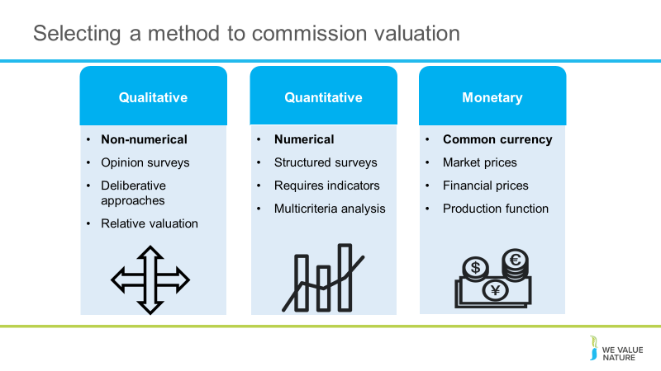
Presenter to run through the three different valuation methods, using the points on slides and notes below:
Qualitative
Opinion surveys: Surveys designed to represent view through a series of questions (e.g. semi-structured interviews). Data considerations: Stakeholder information to inform sampling frame
Deliberative approaches: Facilitated group discussions or focus groups that can involve debate and learning such as brainstorming sessions etc. Data considerations: Stakeholder information to inform sampling frame
Relative valuation: Use of high/medium/low values to determine relative value of benefits (and/or costs) in categorial terms. Data considerations: Information on all parameters to be valued
Quantitative
Structured surveys: Surveys or questionnaires used to elicit quantitative values that allow for statistical analysis. Data considerations: Stakeholder information to determine sampling frame
Indicators: Various indicators can be used to quantify information, such as air emissions, yield per hectare, or risk of species extinction. Data considerations: Information on all parameters to be valued— ideally quantified information
Multi-criteria analysis using scoring and weighting: Involves selecting a range of parameters and rating and ranking their value through scoring and weighting, using workshops, available data, and/or expert judgement. Data considerations: information on all parameters to be valued— ideally quantified information
Monetary
Market and financial prices: Includes several related approaches, including:
- Costs/prices paid for goods and services traded in markets (e.g. timber, carbon, pollution permit)
- Other internal/financial information (e.g. estimated financial value of liabilities, assets, receivables)
- Other interpretations of market data (e.g. derived demand functions, opportunity costs, mitigation costs)
- Data considerations: Market prices of ecosystem goods and/or services. Costs involved to process and bring the product to market (e.g., crops)
- Production function (change in production): Empirical modelling approach that relates change in the output of a marketed good or service to a measurable change in natural capital inputs (e.g. the quality or quantity of ecosystem services). Data considerations: Data on changes in output of a product. Data on cause and effect relationship (e.g., crop losses due to reduced water availability)

Slide 90
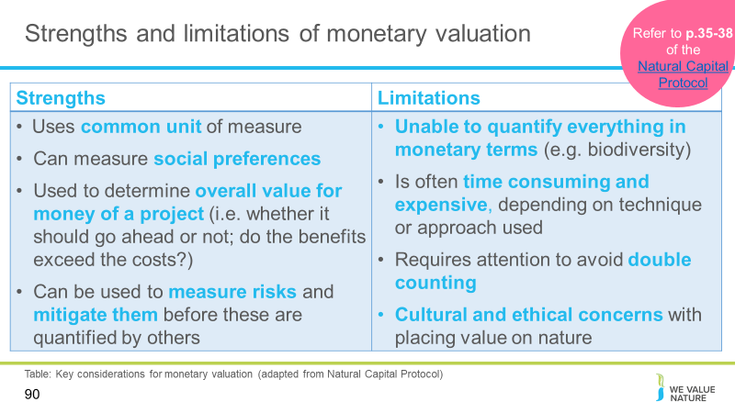
Presenter to explain strengths and limitations of completing monetary valuation:
Monetary valuation works by translating quantitative estimates of costs and/or benefits into a single common currency
The strengths of monetary valuation include:
- Can provide information on the marginal value of incremental changes in impacts or dependencies, either at a point in time or over a given period
- Monetary valuation can also be used to assess trends in value as a function of changes in supply and demand conditions. Both market and non-market approaches to monetary valuation aim to measure social preferences—using observed prices in the market in the former case, and “revealed” or “stated” preference methods for impacts or dependencies that do not have explicit market prices
- Monetary valuation is good for ease of comparison with financial values because it puts values in a common unit of measure. When monetary values are estimated correctly and consistently, they are broadly comparable and offer meaningful information to assess trade-offs
Limitations of monetary valuation includes:
- Sometimes stakeholders find it difficult to accept or interpret the monetary valuation of certain benefits.
  - Societal costs and benefits for example, rarely translate directly into financial costs and benefits to businesses, even when they are expressed in monetary terms. This means that monetary estimates are often only partial estimates of the overall value.
  - This is because these societal costs and benefits can rarely be imposed by companies precisely. For example, the financial costs imposed by environmental legislation are often lower than the societal costs of the impacts avoided. Equally, the financial costs of reputational damages associated with impacts on natural capital may be greater than the societal costs of the impacts themselves.
- It can be time consuming and expensive, especially if primary research is required to generate data although some lower-cost monetary valuation methods are available like value transfer
- Ultimately, not everything can be quantified in monetary terms – considering the value of ecosystem services in terms of the impact of human well-being, for instance, may be more helpful in framing corporate ecosystem valuation

Presenter to stress that in a biodiversity-inclusive natural capital assessment, Monetary valuation is likely to only be done as estimates or minimum value because of the hidden and intrinsic values that biodiversity has. Any values derived should be viewed with caution along with other information that can assist the decision-making, rather than replace.

Slide 91
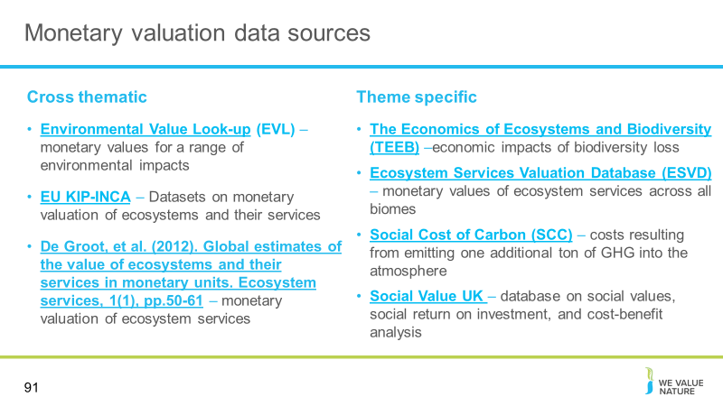
Presenter to provide some examples of monetary valuation data sources
- EVL: The Environmental Value Look-Up (EVL) Tool is a searchable database which contains indicative monetary values for a range of environmental impacts.
- EU KIP-INCA: An integrated natural accounting system for ecosystems and their services and associated data sets is being developed by the Knowledge Innovation Project (KIP INCA).
- De Groot et al. (2012): This paper gives an overview of the value of ecosystem services of 10 main biomes expressed in monetary units.
- TEEB: The aim of TEEB is to assess the economic impacts of biodiversity loss and to offer practical responses to ecosystem decline
- ESVD: The Ecosystem Services Valuation Database (ESVD) is a follow-up to the “The Economics of Ecosystems and Biodiversity” (TEEB) database which contained over 1,300 data points from 267 case studies on monetary values of ecosystem services across all biomes.
- Social Costs of Carbon: The SCC is a tool that estimates, in dollars, the economic damages that would result from emitting one additional ton of greenhouse gases into the atmosphere
- Social Value UK: database of over 800 social value, SROI and cost benefit analysis report.
- Environmental Prices Handbook EU28 version – Environmental prices are prices for the social cost of pollution, expressed in Euros per kilogram pollutant. Environmental prices indicate the loss of economic welfare that occurs when one additional kilogram of the pollutant finds its way into the environment. Captured in a single monetary unit.
- OECD Meta-analysis of Value of Statistical Life estimates - It is increasingly common to include estimates of value of statistical life (VSL) in analyses of proposed policies that affect people’s mortality risks.The analysis is presented in the publication Mortality Risk Valuation in Environment, Health and Transport Policies.
Slide 92
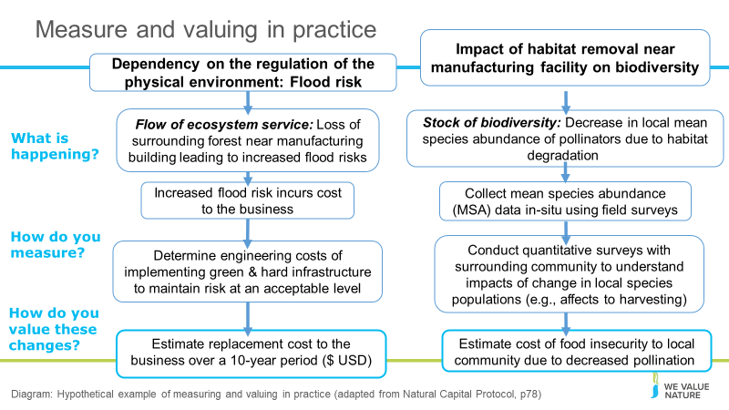
Presenter to run through the hypothetical example of measuring and valuing in practice, using the points in the diagram.
Left shows business valuation, right shows effects to society

Slide 93
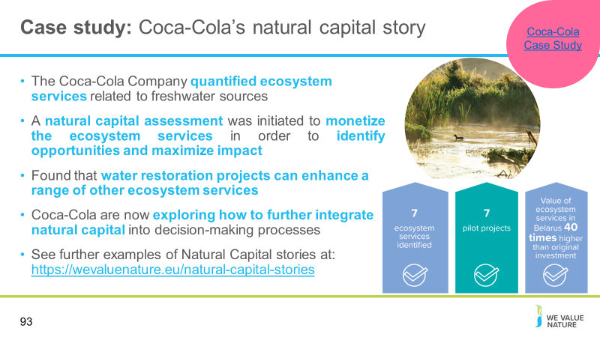
Presenter to outline Coca-Cola case study, using notes below:
The Coca-Cola Company (TCCC) quantified ecosystem services related to freshwater sources to better capture and communicate impacts of water community projects beyond replenishment.
Having invested a lot in water replenishment projects, TCCC was driven to understand the variety of benefits that these projects provide to people and society beyond water volumes only. A natural capital assessment was initiated to monetize the ecosystem services in order to identify opportunities and maximize impact. Together with their partners, they developed and piloted a methodology in seven of their European projects.
While monetizing impacts was not always easy, the results were clear: water restoration projects can enhance a range of other ecosystem services. If done right, these benefits outweigh the original project investment in a limited period of time. The assessment helped TCCC progress on their natural journey and they are now exploring how to further integrate natural capital into decision-making processes. TCCC has disclosed their methodology as part of their commitment to transparency and to help other businesses in their natural capital journeys.
The natural capital story of The Coca-Cola Company, the world’s largest beverage company, demonstrates that natural capital can provide a useful lens to communicate about nature within a business context and to maximize the impact of nature-related projects.

Slide 94
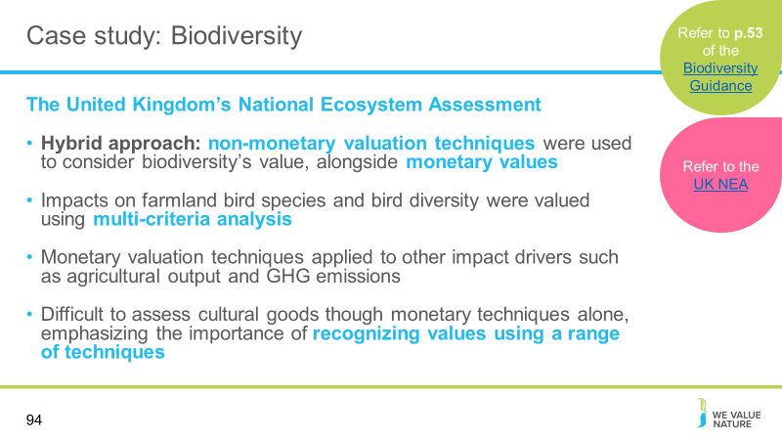
Presenter to explore the case study of The UK National Ecosystem Assessment which uses a combination valuation approach.
The United Kingdom’s National Ecosystem Assessment (UK NEA) provides an example of how non-monetary valuation techniques can be used to consider biodiversity’s value alongside monetary values. In this assessment, impacts on farmland bird species and bird diversity were valued using multi-criteria analysis. Monetary valuation techniques were applied to other impact drivers such as agricultural output, greenhouse gas emissions, as well as to recreation and urban greenspace under different scenarios.
The different types of value could then be considered in parallel in decision-making—this is therefore also an example of a hybrid approach. The NEA synthesis report shows how this hybrid approach has been applied and a study by Defra (UK, Department for Environment, Food, and Rural Affairs) also highlights the difficulty of assessing cultural goods though monetary techniques alone, emphasizing the importance of recognizing their values using a range of techniques, such as MCA. The collective value of biodiversity and ecosystem services requires a hybrid approach, using both quantitative and qualitative techniques. Businesses would be able to apply this approach to integrate both the values of biodiversity stocks and final benefits when undertaking natural capital assessments.

Slide 95
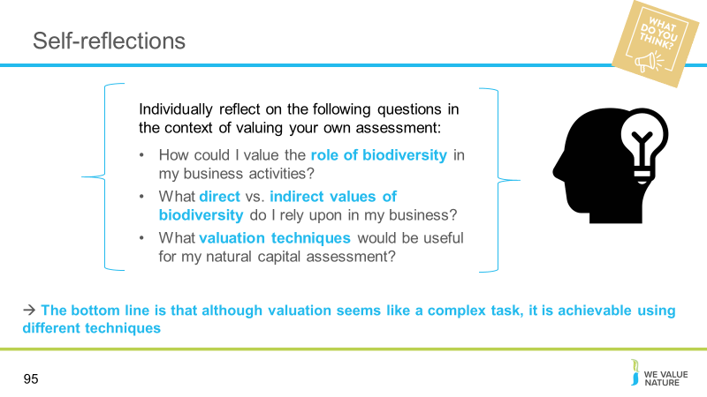
Presenter to read the question on the slide providing time for the participants to reflect and answer. Once reflection is complete, presenter should explain that the type of valuation techniques that exist with a focus on valuing biodiversity (e.g. values businesses extract from ecosystem goods and services is dependent on many factors for example:

For example, an agricultural production company, may rely on ecosystem goods and services very directly whereas a tourism agency, may rely on ecosystem goods and services for indirect value

Presenter to add their own examples and add other factors which may influence values.

Virtual: Presenter should ask each delegate to share their thoughts in the chat
In person: Each table will be asked to reflect on these points as a group and feedback

Slide 96
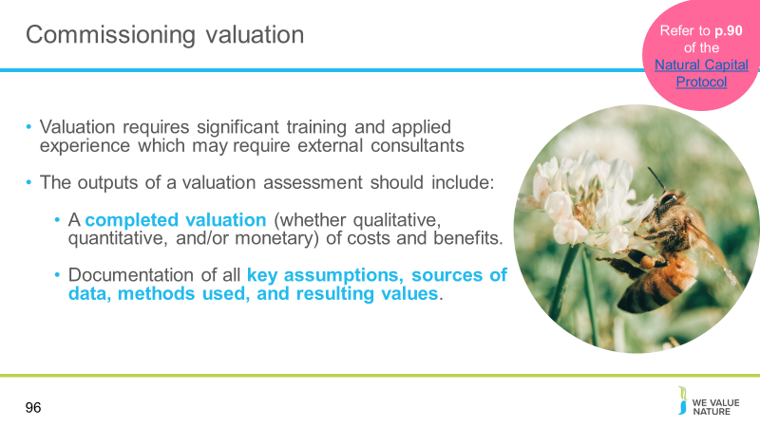
Presenter to explain how to commission valuation, using the notes below:
Based on your assessment objective, combined with the information you have compiled and the valuation techniques selected, you should now be in a position to either undertake or commission the relevant valuation for your chosen assessment. Note: Because significant training and applied experience is generally required to apply natural capital valuation techniques with confidence, the Protocol does not give details on application and execution of these techniques. However, further guidance on each of the techniques is provided in Annex B.
Highlight that you may need to hire someone for the job.
The outputs of this Step should include:
  - A completed valuation (whether qualitative, quantitative, and/or monetary) of costs and benefits.
  - Documentation of all key assumptions, sources of data, methods used, and resulting values.

Slide 97
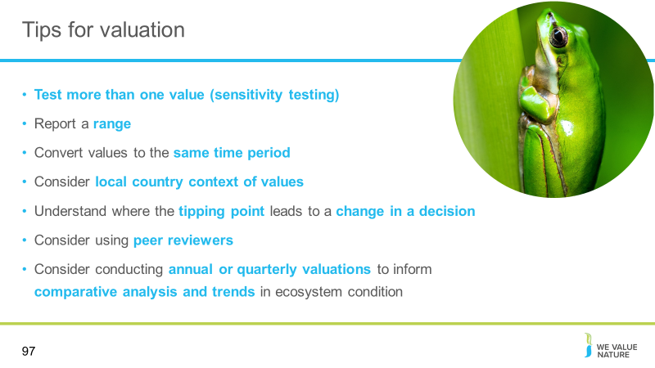
Presenter to describe tips for completing valuation assessments using information on slides

Slide 98
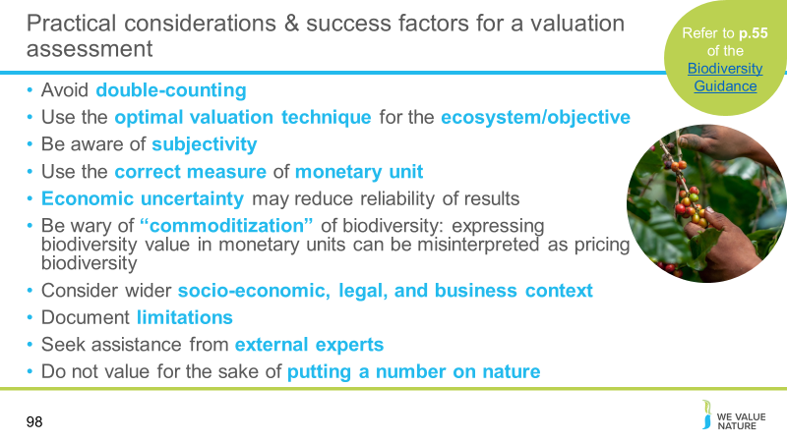
Presenter to detail additional considerations for completing a valuation assessment.
When doing a biodiversity-inclusive natural capital assessment it is important to recognise that you may be double counting.
Double-counting can be a concern when you value biodiversity and ecosystem services. This is because biodiversity delivers benefits in multiple ways.
- For example, in production of agricultural crops, biodiversity supports nutrient cycling and pollination. These ecosystem services (and other benefits from biodiversity) combine to provide one final benefit to a business—increased crop yields.
- If you value each ecosystem service individually you may count the role of biodiversity several times. To avoid double-counting, you can focus on final benefits, such as the crop yield, rather than intermediate or supporting services, such as nutrient cycling or pollination.
- However, when you value final benefits (if they are flows resulting from values other than biodiversity’s direct value) the connection between business benefits and the underlying condition of biodiversity stocks may be overlooked.
- Optimal valuation technique
- Subjectivity – Values are a reflection of how a single group of people perceive their relationship with biodiversity at a single point in time.
- Correct measure of monetary unit
- Economic uncertainty – Economic uncertainty can contribute to the complexity of valuations (particularly where ecologically uncertain relationships exist) and risks reducing the reliability of the results.
- “Commoditization” – Expressing biodiversity values in monetary units can be misinterpreted as pricing and marketing biodiversity.
- Valuing natural capital can be helpful but is not the only basis for decision making, hence results should be presented as part of a suite of information, including details of the wider socio-economic, legal, and business context.
- There will always be estimation or uncertainty of some kind involved in your valuation; therefore it is important to identify where this occurs and clearly document the limitations of your assessment. Even rough approximations of value, when combined with a good understanding of the context, can provide relevant information for decision making.
- It is likely that you will need assistance from external experts in natural capital valuation to undertake many of the methods described in this Step, unless you have access to these skills in-house.
- Number on nature – valuation should inform the scale of the benefits/losses that will result from the business activities taking place. It should also inform the opportunity costs of consumption/production that result from the business. The goal shouldn’t be merely to quantify nature and its services but to map out the changes in the frequency, intensity, extent, and condition of ecosystems and their services and its impact on the economic and societal level.

Slide 99
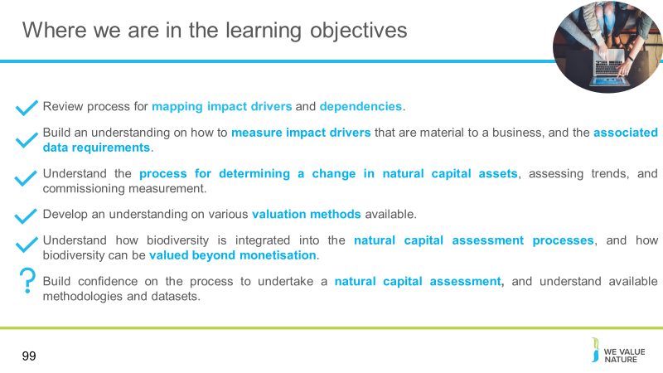
Presenter to highlight that all learning objectives have now been covered
Presenter to discuss the final objective with attendees – ask audience if they have gained confidence to complete a natural capital assessment and provide a reason why. If not, what is missing?

Slide 100
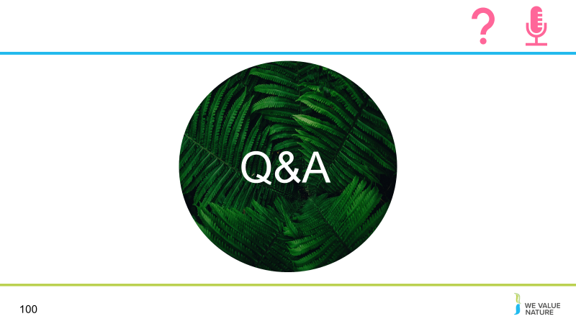
Presenter to invite participants to ask questions

Wrap up & close
Slide 101
Presenter to reiterate that learning objectives have been met, showing the fact we understand impact drivers, dependencies and impacts, measurement and valuation methods, and how to undertake a natural capital assessment

Slide 102
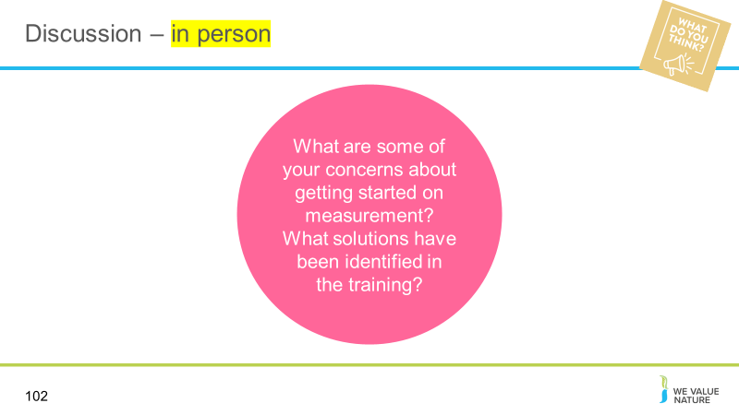
Presenter to ask participants to discuss concerns they may have, and potential solutions identified through this training session.
Some of the concerns about getting started on measurement, and solutions identified in the training – participants to write down and share examples.
Presenter to ask a few groups to feed back key points of discussions (time pending).

Slide 103
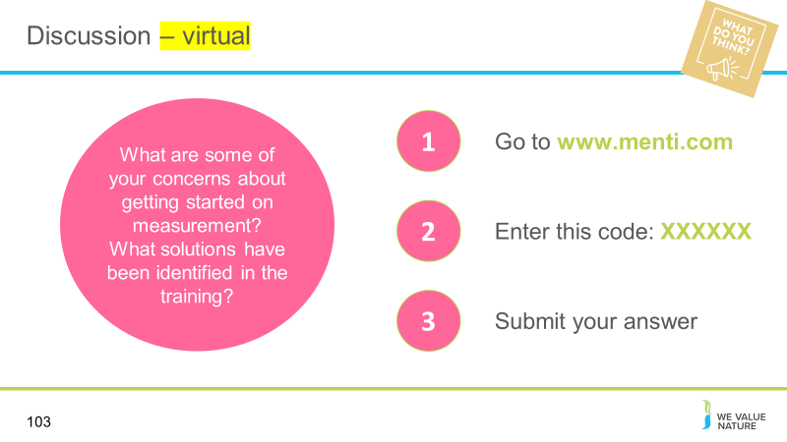
Presenter to complete discussion using Menti.
Using menti: ask participants to share some of the concerns about getting started on measurement, and solutions identified in the training – participants to share on menti by answering open ended question.

Slide 104
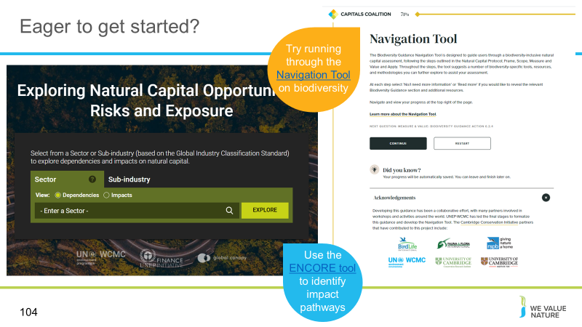
Presenter to suggest practical next steps that participants can take, and direct them to appropriate tools as shown on the slide

Slide 105
Thank everyone for their attendance

Slide 106
Presenter to allow for questions - time permitting

Slide 107
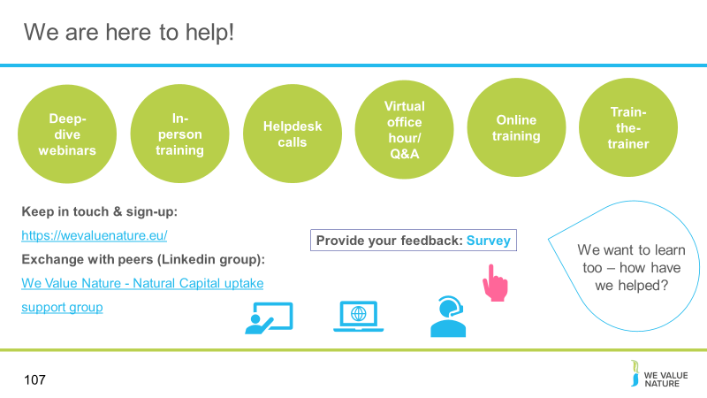
Presenter to point the delegates towards other resources that they can explore. Use the notes below as well as the notes on the slide:
- What else would you need? What support would you need?
- Sign-up for in-person day training
- If want support, need to fill out survey (Google form survey)
- Refining training further, keen to know how have used this training and catch-up via call (if don’t want to, let us know)

Slide 108
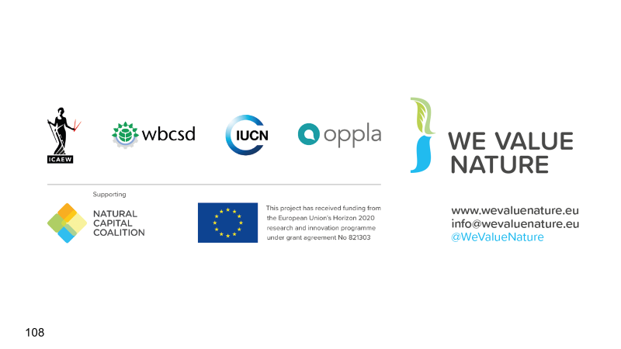
Presenter to conclude the presentation

Slide 109
