The Economics of Ecosystems and Biodiversity for Agriculture and Food (TEEBAgriFood) presents:

Putting nature and people at the center of food system transformation​​​

Trainee Workbook

The Trainee Workbook and Facilitator Guide were developed by Capitals Coalition as part of the TEEBAgriFood for business project with the support of Nature^Squared.

Developed by:
Capitals Coalition - https://capitalscoalition.org/
Louise Amand louise.amand@capitalscoalition.org
Martine van Weelden martine.vanweelden@capitalscoalition.org
Kate Swindells kate.swindells@capitalscoalition.org

Supported by:
Nature^Squared - https://www.nature-squared.org/
Iris Visser iris@nature-squared.org
Kayleigh O’Gara
Daria Selyavina
Table of Contents
Introduction to the training 5
Your learning journey 5
How to use this workbook 7
Description of module 1 8
Learning objectives 8
Module 1 exercises 9
Exercise 1 9
Exercise 2 10
Description of module 2 12
Learning objectives 12
Module 2 exercises 13
Exercise 1: Potential objective 13
Exercise 2: Scope of interest 14
Exercise 3: Selecting potential impacts and dependencies 16
Exercise 4: Homework Exercise – Prioritization Matrix 18
Description of module 3 21
Learning objectives 21
Module 3 exercises 22
Exercise 1: Fill in an impact pathway 22
Exercise 2: Indicators 24
Exercise 3: Reflection exercise - data needs 25
Description of module 4 28
Learning objectives 28
Module 4 exercises 29
Exercise 1: Verification and validation 29
Exercise 2: How to integrate results into decision making 31
Glossary 33
References & Resources 38
Contact 39

Introduction to the training
This Trainee Workbook has been developed to support you throughout the TEEBAgriFood training Putting nature and people at the center of food system transformation. This package includes the associated exercises, and space for you to take any notes you may need.

The overall ambition of the TEEBAgriFood program is to support businesses towards a nature positive, socially just food system. The training will guide you through theory that will enable you to conduct a capitals assessment – and this will help you understand why including the value of natural, social and human capital can lead to better decisions and improved business practices. By the end of this training program, you will also have an understanding of how to measure and value your business’ impacts and dependencies on nature and people as well as to act on the understanding of these interactions.

Your learning journey
The training sessions you have signed up to will run over four sessions, with one module per session. The sessions correspond to the four stages of a capitals assessment which relates to the TEEBAgriFood Guidelines.

- The first training module poses the question “Why is a capitals assessment relevant to my business?” and will guide you through the first stage of the Guidelines.
- The second training module will address the question “What is an appropriate objective for my capitals assessment?” and explore the different shapes, forms and scopes an assessment can take.
- The third training module will guide you through the process of measuring and valuing the capitals in relation to your business.
- The fourth and final module will provide you with information on how to interpret and verify the results of your assessment, and how to use the results to make positive transformative actions.

By the end of the training, we hope you will have gained the knowledge to begin your own capitals assessment, and to use the assessment to start making positive changes for people and planet.

Upon completion of the training, you will:
- Understand how the capitals approach provides direction for better business decision-making.​
- Be familiarized with how to assess business risks and opportunities based on natural, social, human capital.​
- Have a basic understanding on how to assess, measure and value your impacts and dependencies on nature and people across operations and value-chains. ​
- Be familiarized with the process of a capitals assessment and be equipped with the tools to start an assessment in your company.​
- Be inspired to drive change within your organization, by sharing data, setting targets and transforming business actions.​

How to use this workbook
Throughout the four modules, you will be expected to complete the exercises presented during the trainings. This workbook will provide you with the space to complete the exercises, and will act as a repository once completed. These exercises can then assist you in completing your user template, which will guide you on your assessment process. Furthermore, there is space in this workbook to take notes during the training. Be sure to utilize this workbook during the trainings, and to note down any useful information that may benefit you or your company in the future.

Description of module 1
Module 1 is the introductory module to the four trainings. It will firstly introduce the Capitals Coalition, the business case for capitals decision-making and the TEEBAgriFood project. The TEEBAgriFood project for Business is part of the larger TEEBAgriFood implementation project. This project is led by the United Nations Environment Program under The Economics of Ecosystems and Biodiversity initiative (UNEP TEEB) and is funded by the EU. The UNEP TEEB team leads on public sector engagement, while the Capitals Coalition are rolling out this project with the private sector. For more information, visit https://teebweb.org/.

Secondly, module 1 will cover the first stage of the Guidelines: Frame. You will be introduced to key concepts of the capitals approach including: the impacts and dependencies conceptual model, the four capitals (natural, human, social and produced), and the foundational concepts of capital stocks, flows and values. Afterwards, there is an example on the interactions between capitals for an agricultural business and the related risks and opportunities. You will also begin to discuss the potential applications for a business assessment and will be introduced to the user template.

Learning objectives
By the end of this module, you will:
- Understand the learning objectives of the training​.
- Have learned about the challenges and the solution to preserve value​ for nature, people and business.
- Be introduced to the TEEBAgriFood Guidelines for Business and the first stage: Frame (WHY?) .
- Be familiarized and have practiced with the key concepts of the capitals approach:
- Natural, social, human and produced capital​
- Stocks and flows​
- Impacts and dependencies​
- Risks and opportunities ​
- Be inspired by potential business applications and how a capitals assessment can be used in your own business context.
Module 1 exercises

Exercise 1
Using the circles provided, circle one or more capitals that would be interesting to assess in your business:
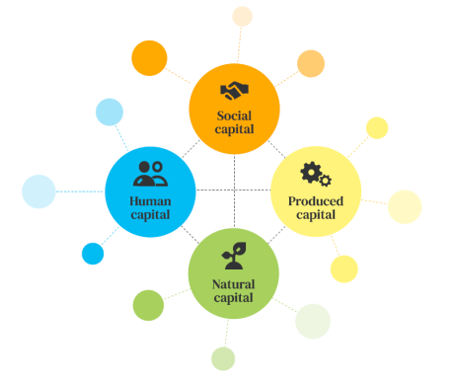

Why did you select this/these capitals to assess? Provide your reason(s) below:

Exercise 2
Circle the business application that could apply for a capitals assessment in your business:

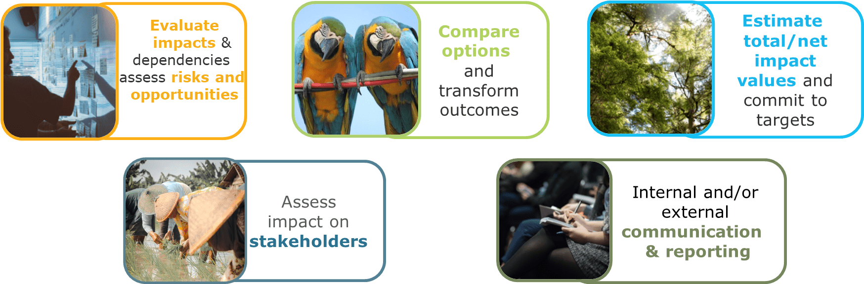

Why did you choose this/these business application(s)? Provide your reason(s) below:

Notes:

Description of module 2
Module 2 will delve into the Scope Stage. It will walk through the steps needed to scope your assessment. In order to have an appropriate scope, you must articulate the objective of your assessment. The module will walk you through a step-by-step process, which includes defining key elements such as the organizational focus, the value-chain boundary, the valuation perspective (business and/or society) and type of valuation (qualitative, quantitative, monetary) of your assessment. Defining the objective of your assessment happens alongside identifying your target audience. Identifying your target audience helps to inform your objective, and your objective helps you to know which stakeholders to engage with further. The module will cover the importance of knowing and engaging with your key stakeholders across the value chain, and the importance of considering both the business’ and the target audience’s perspectives.

The module will also introduce dependencies, impact drivers and impact pathways. Throughout the module, five exercises will be completed to help you understand the scoping process.

Learning objectives
By the end of module 2, you will:
- Be introduced to the Guidelines second stage: Scope (WHAT?)
- Learn how to set an objective for your business’ capitals assessment.
- Learn how to identify the target audience and stakeholders of your assessment.
- Understand the different ways businesses can impact and depend on nature, people and society and understand the steps of an impact and dependency pathway.
- Learn how to prioritize impacts and dependencies using the prioritization matrix template

Module 2 exercises
Exercise 1: Potential objective
Write a potential objective for your capitals assessment. This can be informed by identifying the business application, potential target audience and stakeholders, and the anticipated benefits. You can input your answer in the white box below.

You can use the business application you selected in Module 1 Exercise 2. When thinking about your target audience, remember to select a group which can make actionable decisions to improve your business’ relationship with the four capitals (natural, human, social, produced capital). Stakeholders can be groups within your organization (internal), or external to your organization.

Business application | Target audience | Stakeholders | Anticipated benefit | Potential objective
What would be a good business application? | Who will use the assessment results and make final decisions? | Who you can consult and who will be affected by the assessment? | Details benefits of an assessment | Write a potential assessment objective
Exercise 2: Scope of interest
Select the scoping elements that are relevant to meet the objective of your assessment. Remember to relate this to your business case, as this will be useful for the user template (see p. 11-12).
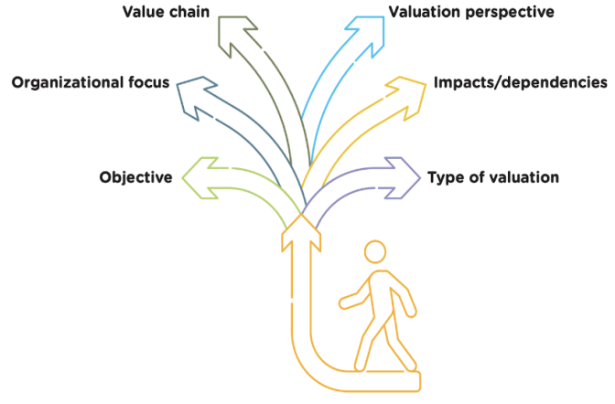
Objective
Write down your objective:

Organizational focus
☐ Corporate
☐ Product
☐ Project

Value chain boundary
☐ Direct operations
☐ Upstream
☐ Downstream

Valuation perspective
☐ Society

If selected, specify which stakeholder(s):

☐ Business

Impacts / Dependencies:
☐ Impacts on your business (from external factors)
☐ Your impacts on society (externalities)
☐ Your business dependencies (use or input)

Type of valuation:
☐ Qualitative
☐ Quantitative
☐ Monetary

Exercise 3: Selecting potential impacts and dependencies
Select the impact drivers and dependencies which are relevant to your business case. Select as many as you think are relevant to your business. This question is also available in the User Template, in section 4.1 and 4.2 (see p. 14-15).
Dependencies |  |  | Impacts
Natural | ☐ Water supply |  | Natural | ☐ Water use
 | ☐ Water purification |  |  | ☐ Terrestrial ecosystem use
 | ☐ Soil quality |  |  | ☐ GHG emissions
 | ☐ Pollination |  |  | ☐ Pesticide and herbicide use
 | ☐ Pest control |  |  | ☐ Fertilizer use
 | ☐ Genetic material |  |  | ☐ Soil use
 | ☐ Rainfall pattern regulation |  |  | ☐ Waste generation
 | ☐ Land |  |  | ☐ Animal welfare conditions
 | ☐ Energy |  |  | ☐ Genetic modified organisms
 | ☐ Other…………………………………… |  |  | ☐ Water use
Human | ☐ Skills and knowledge |  |  | ☐ Terrestrial ecosystem use
 | ☐ Experience |  |  | ☐ GHG emissions
 | ☐ Workforce availability |  |  | ☐ Pesticide and herbicide use
 | ☐ Health of workers |  |  | ☐ Other……………………………………
 | ☐ Agricultural Practices |  | Human | ☐ Nutritional content of food
 | ☐ Nutritional Security |  |  | ☐ Use of substances harmful to consumer
 | ☐ Other…………………………………… |  |  | ☐ Food safety practices
Social | ☐ Social networks and cooperation |  |  | ☐ Employee health and safety conditions
 | ☐ Propriety rights |  |  | ☐ Salaries and benefits
 | ☐ Social acceptance and trust |  |  | ☐ Workers’ living conditions
 | ☐ Law and regulation |  |  | ☐ Labor rights
 | ☐ Food security |  |  | ☐ Child and slave labor laws
 | ☐ Other…………………………………… |  |  | ☐ Priority rights
Produced | Accessibility to infrastructure & technology |  |  | ☐ Gender rights
 | ☐ Other…………………………………… |  |  | ☐ Workers’ representation
 |  |  |  | ☐ Other……………………………………
 |  |  | Social | ☐ Food security
 |  |  |  | ☐ Food loss
 |  |  |  | ☐ Food waste
 |  |  |  | ☐ Integration of workforce into communities
 |  |  |  | ☐ Benefit sharing with indigenous communities
 |  |  |  | ☐ Other……………………………………
Exercise 4: Homework Exercise – Prioritization Matrix
A business has many potential impacts and dependencies on nature and people. As it is not possible to measure all, establishing a priority list of the most important (or material) impacts and dependencies is crucial. The Guidelines recommend the following step-by-step approach:
- List the objective of your assessment
- List potentially relevant impact drivers & dependencies
- Identify the criteria for prioritization (can be based on your risk & opportunity categories)
- Rank impacts and dependencies based on prioritization criteria
- Indicate which impact drivers to include in your assessment
- Create priority list of impact drivers & dependencies
Support your decisions by using what you have learned within the trainings, and the completed exercises. Practice with this template and consider what is most important to your business.
The User Template (see p. 17) also contains an interactive matrix template that will help you to plot the impacts and/or dependencies to support you in your own prioritization.
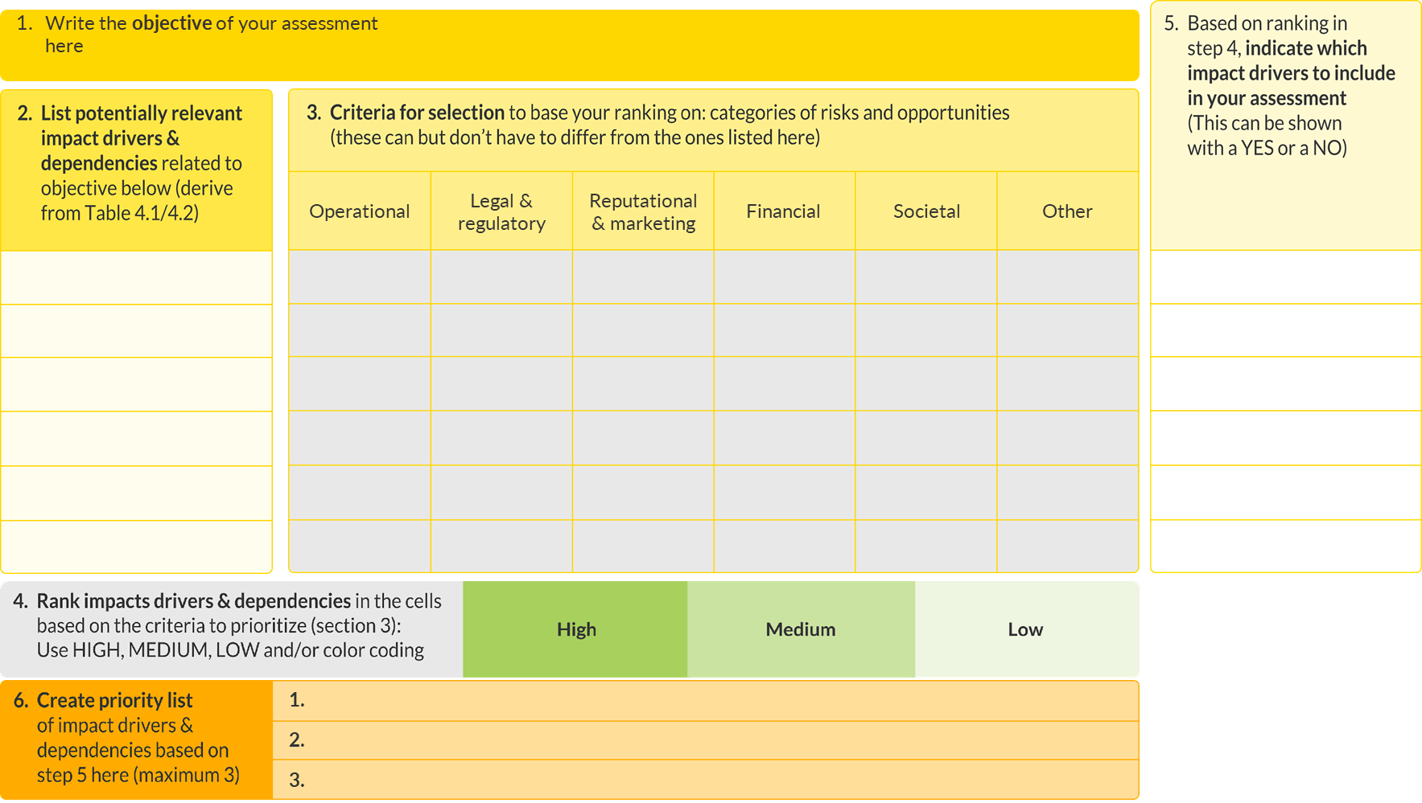

Notes:

Description of module 3
Module 3 focuses on the third stage of the Guidelines: Measure and Value. Following from the concept of impacts, dependencies and the associated impact and dependency pathways, this module will show you how to firstly measure your impacts and then value them. The impact pathway connects drivers (business activities or external factors) to changes in the state of the capitals, and then to the final consequences of said activities. This module and the associated exercises will help you define your indicators and to select the type of data needed to start measuring your activities and the change in capitals. The module will describe the differences between direct and indirect measurement, such as using models. Moving onto value, module 3 will walk through different forms of valuation: qualitative, quantitative and monetary.

Learning objectives
By the end of this module, you will:
- Be introduced to the Guidelines third stage: Measure & Value (HOW)?
- Understand how to map impacts and dependencies across a value-chain.
- Understand how to use indicators to measure impacts drivers, dependencies, and how to value the consequences of the changes in the capitals.
- Gain inspiration from businesses that have measured and valued their impacts and dependencies on the capitals.

Module 3 exercises
Exercise 1: Fill in an impact pathway
This exercise aims to assist you in understanding the causal logic between business activities and impacts and outcomes using an impact pathway. Understanding this causal relationship is paramount for the assessment process, as it enables you to measure the impact drivers (business activities) and the corresponding change in capitals and to value the resulting outcomes.

Two hypothetical situations are provided where business actions lead to impacts and outcomes. Allocate the different boxes below the corresponding ball or write down the letter (A, B, C) below the corresponding ball.

- What is an example of (measuring) an impact driver?
- What is an example of (measuring) a change in capitals?
- What is an example of (valuing) an impact?

Example 1:
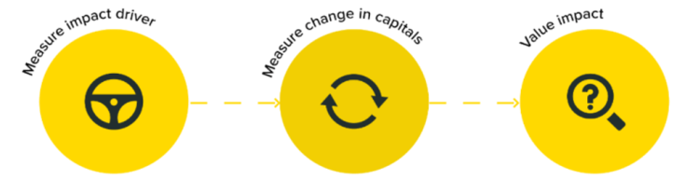

C. Greenhouse gas emissions
B. Change in global mean temperatures
A. Change in disease incidence
Example 2:

C. Employee health and safety conditions
A. Change in fatigue and stress level of workers
B. Change in number and severity of injuries

Exercise 2: Indicators
What could be potential indicators that you could use to measure the impacts drivers and dependencies listed below?

Indicators can be either qualitative, quantitative, or monetary.

Pesticide use Gender rights Experience Energy

Exercise 3: Reflection exercise - data needs
Based on the indicators you identified, what type of data would you need to measure the impact drivers and dependencies?

Examples of data sources:
- Primary data: Data collected for the assessment (internal business data; data from suppliers & customers)
- Secondary data: Published, peer-reviewed and grey literature (past assessments, estimates from modelling)

Do you know if you have any of this data already available?
- From direct measurements: any in-house data that is available already?
- From modeling: any resources you can use?

Give an example below. Alternatively, if the data is not available, what could be a strategy to acquire that data?
What would be an appropriate valuation type for your assessment? Qualitative, quantitative and/or monetary? You do not have to choose only one valuation type, but can combine different types valuations in one assessment.

Provide your reason(s) below:
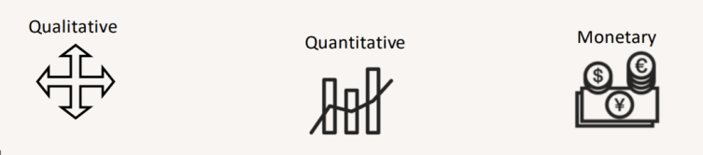

Informed by the type of valuation you selected, what type of valuation technique would be appropriate to value the impacts and dependencies?
Examples of valuation techniques:
- Qualitative valuation techniques- used to inform the potential scale of costs and/ or benefits expressed through qualitative, non-numerical terms. For example, questionnaire surveys, deliberate approaches, expert opinions, focus group discussios.
- Quantitative valuation techniques: focus on numerical data which are used as indicators for these costs and/or benefits. For example, structured surveys, Multi-criteria Analysis (MCA) using weighing and scoring.
- Monetary valuation techniques: translate quantitative estimates of costs and/or benefits into a single common currency. For example, market and financial prices, replacement costs, damage avoided costs.

Notes:

Description of module 4
Module 4 is the final module of the training. It focuses on the Apply Stage. The Apply Stage asks the overarching question ‘How to interpret and verify the results of the assessment and how to take action?’. This Step provides practical guidance on how to interpret and apply the results of your assessment.
Firstly, the module will help you to determine how reliable your assessment process and the results have been. This includes guidance on how to validate the assessment process itself, as well as how to test that your assumptions have been correct and to determine the level of confidence in your results. A sensitivity analysis can help you to test assumptions and gain confidence in the assessment. The module also shows examples of how to present the results in an attractive way to your target audience, as well as how to act upon results to make meaningful decisions.
It will also introduce you to the ACT-D framework, which stands for Assess (impacts & dependencies), Commit (to set science-based targets), Transform (business practices to create value for the company and for society) and Disclose (reporting, accountability to share progress with stakeholders). This framework is recognized by major corporate sustainability stakeholders (WBCSD, Business for Nature, TNFD, SBTN, WED, WWF, Capitals Coalition). Using reflective exercises, this module will help you articulate tangible business decisions in which you can make your business contribute positively to the Capitals.

Learning objectives
By the end of this module, you will:
- Understand the ways to interpret, validate and verify your assessment process and results.
- Have an understanding of the ways in which you can communicate your results internally and externally.
- Have learned how businesses can apply the results of a capital assessment to drive transformative and impactful change.

Module 4 exercises
Exercise 1: Verification and validation
When verifying and validating an assessment, it is important to run a sensitivity test and to identify who is affected by the business decisions. In doing so, we create more robust and trustworthy results to share with the target audience. The step-by-step guidelines are also underpinned by principles which help us to verify and validate each step of the process. Take a brief look below at the five principles below:

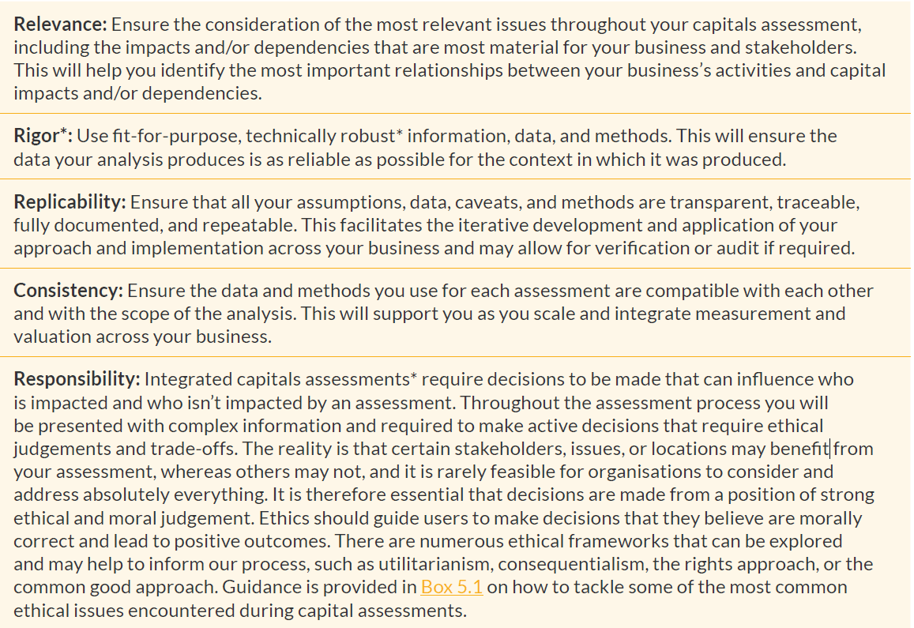

How do these principles help improve the assessment?

Take a moment with your fellow learners to brainstorm about how these principles could be applied throughout your assessment process. Potentially, some principles are easier to apply than others.

Do not worry if you can’t discuss all five, as this is only a hypothetical exercise to assist you in applying the principles in practice.

Exercise 2: How to integrate results into decision making Congratulations! You are now at the final exercise of the training course. Drawing from the information you have learned in the four modules, discuss with your fellow learners how your assessment results could be integrated into your business decisions, with the aim of contributing to a nature positive and equitable food system.

You can reflect on:

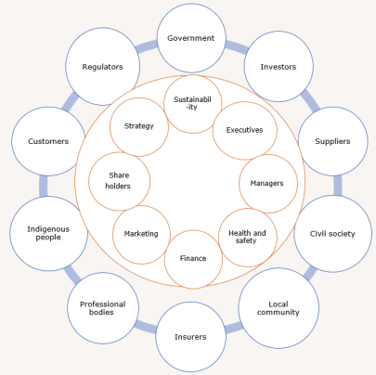
- How and with whom do you plan to communicate the results?​

- How can the assessment results be used to inform decisions to contribute to a nature positive and equitable food system?

Think about your target audience (decision-makers) and integration with existing business processes (risks assessment, reporting, financial accounting)

Notes:

Glossary
A list of key terms and their definitions can be found on p. 139-142 in Guidelines.

Term | Definition
Abiotic services | The benefits arising from fundamental natural and geological processes (e.g., the supply of minerals, metals, oil and gas, geothermal heat, wind, tides, and the annual seasons).
Baseline | In the Guidelines, the starting point or benchmark against which changes in capitals attributed to your business activities can be compared.
Biodiversity | The variability among living organisms from all sources including, inter alia, terrestrial, marine, and other aquatic ecosystems and the ecological complexes of which they are part; this includes diversity within species, between species, and of ecosystems (UN 1992).
Business application | The intended use of the results of your capitals assessment to help inform decision making, answering to how you intend to use the results.
Capitals assessment | A capitals assessment is the process of understanding, measuring, and valuing an organization’s relationship with natural, social, human, and/ or produced capital to answer a specific question or inform a decision. Assessments often inform internal decisions rather than disclosure.
Components | The three elements of a complete capitals assessment: impacts on your business, your impacts on society, and your business dependency.
Counterfactual | A form of scenario that describes a plausible alternative situation, and the environmental conditions that would result if the activity or operation did not proceed (adapted from Cambridge Natural Capital Leaders Platform 2013).
Dependency pathway | A dependency pathway shows how a particular business activity depends upon specific features of natural, human, social, or produced capital. It identifies how observed or potential changes in capitals affect the costs and/or benefits of doing business.
Double Counting | There is a risk that impacts and dependencies on capital assets will be counted twice, or even potentially multiple times. This issue can be exacerbated in integrated capital assessments.  Ensure that capital asset impact values are explicitly categorized between the different capitals and wherever possible are not counted twice. Where you are dealing with a hybrid asset, be clear about under which capital you will account for it. It is advised to organize a process that does not count the impact or asset twice.  Avoiding double counting produces more accurate and valid results and thereby improves decision making.
Ecosystem | A dynamic complex of plants, animals, and microorganisms, and their non-living environment, interacting as a functional unit. Examples include deserts, coral reefs, wetlands, and rainforests (MA 2005a). Ecosystems are part of natural capital.
Ecosystem services | The most widely used definition of ecosystem services is from the Millennium Ecosystem Assessment (MA 2005a): “the benefits people obtain from ecosystems.” The MA further categorizes ecosystem services into four categories:  - Provisioning: Material outputs from nature (e.g., seafood, water, fiber, genetic material).  - Regulating: Indirect benefits from nature generated through regulation of ecosystem processes (e.g., mitigation of climate change through carbon sequestration, water filtration by wetlands, erosion control and protection from storm surges by vegetation, crop pollination by insects).  - Cultural: Non-material benefits from nature (e.g., spiritual, aesthetic, recreational, and others).  - Supporting: Fundamental ecological processes that support the delivery of other ecosystem services (e.g., nutrient cycling, primary production, soil formation).
Human capital | An individual’s knowledge, skills, competencies, and attributes
Impact driver | In the Guidelines, an impact driver is a measurable quantity of a natural, human, social, or produced resource that is used as an input to production (e.g., volume of water used for crop irrigation) or a measurable non-product output of business activity (e.g., a kilogram of CO2e emissions released into the atmosphere by a manufacturing facility).
Impact pathway | An impact pathway describes how, as a result of a specific business activity, a particular impact driver results in changes in capitals and how these changes in capitals affect different stakeholders.
Integrated capitals assessment | A capitals assessment which explicitly takes into account the interconnections both within and between all of the capitals.
Life cycle assessment | Also known as life cycle analysis. A technique used to assess the environmental impacts of a product or service through all stages of its life cycle, from material extraction to end-of-life (disposal, recycling, or reuse). The International Organization for Standardization (ISO) has standardized the LCA approach under ISO 14040 (UNEP 2015). Several life cycle impact assessment (LCIA) databases provide a useful library of published estimates for different products and processes.
Measurement | In the Guidelines, the process of determining the amounts, extent, and condition of a capital or the benefits that flow from it, in physical terms.
Monetary valuation | Valuation that uses money (e.g., $, €, ¥) as the common unit to assess the values of capital impacts or dependencies.
Multi-capital assessment | A capitals assessment measuring and valuing all the capitals in terms of a business’s impacts and dependencies on them, showing the results for each capital ”side by side” (i.e., in a series).
Natural Capital Protocol | A standardized framework to identify, measure, and value direct and indirect impacts (positive and negative) and/or dependencies on natural capital.
Organizational focus | In the Guidelines, the part or parts of the business to be assessed (e.g., the company as a whole, a business unit, or a product, project, process, site, or incident). For simplicity, these are grouped under three general headings:  - Corporate: assessment of a corporation or group, including all subsidiaries, business units, divisions, different geographies or markets, etc.  - Project: assessment of a planned undertaking or initiative for a specific purpose, and including all related sites, activities, processes, and incidents.  - Product: assessment of particular goods and/or services, including the materials and services used to produce these products.
Prioritization | In the Guidelines, prioritization refers to a less rigid version of materiality that helps focus your resources on the issues that are of higher priority for you to take forward into the Measure and Value Stage.
Produced capital | The human-made goods as well as all financial assets that are used to produce goods and services consumed by society.
Qualitative valuation | Valuation that describes capital impacts or dependencies and may rank them into categories such as high, medium, or low.
Quantitative valuation | Valuation that uses non-monetary units such as numbers (e.g., in a composite index), areas, mass, or volume to assess the magnitude of capital impacts or dependencies.
Scenario | A storyline describing a possible future. Scenarios explore aspects of, and choices about, the future that are uncertain, such as alternative project options, business as usual, and alternative visions.
Single capital assessment | Measures and values impacts and dependencies on a single capital.
Social capital | Networks and their shared norms, values, and understanding.
Social & Human Capital Protocol | A standardized framework to identify, measure, and value direct and indirect impacts (positive and negative) and/or dependencies on social and human capital.
Spatial boundary | The geographic area covered by the assessment, for example, a site, watershed, landscape, country, or the planet. The spatial boundary may vary for different impacts and dependencies and will also depend on the organizational focus, value-chain boundary, value perspective, and other factors.
Stakeholder | Any individual, organization, sector, or community with an interest or “stake” in the outcome of a decision or process.
Stock | A store of value that can be enhanced or eroded.
Target audience | The main users of the assessment output (i.e., the people who will read and use the output to make decisions).
Temporal boundary | The time horizon of the assessment. This could be a current “snapshot,” a 1-year period, a 3-year period, a 25-year period, or longer.
Transmission channels | The complex interplay of nature-related dependencies and impacts over multiple time periods can result in earning and cashflow vulnerability. This can transmit into a broader range of financial risks, including market, credit and liquidity risks. These transmission channels include both micro-channels (such as supply chain uncertainty due to disruptions to production activities and value chains imposing unexpected costs; changes in profitability and asset values; and increased litigation) and macro-channels (such as changing demand and raw material price volatility). (TNFD, 2023)
Valuation | The process of estimating the relative importance, worth, or usefulness of capitals to people (or to a business), in a particular context. Valuation may involve qualitative, quantitative, or monetary approaches, or a combination of these.
Valuation technique | The specific method used to determine the importance, worth, or usefulness of something in a particular context.
Value perspective | The perspective or point of view from which value is assessed; this largely determines which costs or benefits are included in an assessment. Business value: The costs and benefits to the business, also referred to as internal, private, financial, or shareholder value. Societal value: The costs and benefits to wider society, also referred to as external, public, or stakeholder value (or externalities).
Value transfer | A technique that takes a value determined in one context and applies it to another context. Where contexts are similar or appropriate adjustments are made to account for differences, value transfer can provide reasonable estimates of value.
Value-chain boundary | The part or parts of the business value chain to be included in a capitals assessment. For simplicity, the Guidelines identify three elements of the value chain: upstream, direct operations, and downstream. An assessment of the full lifecycle of a product would encompass all three parts. Upstream (cradle-to-gate): covers the activities of suppliers, including purchased energy. Direct operations (gate-to-gate): covers activities over which the business has direct operational control, including majority-owned subsidiaries. Downstream (gate-to-grave): covers activities linked to the purchase, use, reuse, recovery, recycling, and final disposal of the business’s products and services.

References & Resources
For a long list of relevant content, explore the Guideline’s bibliography (p. 143-153) and Annex A (p. 155-165).

- Accounting for Sustainability. Click here
- Aries. Click here
- Millennium Ecosystem Assessment. Click here
- TEEB Scientific and Economics Foundations. Click here
- British Standard on Natural Capital BS 8632:2021. Click here
- Convention on Biological Diversity COP 15 Targets. Click here
- Ecosystem Services Partnership. Click here
- Esmeralda Maes Explorer. Click here
- FAO: SAFA, natural capital impact in agriculture, land use, Geodata portal, FAOSTAT, etc. Click here
- ISO 14008:2019 on monetary valuation of environmental impacts & 14007:2019 on Environmental management
- Natural Capital Accounting British Standard. Click here
- TNFD Nature-related Risk & Opportunity. Click here
- Natural Capital Protocol. Click here
- True Cost Accounting AgriFood handbook. Click here
- Natural Capital Toolkit. Click here
- Science Based Targets 2022 Forest land & agriculture. Click here
- OECD-FAO Guidance for Responsible Agricultural Supply Chains. Click here
- TEEB Measuring what's matters in AgriFood. Click here
- UN Global Guidance for Life Cycle Impact Assessment Indicators. Click here
- UN System of Environmental Accounting – Ecosystem Accounting. Click here
- WBCSD – Nature positive roadmap for Food & Agriculture. Click here
- World Benchmarking Alliance Methodology for the food & Agriculture Benchmark. Click here

Contact
Keep in touch! You can contact Louise Amand at louise.Amand@capitalscoalition.org and Martine van Weelden at martine.vanweelden@capitalscoalition.org for specific questions on the trainings or training materials or to inquire further information on the work of the Capitals Coalition. If you want to be involved in our Community, then please sign up through this link, and connect with others who are advancing on their Capitals Journey

